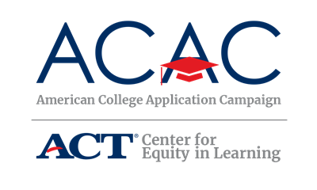

Communication Audit: State Level

Use the following table to identify current communication channels managed by the steering/planning committee members and other critical college access partners in your state. These channels should be considered as a way to promote the Campaign, call for host sites and to recruit volunteers. Charting the information will help you identify when and where to share the Campaign messaging.

Additionally, use this audit to identify ways to build off current efforts and develop a plan specific to the College Application Campaign communication needs.

Communication Channel | Frequency | Target Audience | Organization/Primary Contact
Example: Email newsletter | Monthly | Counselors | State Counselor Association
Example: Webinars | Twice a month | Counselors, college access professionals | State College Access Network
Example: Instagram | Daily | Students | Higher Edu. Institution

