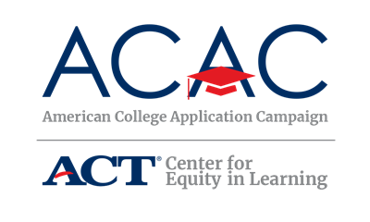

Community Information Letter

[School Logo]
[School Address]

September 2019

Dear Community Member,

[Name of Your High School] is pleased to announce its participation in [Name of State Campaign]! In an effort to further expand college access across the state, the [Names of State Campaign Sponsoring Organizations] are sponsoring [Name of State Campaign] from [Campaign date(s)]. The goal of [Name of State Campaign] is to provide every graduating high school senior the opportunity to apply to college [Insert additional goals, if necessary].
This event is possible due to the collaborative efforts of the administration, faculty, and staff at [Name of your high school], as well as students, their families, and volunteers across the community.

The purpose of this [day/week/month] is to acquaint students with the college application process and to communicate the importance of applying to college. Information about completing the Free Application for Federal Student Aid (FAFSA) will also be made available during the event.

[Name of your high school] will be hosting our College Application event on [Date(s) of event] to assist their students during the application process. We welcome the community to be a part of the program. If you are interested in volunteering or guest speaking during the event, please let me know. Volunteers can greet and sign-in students, assist students with the completion of college applications, or distribute information about financial aid opportunities.

Additionally, we encourage you to join us in celebrating the college application process on social media. September 20 will kick off the American College Application Campaign and application season with #WhyApply Day. We encourage you to use the hashtag #WhyApply to share with students the importance of applying for college. Students will also be encouraged to utilize #IApplied as they complete their applications.

If you have any questions please call [Site Coordinator’s Name, Site Coordinator’s Title], at [Site Coordinator’s phone number]. Thank you in advance for your support of this exciting initiative to encourage all [State’s Name] students to make college a part of their future.

Sincerely,
[Name of Site Coordinator]
[Title]

