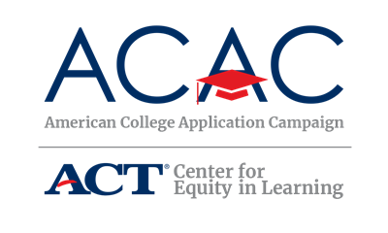

Thank you for participating in the [campaign name], [campaign date]!

Because of your tremendous efforts at [High School Name]:

- X of your X seniors participated in [campaign] activities
- X of your X seniors completed at least one college application
- X of these applications were to colleges and universities in [state]
- X applications were to four-year public institutions
- X applications were to two-year public institutions
- X applications were to private institutions
- X applications were to other programs such as cosmetology, military, etc.
- X seniors were able to use fee waivers when submitting their application
- X seniors completed their first college application during [campaign name]
- X students who will be the first in their family to attend college completed an application

Congratulations to you and your students, and best of luck to your seniors as they move through the admissions process!

