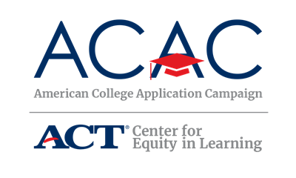

Sample Invitation Letter

Dear [Superintendent/Principal/School Counselor Name],

As part of a national initiative sponsored by ACT’s Center for Equity in Learning, [state name] has joined the American College Application Campaign (ACAC) and will host [State’s Campaign name] on [dates]. This will be the [number] year that [state] has hosted a college application event!

The goal of ACAC and [State’s Campaign name] is to increase the number of first-generation students and students from low-income families who pursue a postsecondary education by assisting high school seniors as they navigate the college admissions process, ensuring each participating student submits at least one admissions application. As we know, if [state name] is to develop the educated workforce needed for progressive economic development, we need to significantly increase the number of first generation students and students from low-income families pursuing and completing a certificate program, associate’s degree, or a bachelor’s degree.

We are seeking schools interested in participating in [State’s Campaign name]. We believe that this initiative will complement the work your school community is already doing to increase awareness of college preparedness and the application process. As a result of your school’s participation in this program, we anticipate that your school will experience an increased number of students submitting college applications.

If your school commits to hosting a [State’s Campaign name] event, a Site Coordinator will need to be identified for your school, typically a school counselor, college advisor, teacher or assistant principal. Your school will be asked to coordinate and dedicate time during the regular school day on a day or days during [State’s Campaign name] to assist seniors as they complete a college application.

[State’s Campaign name] will provide training to your school’s Site Coordinator regarding how to implement the program including organization, planning, use of volunteers, encouraging student participation, and securing application fee waivers for low-income students. Training will be available [dates] through [in-person, webinar, conference call]. Details regarding training will be sent to registered high schools at a later date. In addition, your school can indicate whether you would like [State’s Campaign name] to assist in identifying volunteers to help support your local initiative. [State’s Campaign name] is available to provide technical assistance as your Site Coordinator plans and implements the Campaign locally. And, finally, a guidebook/toolkit of resources including sample letters, schedules, and checklists will be provided to your school. There is no cost to your school to join the Campaign. We anticipate this event will be held at least one day during [State’s Campaign name]. Other than those commitments, the planning of [State’s Campaign name] at your school can be as big or little as you want to make it – although we encourage you to assist students in advance of the program to ensure they are prepared! So, additional time dedicated to the program will vary by school.

Please let us know if you are interested in joining the Campaign no later than [date] by completing the registration form (link or enclosed) [provide a link or include the form in your invitation].

We hope that your school will join this exciting initiative! Should you have any questions about [State’s Campaign name], please do not hesitate to contact [State Coordinator’s Name], [State’s Campaign title], at [email address] or by phone at [phone number].

Sincerely,

[insert name]

