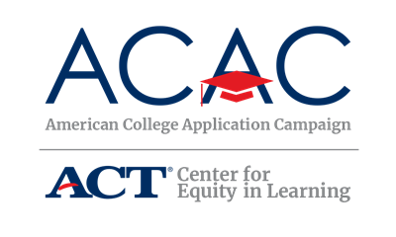

Sponsorship Request Letter Template – State Level

[Date]

Dear [Organization],
During the [week/month] of [Dates of ACAC Program], [Names of ACAC Sponsoring Organizations] will be sponsoring [Name of State’s ACAC Program]. On [Date(s) of event], all seniors at [Number] high schools across the state who are expected to graduate at the end of this academic year will be encouraged to apply for admission to at least one college or university, if they have not already done so. This event is possible due to the collaborative efforts of the administration, faculty, and staff at participating high schools as well as students, their families, and volunteers across the state and in local communities.
The purpose of [Name of State’s ACAC Program] is to acquaint students with the college application process, to communicate the importance of applying to college, and support students as they complete college applications. Information about completing the Free Application for Federal Student Aid (FAFSA) will also be made available during the event.
Although [Name of State’s ACAC Program] is focused on supporting students during the college application process, there are many activities participating schools will be doing with students leading up to the event to prepare and after the event to ensure the application process is complete. We welcome your organization’s sponsorship of [Name of State’s ACAC Program] to support our participating high schools and students as they prepare for and complete college applications. [Consider listing ways to support state campaign: State ACAC Program collateral such as “I Applied!” stickers for students, giveaways to participating students, volunteer opportunities, contest prizes].
If you have any questions about how your organization can support [Name of state’s ACAC initiative] please call [State Coordinator’s Name, State Coordinator’s Title], at [State Coordinator’s phone number]. Thank you in advance for your support of this exciting initiative to encourage all [State’s Name] students to make college a part of their future.
Sincerely,
[Name of State Coordinator]
[Title]

