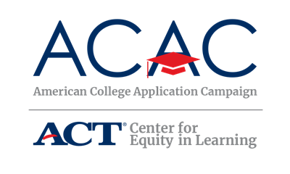

Understanding Financial Aid Award Letters

The Financial Aid Office at a college or university is responsible for sending information letters regarding financial aid. It is important that you read your award letters carefully to understand the type of aid being offered and how you indicate the aid you would like to accept. The information below is provided by the Financial Student Aid office of the U.S. Department of Education. For additional information on the various types of aid, definitions of common language found in financial aid award letters, a budget calculator to help you estimate the amount of aid you need, and other helpful information regarding paying for college, please visit their website at: http://studentaid.ed.gov/

When you receive an award letter, there may be a variety of aid options available. Be sure to read your letter carefully in order to make an informed decision about what aid you will accept. The general rule is: accept free money first (scholarships and grants), then earned money (work-study), and then borrowed money (federal student loans). The following outlines the order in which to accept specific types of aid and some important points to keep in mind.

- The first type of aid to accept is aid that you do not need to pay back: Scholarships and Grants. Make sure you understand the conditions you must meet (for instance, you might have to maintain a certain grade-point average in order to continue receiving a scholarship, or a grant may turn into a loan if you don’t follow specific requirements.)

- The second type of aid to accept is aid that you earn: through work-study. Keep in mind, you don’t have to pay the money back, but you do have to work for it, so take into account that will mean less time for studying. However, research has shown that students who work part-time jobs manage their time better than those who don’t!

- The third type of aid to accept is federal student loans: You’ll have to repay the money with interest. Subsidized loans don’t start accruing (accumulating) interest until you leave school, so accept a subsidized loan before an unsubsidized loan.

- The next type of aid to accept is loans from your state government or your college: You’ll have to repay the money with interest, and the terms of the loan might not be as good as those of a federal student loan. Be sure to read all the fine print before you borrow.

- The final type of aid to accept is private loans: You’ll have to repay the money with interest, and the terms and conditions of the loan almost certainly will not be as good as those of a federal student loan. https://studentaid.ed.gov/sa/fafsa/next-steps#what-aid-to-accept

If accepting a loan, always accept the loan with the most favorable terms and conditions. If you have any questions or don’t understand what types of loans are in your award letter, contact the Financial Aid Office at the college. Always ask questions and be an informed borrower. Make sure you understand what you’re receiving and the repayment terms.

When it comes to loans, you should only borrow what you need. If your living expenses are not going to be as high as the amount estimated in the award letter, you can turn down the loan or to request a lower loan amount. In the award letter, the college will tell you how to do this. Use the budget calculator available on FSA’s website to get an idea of your college expenses.

To tell the college what aid you are accepting, read and follow the directions on your award letter. Pay close attention to deadlines! If you have questions about your award letters, talk with your school counselor, call the Financial Aid Office at your college, and/or visit the FSA website (http://studentaid.ed.gov/).

