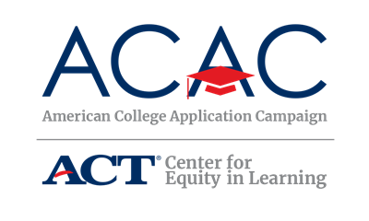

Why and How Branding Can Help ACAC and State Campaigns
Goal: Create more local, state and national success by telling the entire story of the college application efforts. We can do this through more coordinated and stronger branding.

The more unified the individual state campaigns appear, the more recognizable our efforts will be. Though many states have created their own logos and websites to fit the needs of your state, we encourage you to utilize the ACAC name and logo as much as possible. Please keep this in mind as you adapt the available ACAC templates.

If your state has access to a marketing specialist, leverage their knowledge and expertise to create a brand for your College Application Campaign event. Including this individual on the state steering committee would also be important. In addition, if your state already has a college access marketing or branding strategy, investigate how your College Application Campaign initiative can become a part of it and how the ACAC name and logo can also be included to demonstrate your state’s participation in a national initiative.

- Consistent use of the logo, graphic style, wording and other elements will result in greater acceptance and awareness in the marketplace of ideas.
- National and state partners often work together in other initiatives; such a branding partnership bolsters each partner. Examples:
  - Local United Way campaigns that align with national campaign
  - Local TV affiliates of national networks
  - Local agriculture departments that are tied to state and national ag departments
Things State Campaigns Can Do
- Consistently use the ACAC logo on email messages, e-newsletters, backdrops, printed material, videos, webinars, website, etc. There are always ways to incorporate the ACAC colors or compatible colors in state campaign logos and material.

- Use the ACAC message: ACAC is a national effort to increase the number of first generation college students and students from low-income families pursuing a postsecondary degree. The goal of the campaign is to increase the number of students who apply to and enroll in college. At events held in the fall during the school day, students complete and submit at least one college application. Participating high schools create a college-going culture prior to and during each event.
- There are creative ways to build this brand aligment. For example, “Louisiana College Application & Access Month, partner of the American College Application Campaign.”
- Help stakeholders, influencers and the media in understanding the state campaign is part of a national movement. ACAC messages can be included in news releases, talking points, speeches, social media posts, and mayoral and gubernatorial proclamations as a way to make the connection.

National ACAC Color Palette

ACAC Red

RGB: 227 28 35

CMYK: 5 100 100 1

HEX#: e31c23

ACAC Blue

RGB: 0 46 98

CMYK: 100 89 34 25
HEX#: 002e62
Recommended font
Avenir Next LT Pro and New Times Roman for designed materials. Work Sans is used throughout the website.
Logo
The ACAC logo and recommended font are available on the ACAC Website and/or can be made available upon request. Contact Lisa King at Lisa.King@act.org.

