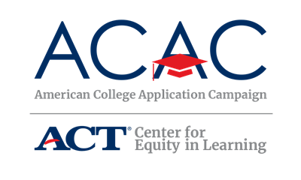

**Host Sites: Engaging with Social Media**

Use social media tools and networks to engage students about where they want to go to school, what they are doing to get there and questions or concerns they have. The top utilized social media platforms for young adults ages 18-to 24-year olds are Snapchat (78%) Instagram (71%), and Twitter (45%). Facebook and YouTube remain the most popular among U.S. adults ages 18-64 years old ([Pew Research Center, April 2019](https://www.pewresearch.org/fact-tank/2019/04/10/share-of-u-s-adults-using-social-media-including-facebook-is-mostly-unchanged-since-2018/)).

Your school’s planning committee should discuss which social media accounts currently exist among the high school and partners and review the audiences each reaches. Some high schools and states have coordinated social media contests to encourage engagement.

**ACAC Recommended Hashtags**

Hashtags are mainly used to indicate specific topics of conversation. For example, Twitter has a sidebar of trends and a list of hashtags you might be interested in based on the hashtags and content of your tweets. For your College Application Campaign, we encourage states and schools to use the same hashtags to increase visibility of our collective efforts. Simply note on any college application campaign materials, communication and social media content the chosen hashtag(s) by ACAC and your state.

#WhyApply

All adults, including counselors, teachers, parents, volunteers, and community leaders, are asked to join the conversation on social media. Use #WhyApply to remind and encourage students about the reasons to apply to college. Share your reasons for applying to college and encourage your colleagues and partners to do the same! ACAC has marked Friday, September 20 as #WhyApply Day and the official kickoff to the college application season.

#IApplied

Encourage students to share where they have applied using #IApplied within their social media posts. Share those posts to help celebrate the students and raise awareness of the application process. Remember to tag the colleges to which students have applied.

[Insert state campaign hashtags and how they should be used]

**ACAC Social Media Accounts**

ACAC will highlight every state’s initiative this fall. Like our page and/or follow us to see how colleagues across the country are accomplishing the ACAC goal. Post photos, media stories and other items from past and future events. We look forward to featuring your great work!

ACAC Facebook: [www.facebook.com/americancac/](http://www.facebook.com/americancac/)

ACAC Twitter: @American_CAC <https://twitter.com/American_cac>

ACAC Instagram: [www.instagram.com/american_cac/](http://www.instagram.com/american_cac/)

[Insert state campaign social media]

**State Social Media Examples We Love**

