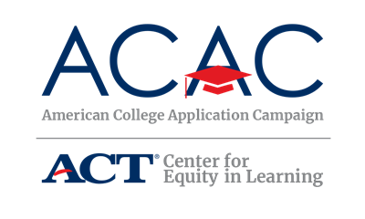

FAFSA Completion Event Reminders

[Name of State’s FAFSA Completion Event]
[FAFSA Completion Event’s Logo]

Assistance with Your Free Application for Federal Student Aid (FAFSA)

Date: [FAFSA Completion Event Date]
Time: [FAFSA Completion Event Time]
Location: (Nearest location)

Contact Info
Host: [FAFSA Completion Event Group or Organization]
Contact Phone Number: [Phone Number for FAFSA Completion Event]
Contact Email: [Email for FAFSA Completion Event]

What to Bring
The following items are what you should bring to the event.
- Your FSA ID, if you have been assigned one. You should have registered for your FSA ID during [Name of State’s ACAC program]. If you do not already have a FSA ID or if you have forgotten your FSA ID and need to retrieve it, you can go here: https://studentaid.ed.gov/sa/fafsa/filling-out/fsaid. Be sure to do this prior to the event!
- If you have previously completed a FAFSA Worksheet, please bring it with you.
- Your Social Security Number (SSN).
- Your driver's license (if any).
- Your parents' [Tax Year] W-2 forms (if you are a dependent student). If you earned income in [Tax Year], you should also bring your [Tax Year] W-2 forms.
- Your [Tax Year] untaxed income records (e.g., Veteran's non-education benefit records, child support received, worker's compensation).
- Your current bank statements.
- Your current business and investment mortgage information, business and farm records, stock, bond and other investment records.
- Your resident alien registration or permanent resident card (if you are not a U.S. citizen).

For more information, visit the [Name of State’s FAFSA Completion Event] website here:
[FAFSA Completion Event Website]

