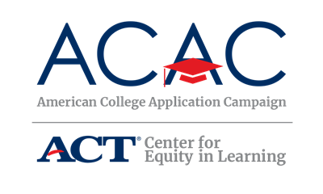

Governor’s Proclamation

In states that have successfully implemented a College Application Campaign event, support from Governors has been attained through visits to participating schools, letters to participating students, and/or annual proclamations of the program. Gubernatorial support is an effective way to gain buy-in at the school, district, and state-levels and to create awareness and interest among students and their families. Typically, a proclamation request is available through the state’s official website for the Governor’s office.

Proclamations will vary by state and should include language specific to your state’s program. Key elements to focus on in your proclamation are:
- Why are you implementing a College Application Campaign event? Discuss the goal of the initiative and why it is important for your state.
- What are the benefits of increasing access to postsecondary education in your state? A better educated workforce and workers prepared to meet the needs of the 21st century and/or the increased level of income, better health, and more community involvement associated with postsecondary education are some examples.
- Use data! What are the workforce and labor needs of your state in regard to the anticipated number of workers needed with a bachelor’s or associate degree?
- Who supports this initiative? This is an opportunity to highlight the partnerships developed through the steering committee to support your Campaign event.
- What do you want your Governor to encourage students to do as part of this proclamation? Some options are encouraging students to research postsecondary institutions, apply to at least one college during the Campaign event, and/or take advantage of the resources available through the Campaign event.

Sample Proclamation Language

Feel free to edit this language to reflect your state’s program:

WHEREAS the college application process may be a barrier to some high school students pursuing postsecondary education due to an absence of information or support

WHEREAS obtaining a postsecondary degree has been linked to higher income, better health, and increased community involvement

WHEREAS only [_percent_]% of [_state_]’s working population, aged 25-64, has at least an associate degree [Pull data from Lumina’s A Stronger Nation Report: http://strongernation.luminafoundation.org/report/2019/#nation]

WHEREAS [_state_] is working to prepare students for the opportunities and challenges of the 21st century

WHEREAS [_state_] is a partner of the American College Application Campaign, a national effort designed to increase the number of students who apply to and enroll in college with a particular focus on first-generation and students from low-income families

I, [_Governor’s Name_] do hereby declare [_dates_] [_State Campaign’s name_] in [_state_] and encourage all seniors to take advantage of the assistance provided through this initiative.

