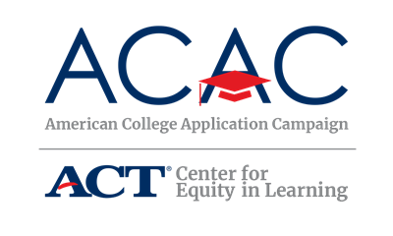

Sample Host Site Data Collection Form

The following questions can be built into an online sign up form via Google Form, Survey Monkey, etc. This form is intended as an official data collection form for high schools to submit to state coordinators. Questions can be revised to fit the data requests of each state.

Thank you for your participation in [State’s Campaign name]. By completing this form, you are completing your requirements as an official [state campaign] host site. These data are compiled with all host site data and submitted to the American College Application Campaign. Your cooperation helps us bring recognition to the hard work of our students and your school at the state and national level.
Please complete this form by [DATE] and submit to [STATE COORDINATOR NAME], [EMAIL].

Q1. High school name: (required):
Q2. Host site coordinator name (required):
Q3. Host site coordinator title (required):
Q4. Host site coordinator email (required):
Q5. Host site coordinator phone number (required):
Q6. School mailing address:
Q7. City: Q8. Zip:
Q9. Number of years participating in [STATE CAMPAIGN NAME] including the fall 2018 event:
[State Coordinators – Please note which questions are required by ACAC vs optional. You may wish to add more questions to collect data important to your state campaign goals.]

Please provide the following data to the best of your ability.

Required:
Q10. Number of seniors who submitted an application:
Q11. Number of college applications submitted:
Optional:
Q12. Size of senior class 2019:
Q13. How many students applied for the first time:
Q14. How many students will be the first in their family to attend college:
Q15. How many applications were submitted to:

- 4-Year Public Institutions:
- 2-Year Public Institutions:
- Private Institutions:
- Other:

Q16. How many applications were submitted instate vs out of state:
- Instate:
- Out of State:
Q17. How much money was spent to host your campaign activities:

- None
- Less than $250
- $250 - $500
- More than $500

Q18. What state campaign resources did you utilize?
- [Insert list of resources. For example: pens, stickers, buttons, etc.]
Q19. How many days of activities did your school provide for [Name of State Campaign]?

- One day
- One to three days
- One week
- One to three weeks
- One month
- More than one month

