WI | SharePoint  External Users Registration Process | Date Effective: 12/7/15  Written By: Shawn McDonnell  Approved By:
Please note the instructions directly below are for individuals whose organization does not have Office 365, if you have Office 365 you will want to use the instructions located here.
Step |  | Work Instruction
1. | ACT SharePoint Site Owner will invite you to the external SharePoint site. Once added you will receive an email.  - Click on the name of the site in orange.  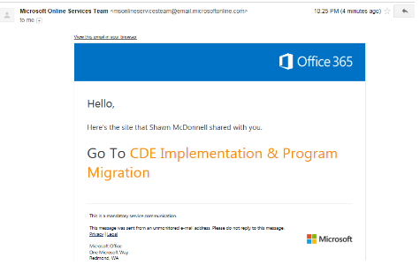
2. | When the site name is selected, you should be taken to a login screen.  - Select ‘Create a Microsoft Account, it’s quick and easy!’  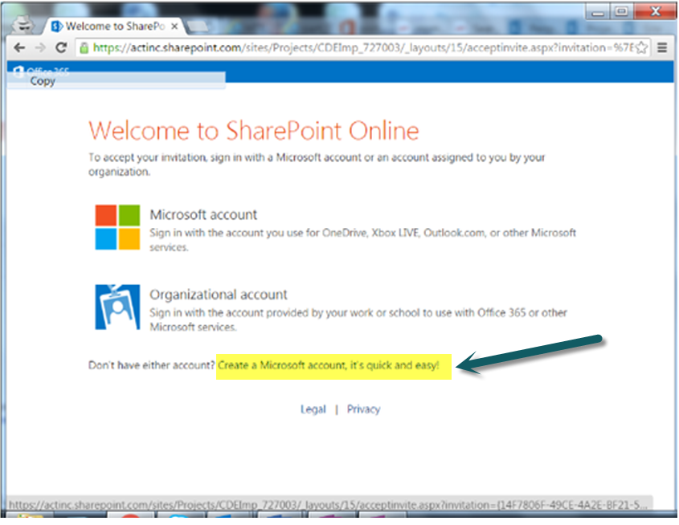
3. | Select Create a Microsoft Account. The following screen will appear.  - Fill out account information. This will be your log in ID and password for the external SharePoint site.  - Uncheck Send me promotional offers from Microsoft… unless you are interested in receiving those emails.  - After filling in all mandatory fields, Create Account.  Please Note: If your Organization has O365 – you will select Organizational account above and logon with your O365 credentials. If this is not working for you please contact ACT. If you are an individual contributor and we are sending your invite to a Microsoft account like Outlook, Hotmail or another live account that you have created – Select Microsoft account and login with your existing account credentials.  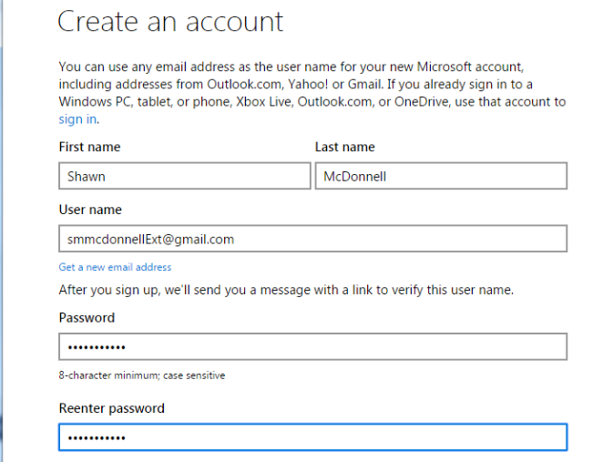  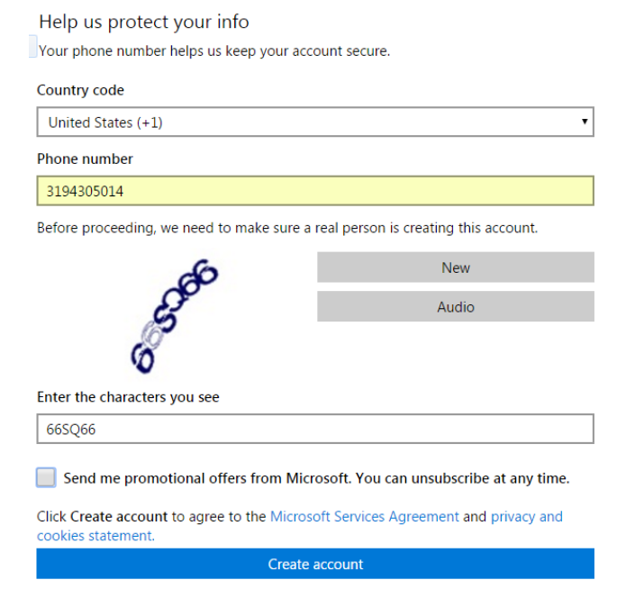
4. | If a new account was created, you will receive an email to confirm email, phone and other information. The code will be entered on the next screen.  - Enter Code  - Uncheck Send me promotional offers from Microsoft…  - Create Account  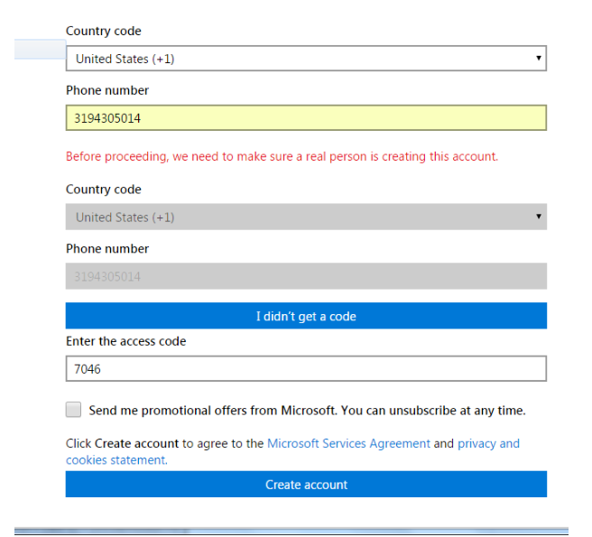
5. | Sign into the SharePoint site  - Enter user ID and password  - Select Keep me signed in  - Sign In  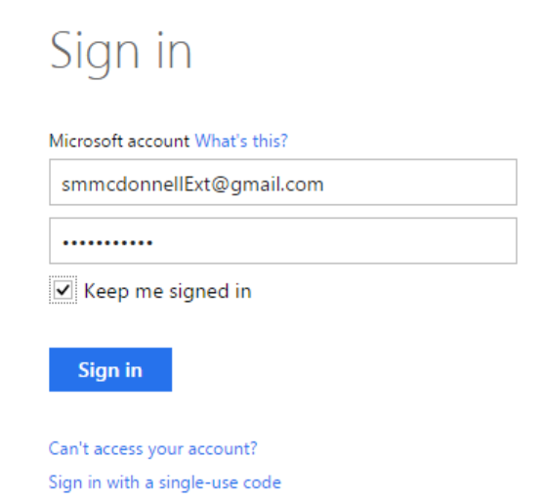
6. | On initial log in, you will need to verify your email. Go to your Inbox and follow instructions documented in the email.  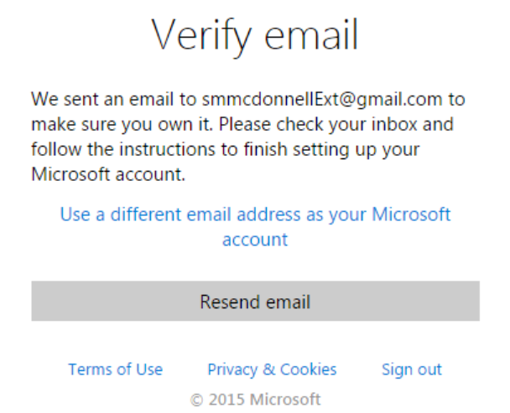  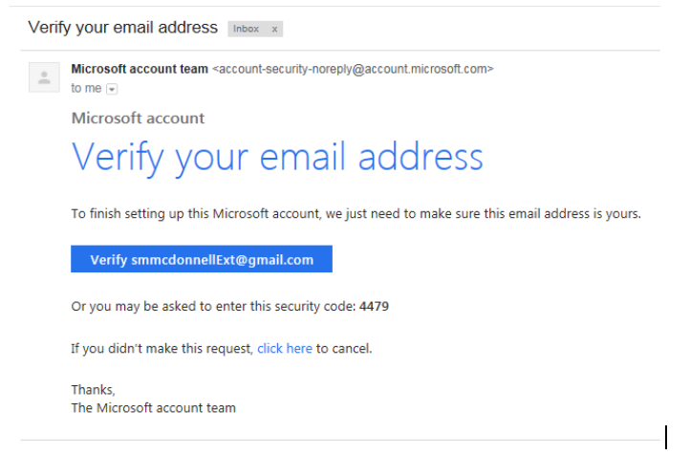
7. | Once you verify your email, you will be ready to begin work on your SharePoint site. Your login screen will appear as below. Select OK.  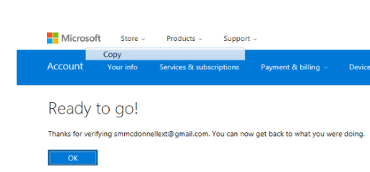
10. | Note that on some occasions the browser can get confused if you have more than one Microsoft account. Sometimes it is helpful to open the browser in “private” mode to log in to the site so the browser session is limited and does not use any of the logged in accounts, etc., from any other browser sessions. Chrome calls this a “new incognito window,” Firefox calls it a “New private window,” and IE calls it “Start InPrivate browsing.”

Instructions for Users who have emails associated with Office 365. If your organization uses Office 365 – please use these instructions.
Step |  | Work Instruction
1. | ACT SharePoint Site Owner will invite you to the external SharePoint site. Once added you will receive an email.  - Click on the name of the site in orange.
2. | 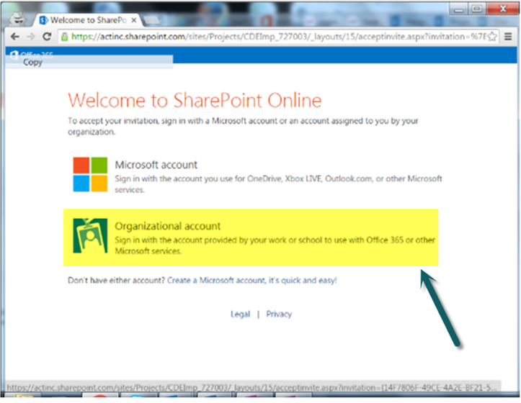
 | Select Organizational Account and login using your Office 365 credentials. If you aren’t sure what these credentials are please contact your IT department for this information.

