WI | Granting Access to External Facing SharePoint Sites to ATOS and Other External Partners using O365 | Date Effective: 03/28/2016  Written By: Shawn McDonnell  Approved By:

Step |  | Work Instruction
1. | ACT SharePoint Site Owner will invite you to the external SharePoint site. Once added you will receive an email.  - Click on the name of the site in orange.  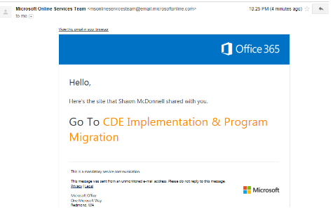

2. | Please NOTE – These are instructions for use when you have an Office 365 Account (i.e. ATOS) –  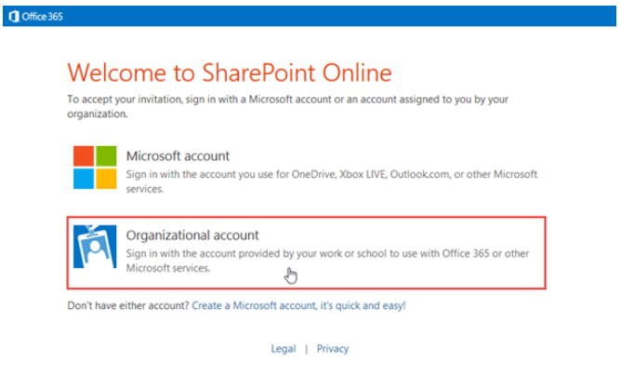
3. | Select Create Organizational Account. The following screen will appear.  - Enter your organizational login – for example – An Atos member would enter their login@atos.net or whatever is normally used to login via their work account.  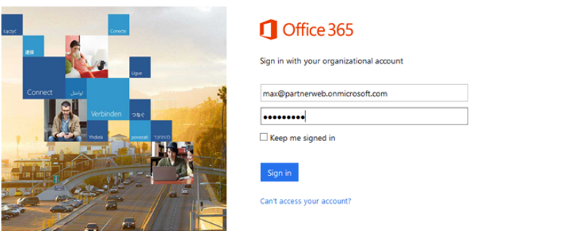
7. | This should take you into the site that you were invited to.
10. | Note that on some occasions the browser can get confused if you have more than one Microsoft account. Sometimes it is helpful to open the browser in “private” mode to log in to the site so the browser session is limited and does not use any of the logged in accounts, etc., from any other browser sessions. Chrome calls this a “new incognito window,” Firefox calls it a “New private window,” and IE calls it “Start InPrivate browsing.”

