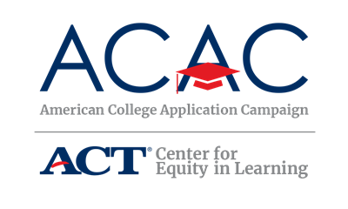

College Application Event Sample Student Sign-Out Form

The following sign-out sheet is an option that allows you to provide the students an individual form to complete. Host sites can modify this form to meet their site needs. Copies of this document will need to be made in order for each participating student to receive one.

Student Name:

How many colleges have you applied to total (including those that you submitted before today’s event)?

How many colleges did you apply to today?

Is today the first time you submitted a college application?

Please list the colleges and indicate if a transcript request has been completed for each college:

College Name | Transcript Requested?

Have you registered for a FSA ID? Yes No

Have you submitted the FAFSA? Yes No

Will you be the first person in your family to attend college? (First-generation means no one in your immediate family has earned a college degree) Yes No

