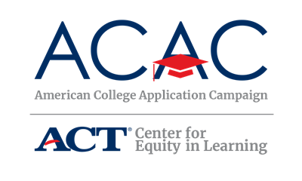

Volunteer Feedback Survey
State Coordinators: The following is a template for a volunteer feedback survey. It is recommended that you create an online survey so volunteers can quickly provide feedback. We recommend free and inexpensive tools like Google Forms and Survey Monkey.

Thank you for volunteering during this year’s [STATE CAMPAIGN NAME]. We appreciate your time and talent. As a volunteer, the [STATE CAMPAIGN NAME] steering committee would like to receive your feedback based on your experience. Please complete this brief survey to help us reflect on our successes this year and improve for next year.
The survey should take 5 minutes to complete. Once you click “submit” at the end of the survey, your answers will be submitted and you will not be able to make further changes.
Your responses will be kept confidential. The survey asks for you to identify the high school(s) where you volunteered to help us provide a summary of feedback to the sites. [STATE CAMPAIGN NAME] steering committee will analyze the data and report findings in aggregate. The name of the high school will never be associated with your responses in any report of the findings.
Please complete the survey by [DATE]. If you have any questions, please contact [STATE COORDINATOR NAME AND EMAIL].
Q1. What type of school/organization are you affiliated with? (required)
- Public college or university
- Private college or university
- Community organizations
- College access network or program
- State agency
- High School
- Other

Q2. Please select your title/position (required)
- Admissions professional
- School counselor
- School teacher
- School administrator
- GEARUP coordinator
- AmeriCorps member
- College access program/network professional
- Youth-serving nonprofit professional
- Other

Q3. Where did you volunteer for [STATE CAMPAIGN NAME] (required)
[Depending on number of sites, consider a drop down menu option or blank space.]

Q4. How many total hours did you volunteer?
- 1-3 hours
- 4-6 hours
- More than 6 hours

Q5. Please rate your satisfaction with how your volunteer time was utilized.
- Poor
- Fair
- Good
- Excellent

Q6. Please rate the quality of the following resources. [List resources available/provided to volunteers such as Volunteer Guide, training, etc]
Resource 1
• Poor
• Fair
• Good
• Excellent

Q7. Overall, how did the event compare with your expectations in regards to organization and flow?
- Below expectations
- Met expectations
- Exceeded expectations
- Other

Q8. Will you volunteer again during [STATE CAMPAIGN NAME]?
- No
- Probably not
- Maybe
- Probably
- Definitely

Q9. Do you have any comments, questions or concerns about [STATE CAMPAIGN NAME]?

