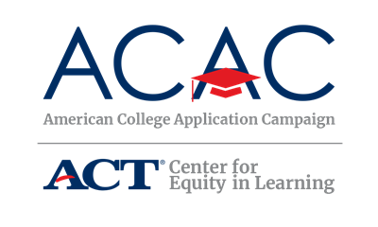

Volunteer Thank You Letter Template

Dear [VOLUNTEER’S NAME],

On behalf of [NAME OF HIGH SCHOOL], I would like to personally thank you for volunteering your time at our [STATE CAMPAIGN NAME] event. This campaign could not have been a success without your help and the help of many others who volunteered their time.

[State Coordinators, include this if you plan to have a volunteer survey] To improve our future [STATE CAMPAIGN NAME] events and your volunteer experience, please complete this short online survey at your convenience: [survey link]

During [NAME OF STATE CAMPAIGN], [NUMBER OF SENIORS SUBMITTING COLLEGE APPLICATIONS] seniors submitted over [NUMBER OF COLLEGE APPLICATIONS SUBMITTED] college applications. [Optional]In addition, [FAFSA COMPLETION PERCENTAGE] of our students filed their FAFSA during/immediately following) the event [DATE]. Thanks to our seniors’ hard work and the assistance of volunteers like you, they are one step closer to actualizing their dreams of attending college!

Once again, [NAME OF YOUR HIGH SCHOOL] thanks you for your efforts and contribution of time during [NAME OF STATE CAMPAIGN]! We look forward to seeing you throughout the school year and especially at our event next year.

Sincerely,

[SITE COORDINATOR NAME]
[YOUR TITLE]
[CONTACT INFO]

