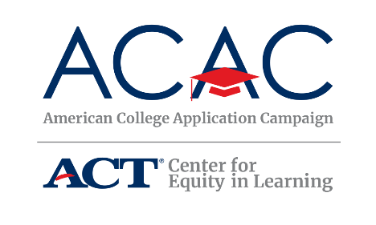

Sample Social Media Editorial Calendar
SEPTEMBER 2019 - NOVEMBER 2019

SEPTEMBER 2019 (Hispanic Heritage Month - 15th)

Publish Date | Twitter | Facebook | Instagram | Notes/Topic Ideas
Sunday, 9/1
Monday, 9/2 | By 2020, 65% of all US jobs will require a postsecondary education. Don’t be left behind. #WhyApply  https://cew.georgetown.edu/wp-content/uploads/2014/11/Recovery2020.SR_.Web_.pdf  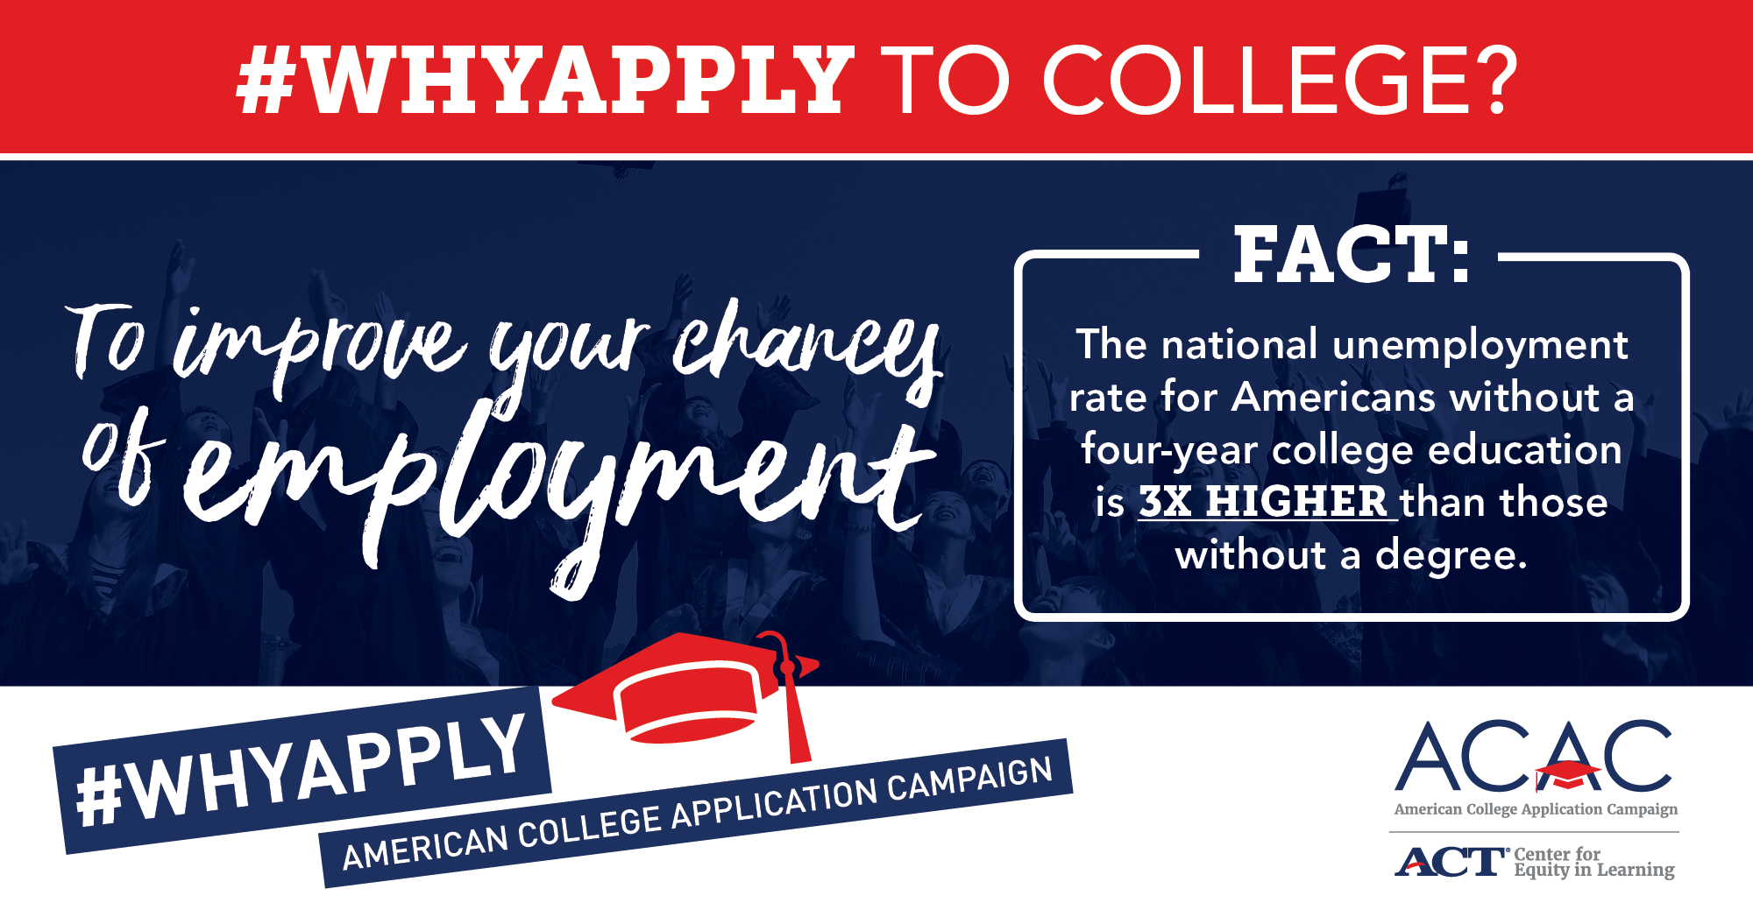 |  |  | Labor Day – post using ACAC graphic about employment  Images saved on ACAC website under “Social Media Materials”:  https://equityinlearning.act.org/acac/resources/state-coordinator-materials/
Tuesday, 9/3 | Calling all college counselors and advisors! Join @American_CAC on 9/10 at 1 pm EDT for a webinar, promoting ACAC’s “How To Implement A College Application Campaign Event” Details and sign up at: https://equityinlearning.act.org/event-type/webinars/ | Calling all college counselors and advisors! Join American College Application Campaign on 9/10 at 1 pm EDT for a webinar on “How To Implement A College Application Campaign Event” Get more information and sign up at: https://equityinlearning.act.org/event-type/webinars/ |  | Promote ACAC Sept 10 webinar for host sites
Wednesday, 9/4 | It’s #ReadABookDay and we’re celebrating by digging into Harry Bauld’s “On Writing the College Application Essay.” Perfect way to gear up for #WhyApplyDay! | It’s #ReadABook Day! Share your top three favorite books you read in college. Or feel free to share your top three books on the college experience. |  | #ReadABookDay
 | RT content from Reach Higher/Better Make Room/ Get Schooled |  |  | Beyonce Birthday (Homecoming/ HBCU)
Thursday, 9/5 |  |  |  | International Day of Literacy #LiteracyDay
Friday, 9/6
Saturday, 9/7
Sunday, 9/8
Monday, 9/9 |  |  |  | Retweet/Share ACAC webinar info
Tuesday, 9/10 | On this #DayOfEncouragement, share reasons that encourage students to apply to college. Snap a selfie and share your reasons using the template available here https://equityinlearning.act.org/wp-content/uploads/2019/05/WhyApply-Invitation-and-Selfie-Printout-2019.docx Tweet them on Why Apply Day Friday, 9/20. Don’t forget to tag @American_CAC and use #WhyApply | On this #DayOfEncouragement, share reasons that encourage students to apply to college. Snap a selfie and share your reasons using the template available here https://equityinlearning.act.org/wp-content/uploads/2019/05/WhyApply-Invitation-and-Selfie-Printout-2019.docx. Tweet them on Why Apply Day Friday, 9/20. Don’t forget to tag @American_CAC and use #WhyApply |  | National Day of Encouragement  #DayOfEncouragement
Wednesday, 9/11 | RT ACAC Content
Thursday, 9/12 | #WhyApply? Colleges consider more than just a student’s grades and test scores for admissions. Your character outside of the classroom counts. Tell your story today.  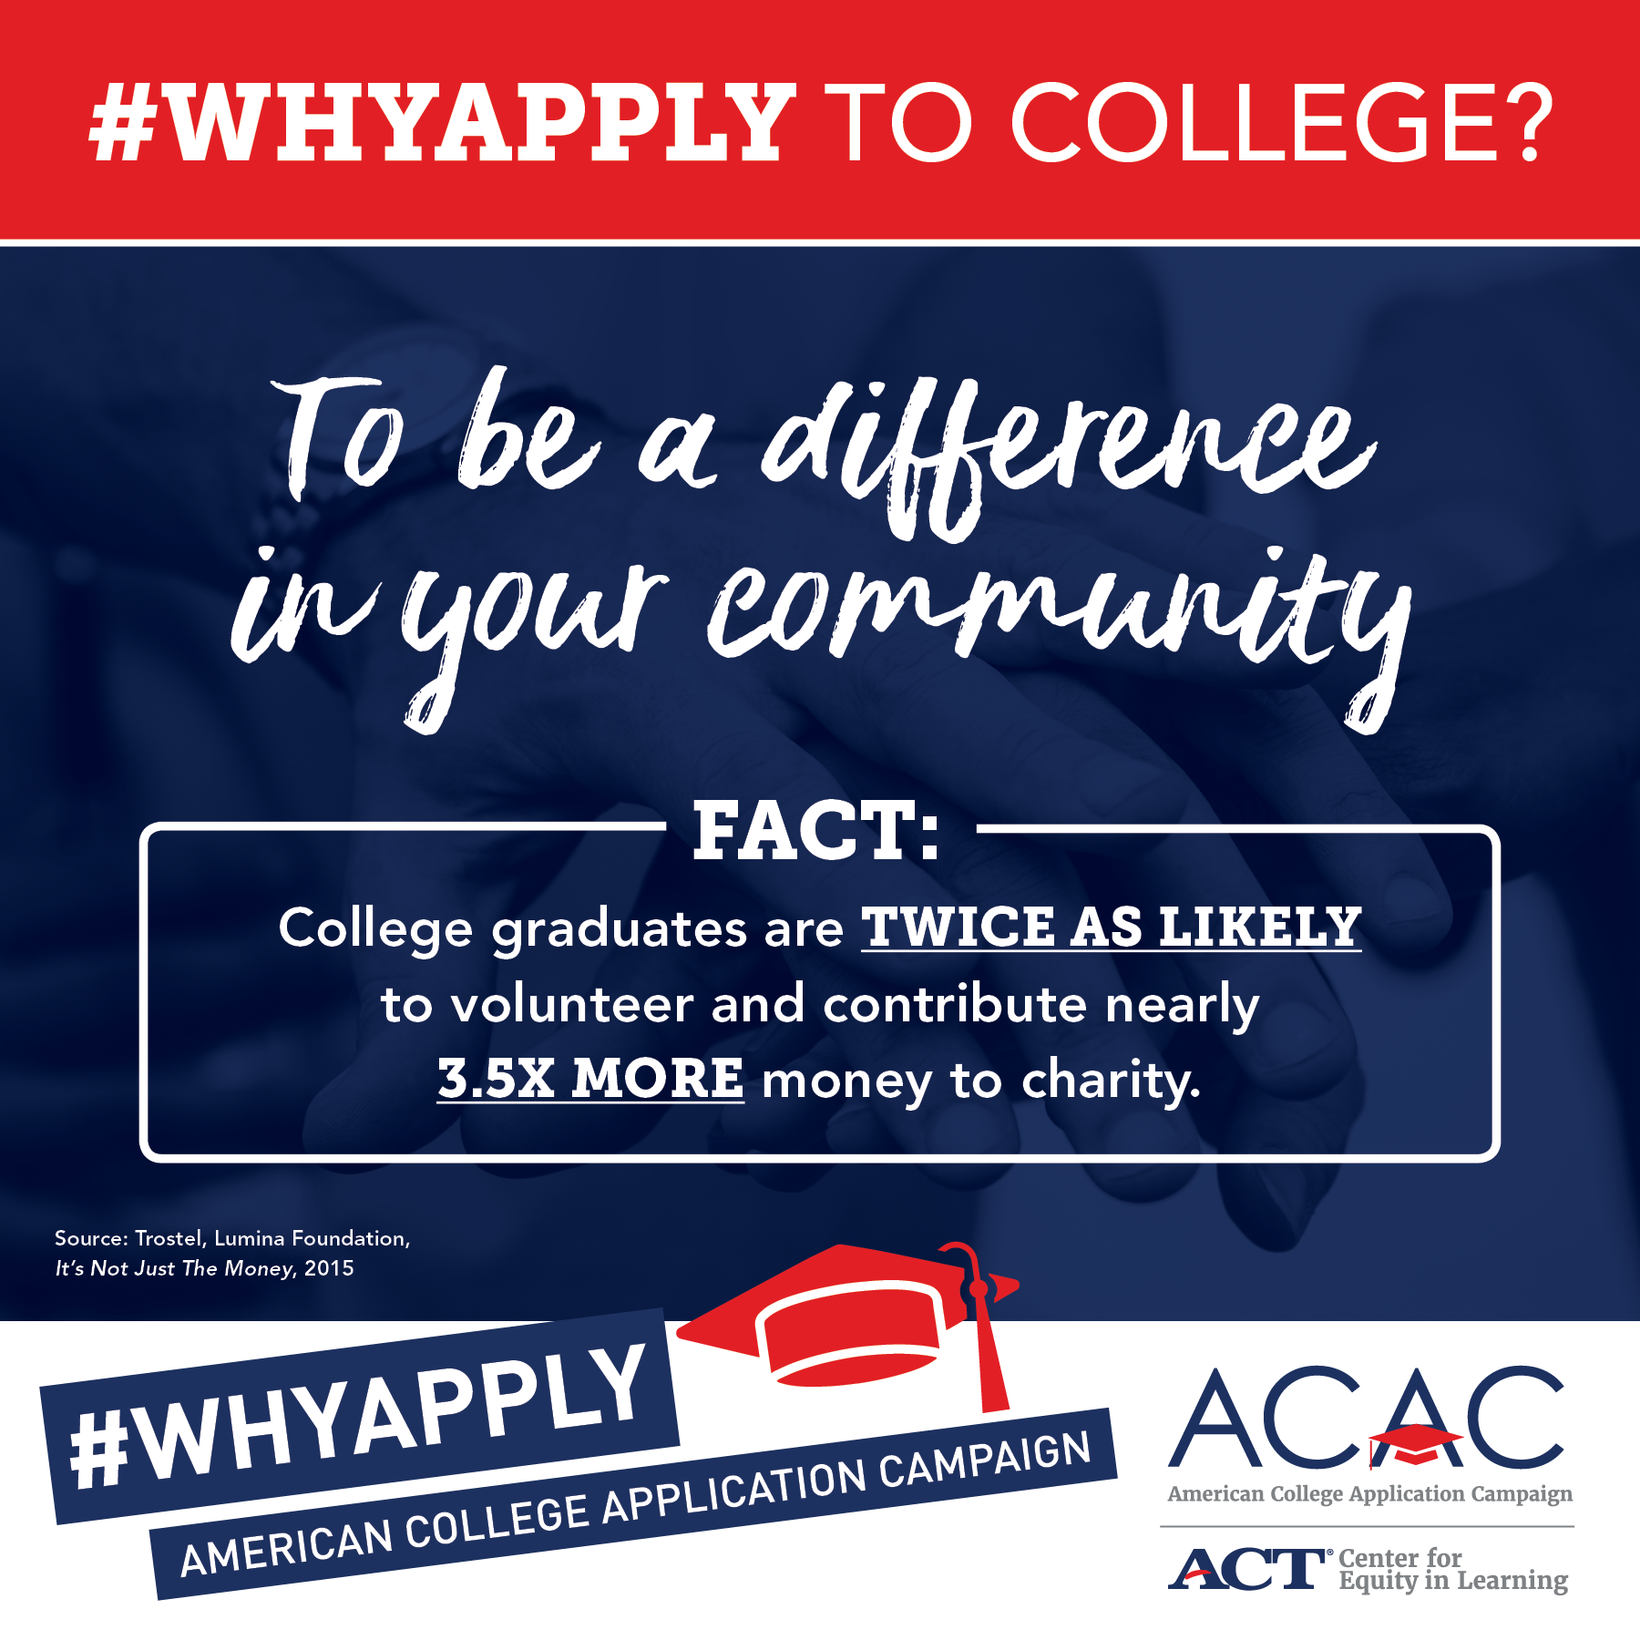 |  |  | Images saved on ACAC website under “Social Media Materials”:  https://equityinlearning.act.org/acac/resources/state-coordinator-materials/
Friday, 9/13 | One week to go! Join us on #WhyApply Day next Friday, Sept. 20 to share your reason for why students should apply to college. |  |  | Include example #WhyApply photo
Saturday, 9/14
Sunday, 9/15 |  |  |  | Hispanic Heritage Month Begins
Monday, 9/16
Tuesday, 9/17 | It’s almost #WhyApply Day! This Friday, wear your college gear and snap a selfie sharing your reason why students should apply to college and tag @American_CAC |  |  | Include example #WhyApply photo
Wednesday, 9/18 | Check out this college application checklist from @American_CAC which covers the basics to prepare for college. #WhyApply  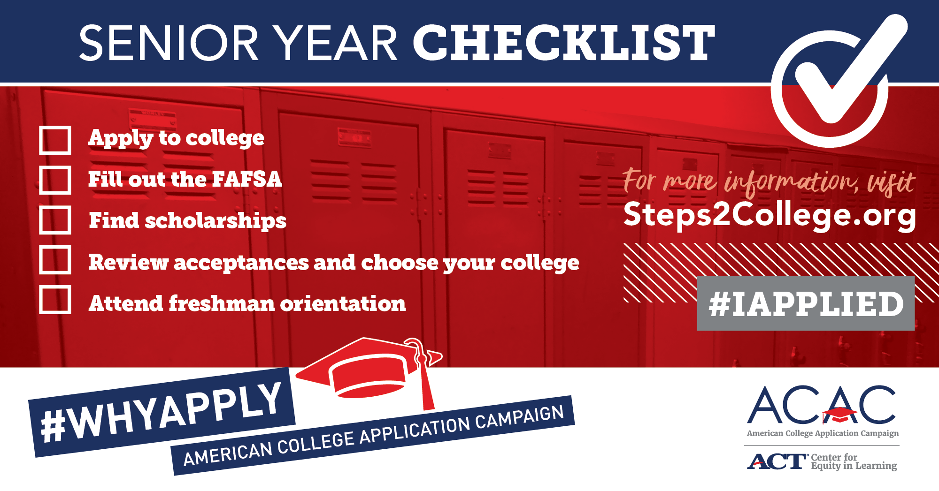 | Check out this college application checklist from @American_CAC which covers the basics to prepare for college. #WhyApply | Check out this college application checklist from @American_CAC which covers the basics to prepare for college. #WhyApply | Images saved on ACAC website under “Social Media Materials”:  https://equityinlearning.act.org/acac/resources/state-coordinator-materials/
Thursday, 9/19 | Tomorrow is the big day! Don’t forget to wear your college t-shirts tomorrow to celebrate #WhyApply. Tweet your photos to @American_CAC using #WhyApply | Tomorrow is the big day! Don’t forget to wear your college t-shirts tomorrow to celebrate #WhyApply! Tweet your photos to @American College Application Campaign using #WhyApply | Tomorrow is the big day! Don’t forget to wear your college t-shirts tomorrow to celebrate #WhyApply! Tweet your photos to @AmericanCAC using #WhyApply | Insert an example #WhyApply photo
Friday, 9/20 | It’s #WhyApply Day! Tweet your selfies in your college gear to @American_CAC with the #WhyApply hashtag. Let students know why they should apply to college.  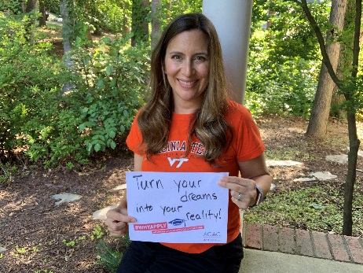 | It’s Why Apply Day! Share your selfies in your college gear to American College Application Campaign with the #WhyApply hashtag. Let students know why they should apply to #college. | It’s #WhyApply Day! Share your selfies in your college gear to @American_CAC with the #WhyApply hashtag. Let students know why they should apply to #college. | National #WhyApply Day  M. Caperton photo is an example. Recommend using someone from your state
Saturday, 9/21
Sunday, 9/22

Monday, 9/23 | Pause the video game. Apply to #college. #WhyApply.
Tuesday, 9/24 |  |  | Check out @AmericanCAC’s college application checklist which covers the basics to prepare for college. #WhyApply  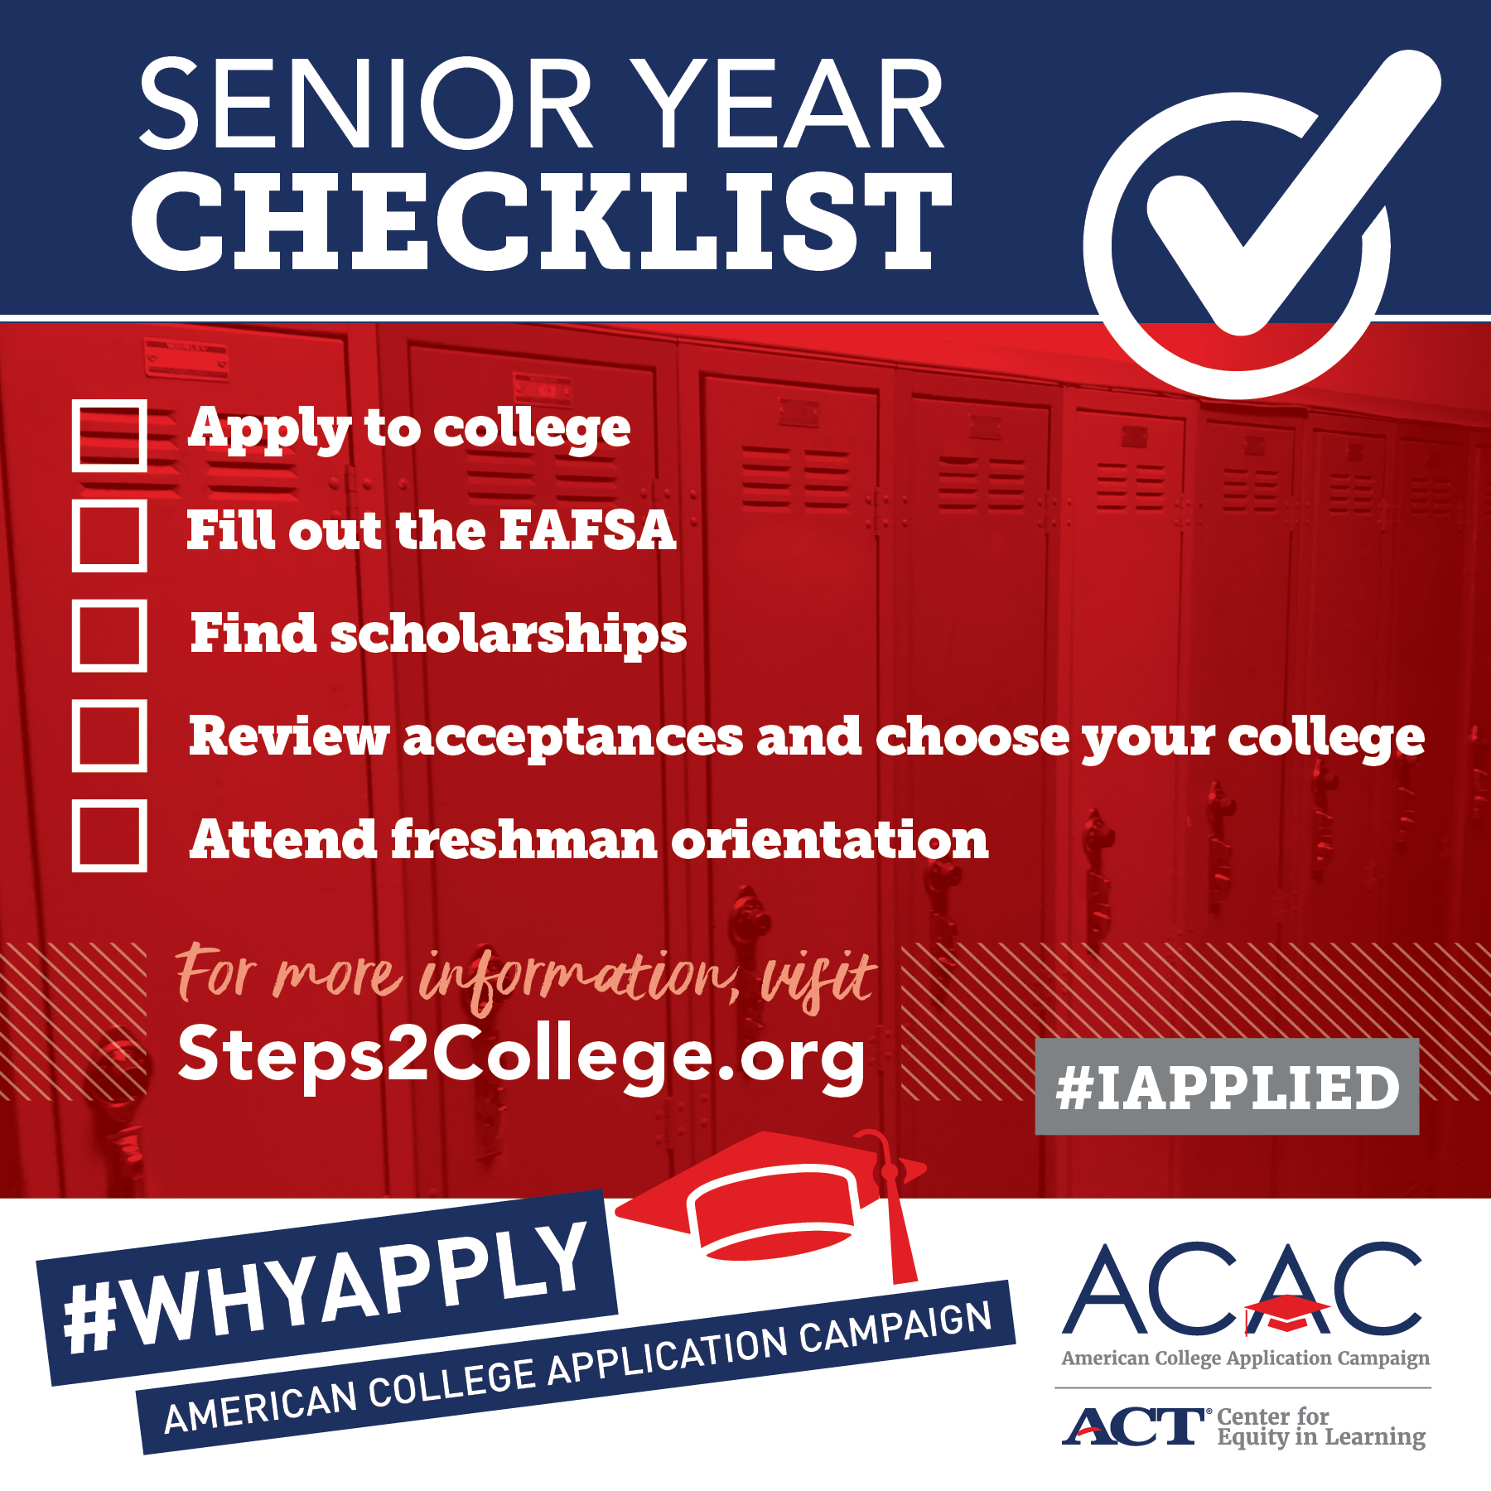 | Images saved on ACAC website under “Social Media Materials”:  https://equityinlearning.act.org/acac/resources/state-coordinator-materials/
Wednesday, 9/25 | #WhyApply to college? Because the wage gap between those with a college education and those without is wider than previous generations. And the earnings gulf won’t narrow. #WednesdayWisdom |  |  | #WednesdayWisdom  Images saved on ACAC website under “Social Media Materials”:  https://equityinlearning.act.org/acac/resources/state-coordinator-materials/
Thursday, 9/26 |  |  |  | #ThursdayThoughts
Friday, 9/27
Saturday, 9/28
Sunday, 9/29 |  | The national unemployment rate for Americans without a four-year college education is 3x higher than those with a degree. #WhyApply |  | Images saved on ACAC website under “Social Media Materials”:  https://equityinlearning.act.org/acac/resources/state-coordinator-materials/
Monday, 9/30 | While at college, major in what the billionaires study. #WhyApply #MotivationMonday https://www.forbes.com/sites/denizcam/2017/10/20/what-should-you-major-in-if-you-want-to-be-a-billionaire/#14216bf07cf4 |  |  | Sample content saved on ACAC website under “Social Media Materials”:  https://equityinlearning.act.org/acac/resources/state-coordinator-materials/

OCTOBER 2019 (Hispanic Heritage Month ends on the 15th)

Publish Date | Twitter | Facebook | Instagram | Notes
Tuesday, 10/1 |  |  |  | FAFSA opens
Wednesday, 10/2
Thursday, 10/3 | #WhyApply? Because only 11 percent of low-income and first-generation students go on to complete college within six years of leaving high school. Let’s change this statistic.  https://www.the74million.org/article/the-b-a-breakthrough-a-first-generation-student-talks-about-her-challenges/
Friday, 10/4
Saturday, 10/5 |  |  |  | #WorldTeachersDay
Sunday, 10/6 | You can rake leaves this afternoon. Or you can apply to #college. #WhyApply [insert leaf raking gif] |  |  | Sample content saved on ACAC website under “Social Media Materials”:  https://equityinlearning.act.org/acac/resources/state-coordinator-materials/
Monday, 10/7
Tuesday, 10/8
Wednesday, 10/9 | Your parent left a list of chores: Walk the dog. Take out the trash. Apply to #college. #WhyApply [Insert walking dog gif]
Thursday, 10/10 |  |  |  | #WorldMentalHealthDay
Friday, 10/11 |  |  |  | International #DayOfTheGirl
Saturday, 10/12 |  |  |  | #TrainYourBrainDay
Sunday, 10/13
Monday, 10/14
Tuesday, 10/15 |  |  |  | End of Hispanic Heritage Month
Wednesday, 10/16
Thursday, 10/17
Friday, 10/18
Saturday, 10/19

Sunday, 10/20
Monday, 10/21 | Check out this senior year checklist from @American_CAC to make sure you’re on track. Today’s the say you apply to college! #WhyApply |  |  | #MotivationMonday  Images saved on ACAC website under “Social Media Materials”:  https://equityinlearning.act.org/acac/resources/state-coordinator-materials/
Tuesday, 10/22 | Pause the video game. Apply to #college. #WhyApply.
Wednesday, 10/23 |  |  |  | #WednesdayWisdom
Thursday, 10/24 |  |  |  | #ThursdayThoughts
Friday, 10/25 | Today is the day you will apply to college! #FearlessFriday |  |  | #FearlessFriday
Saturday, 10/26 | That feeling when you submit your college application #WhyApply [INSERT DANCING GIF]
Sunday, 10/27
Monday, 10/28
Tuesday, 10/29
Wednesday, 10/30
Thursday, 10/31 | Don’t let the college application scare you. Ask for help and apply to #college! #WhyApply |  |  | Halloween

NOVEMBER 2019: Native American Heritage Month

Publish Date | Twitter | Facebook | Instagram | Notes
Friday, 11/1
Saturday, 11/2
Sunday, 11/3
Monday, 11/4
Tuesday, 11/5 |  |  |  | Election Day
Wednesday, 11/6
Thursday, 11/7
Friday, 11/8 |  |  |  | #STEMDay
Saturday, 11/9
Sunday, 11/10
Monday, 11/11 |  |  |  | Veterans Day
Tuesday, 11/12
Wednesday, 11/13
Thursday, 11/14
Friday, 11/15
Saturday, 11/16
Sunday, 11/17
Monday, 11/18 |  |  |  | Suggestion: Week To Be Thankful- Create content thanking volunteers, counselors, etc.
Tuesday, 11/19 |  |  |  | Suggestion: Week To Be Thankful- Create content thanking volunteers, counselors, etc.
Wednesday, 11/20 |  |  |  | Suggestion: Week To Be Thankful- Create content thanking volunteers, counselors, etc.
Thursday, 11/21 |  |  |  | Thanksgiving
Friday, 11/22
Saturday, 11/23

Sunday, 11/24
Monday, 11/25
Tuesday, 11/26 |  |  |  | #GivingTuesday
Wednesday, 11/27
Thursday, 11/28
Friday, 11/29
Saturday, 11/30

