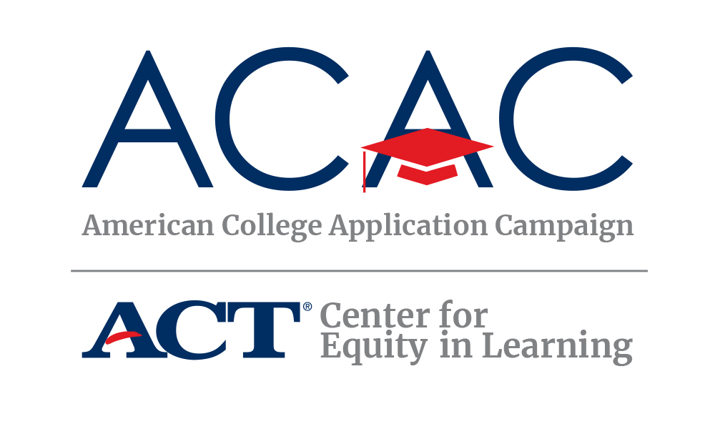
#WhyApply Social Media Content Ideas
FACEBOOK #WhyApply? Colleges consider more than just a student’s grades and test scores for admissions. Your character outside of the classroom counts. Tell your story today.
TWITTER #WhyApply? Colleges consider more than just a student’s grades and test scores for admissions. Your character counts.
FACEBOOK By 2020, 65 percent of all jobs in the US will require a postsecondary education. Don’t be left behind. #WhyApply [Insert ACAC graphic: https://equityinlearning.act.org/wp-content/uploads/2019/05/Workforce-WhyApply-2019-square.png]
TWITTER By 2020, 65% of all US jobs will require a postsecondary education. Don’t be left behind. #WhyApply [Insert ACAC graphic: https://equityinlearning.act.org/wp-content/uploads/2019/05/Workforce-WhyApply-2019.png]
SOURCE: Page 4 of this Georgetown University study, with state-by-state stats to customize the Facebook post/ tweet by state: https://cew.georgetown.edu/wp-content/uploads/2014/11/Recovery2020.SR_.Web_.pdf
FACEBOOK #WhyApply to college? Millennials ages 25 to 32 with a college degree earn $17,500 more annually than their counterparts who didn’t pursue higher education. #MotivationMonday (URL: https://www.usnews.com/news/articles/2014/02/11/study-income-gap-between-young-college-and-high-school-grads-widens )
TWITTER #WhyApply? Millennials ages 25-32 with a college degree earn $17,500 more annually than their counterparts who didn’t pursue #highered #MotivationMonday (URL: https://www.usnews.com/news/articles/2014/02/11/study-income-gap-between-young-college-and-high-school-grads-widens )
FACEBOOK #WhyApply to college? Because Americans with college degrees earned 56% more than those with just a high school diploma in 2015. That’s the difference between earning $36,000 a year and $56,000 a year. https://www.usatoday.com/story/money/2017/01/12/pay-gap-between-college-grads-and-everyone-else-record/96493348/[Insert ACAC graphic: https://equityinlearning.act.org/wp-content/uploads/2019/05/Earn-More-WhyApply-2019-square.png]
TWITTER #WhyApply? Because Americans w/ college degrees earned 56% more than those with just a hs diploma in 2015. That’s the difference between earning $36,000 a year (or $17 per hour) and $56,000 a year (or $27 per hour). https://www.usatoday.com/story/money/2017/01/12/pay-gap-between-college-grads-and-everyone-else-record/96493348/ [Insert ACAC graphic: https://equityinlearning.act.org/wp-content/uploads/2019/05/Earn-More-WhyApply-2019.png]
FACEBOOK #WhyApply to college? Because the robots are coming! Don’t be automated out of a job. In all seriousness, a college degree is an indispensable tool to getting better job opportunities and keeping up with these rapidly changing times. Don’t get left behind. [Include robot gif]
TWITTER #WhyApply to college? Because the robots are coming! Don’t be automated out of a job. In all seriousness, a college degree is an indispensable tool to getting better job opportunities + keeping up with these rapidly changing times. [Include robot gif]
FACEBOOK #WhyApply to college? Because the wage gap between those with a college education and those without is wider than previous generations. And the earnings gulf won’t narrow. #ThursdayThoughts
TWITTER #WhyApply to college? Because the wage gap between those with a college education & those w/o is wider than previous generations. #ThursdayThoughts
FACEBOOK+TWITTER The national unemployment rate for Americans without a four-year college education is 3x higher than those with a degree. #WhyApply [Insert ACAC graphic: https://equityinlearning.act.org/wp-content/uploads/2019/05/Employment-WhyApply-2019.png or https://equityinlearning.act.org/wp-content/uploads/2019/05/Employment-WhyApply-2019-square.png]
FACEBOOK+TWITTER It’s never too late to go to college. #WhyApply [Insert “you can do it! Gif”]
FACEBOOK+TWITTER Feeling old? You’re never too old to get a college education. #WhyApply [insert Melissa McCarthy Life of the Party gif]
FACEBOOK+TWITTER Kids in school now? It’s never too late to go to college. #WhyApply
FACEBOOK+TWITTER You may not be getting any younger. But a college education is forever. #WhyApply [Insert local/regional/state media story of someone older going to college/graduating]
FACEBOOK+TWITTER You can go outside and mow the lawn. Or you can apply to #college. #WhyApply [insert lawn mowing gif]
FACEBOOK+TWITTER Your parent left a list of chores: Walk the dog. Take out the trash. Apply to #college. #WhyApply [Insert walking dog gif]
FACEBOOK+TWITTER Pause the video game. Apply to #college. #WhyApply [insert video game gif]
FACEBOOK+TWITTER You can rake leaves this afternoon. Or you can apply to #college. #WhyApply [insert leaf raking gif]
FACEBOOK+TWITTER Take a break from your latest #Netflix marathon and apply to #college. #WhyApply [Insert ACAC graphic: https://equityinlearning.act.org/wp-content/uploads/2019/08/WhyApply-Stranger-Things-FB-IG.jpg]
FACEBOOK+TWITTER #WhyApply to college? Nearly 500 four-year colleges accept 75% of applicants.
FACEBOOK+TWITTER Everyone loves their grandma. Make her proud. Apply to college. #WhyApply
FACEBOOK+TWITTER College isn’t all about studying. Sometimes there’s a good old-fashioned snow ball fight involved. #WhyApply (photo link: https://flic.kr/p/maywqA)
FACEBOOK+TWITTER Go to college where the billionaires go! #WhyApply #MotivationMonday https://www.cnbc.com/2018/05/18/the-universities-that-produce-the-most-billionaires.html
FACEBOOK+TWITTER While at college, major in what the billionaires study. #WhyApply #MotivationMonday https://www.forbes.com/sites/denizcam/2017/10/20/what-should-you-major-in-if-you-want-to-be-a-billionaire/#14216bf07cf4
FACEBOOK+TWITTER #WhyApply to college? Your opportunities are endless.
FACEBOOK + TWITTER #TBT The good ol’ college days! Ask me about going to college. #WhyApply [insert photos from college years]
FACEBOOK + TWITTER #TipTuesday Ask us your questions about college! #WhyApply
FACEBOOK + TWITTER Today is the day you will apply to college! #FearlessFriday
FACEBOOK + TWITTER Check out these incredible colleges that call the state of [INSERT STATE] home. [INSERT TWITTER HANDLES OF COLLEGES] #FollowFriday
FACEBOOK + TWITTER College is for everyone! Certificate, 2-year or 4-year, there’s a postsecondary path for everyone to accomplish their goals! #WhyApply
FACEBOOK + TWITTER That feeling when you submit your college application #WhyApply [INSERT DANCING GIF]
FACEBOOK + TWITTER Want to make a different in your community? College graduates are twice as likely to volunteer and contribute nearly 3.5 times more money to charity. #WhyApply
(source: Trostel, Lumina Foundation, “It’s Not Just the Money,” 2015.) [Insert ACAC volunteer graphic: https://equityinlearning.act.org/wp-content/uploads/2019/05/Volunteer-WhyApply-2019-square.png]
Facebook + Twitter #WhyApply to college? It’s easier than mastering the #BottleCapChallenge. [Insert ACAC bottle cap graphic: https://equityinlearning.act.org/wp-content/uploads/2019/08/WhyApply-bottle-cap-challenge-FB-IG.jpg]
Facebook + Twitter #WhyApply to college? Because #RepresentationMatters. It’s important for your siblings, cousins and neighbors to see you as a college student!
Reoccurring Hashtags to Consider Using:
- #MotivationMonday
- #TipTuesday
- #TuesdayTrivia
- #WaybackWednesday
- #TBT Throwback Thursday
- #FollowFriday

