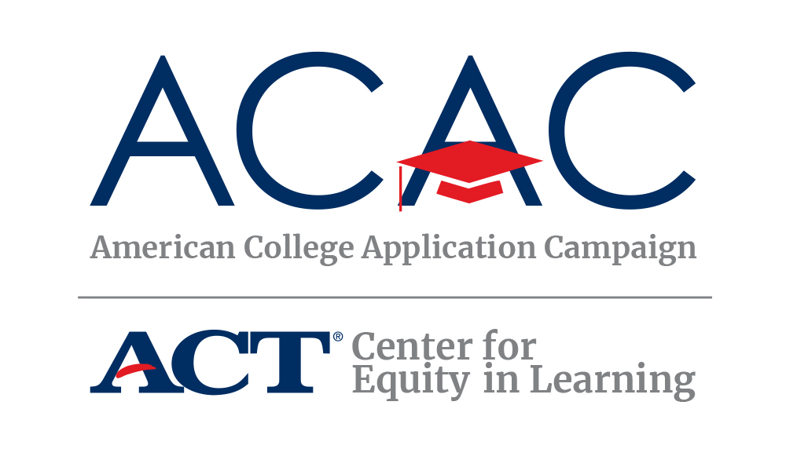

College and Career
Awareness Activities
for Elementary and
Middle School Students

TABLE OF CONTENTS

Introduction 3
Implementing Pre-College and Career Awareness Activities 4
ASCA’s Mindsets and Behaviors Standards 5-13
Activity 1: College Vocabulary 15-19
Activity 2: Career Bingo and Human Bingo 20-23
Activity 3: Match the Mascot to the College 24
Activity 4: Dress for Your Future 25
Activity 5: Starting a College Savings Account 26
Activity 6: School-Based Career Fair 27
Activity 7: College Colors Day and College Colors Map 28-29
Activity 8: My College and Career Collage 30-32

Introduction

ACT’s Center for Equity in Learning and the American College Application Campaign (ACAC) are committed to increasing college access and career readiness through the dissemination of ideas, development of practices, and technical assistance for program implementation that creates or enhances a college-going culture. Schools that invest in the creation of this type of educational environment intentionally seek to remove barriers that prevent all students from pursuing postsecondary education.

This College and Career Awareness for Elementary and Middle School Students augments the Pre-College and Career Readiness Curriculum for Students and Their Families (2017, 2019) which was designed primarily for high school students. Feedback from school counselors led to this development of materials for earlier grades.

The current version includes activities and lessons for pre-kindergarten, kindergarten, elementary and middle school students. The new materials were developed and shared by the College Foundation of West Virginia (CFWV) and GEAR UP Washington State.

This material is intended for school counselors and college access professionals who work with students to identify interests and lay the academic foundation for their careers and life. To provide feedback on the College and Career Awareness Activities for Elementary and Middle School Students, please use the following url: http://bit.ly/2tgbS5m

Copyright 2019 American College Application Campaign (ACAC). All rights reserved. No part of this publication may be reproduced or transmitted in any form without the permission of ACT and ACAC.

IMPLEMENTING PRE-COLLEGE AND CAREER AWARENESS ACTIVITIES

There are at least five major goals associated with increasing educational attainment beyond high school as it pertains to career development. According to MDRC’s Promoting College Match for Low-Income Students report, these include:
- Sharing information and building awareness
- Providing individualized advising
- Assisting with application completion
- Engaging parents and community
- Making decisions and planning ahead

It is during the Elementary through Middle School years that the first goal - sharing information and building awareness about higher education and career readiness opportunities - is essential and easiest done. For many students, the idea of college is not discussed in the home. Providing younger students with an opportunity to build a foundation of awareness about postsecondary education is critical. Building enthusiasm for educational attainment and an individual’s lifelong responsibility for career readiness can never start soon enough. The activities in this guide promote opportunities for younger students to dream big about their futures as you share information and build awareness about higher education and career readiness.

Byndloss, D. Crystal and Reid, Chera, MDRC, Promoting College Match for Low-Income Students: Lessons for Practitioners, Sept. 2013

TIMELINE FOR DELIVERY

- Class time throughout one or more school years could be utilized for these activities.
- Activities can be presented over one or multiple years.
- Your state’s College Application or College Application and Career Exploration period in the fall is an excellent time to include younger students in activities that reinforce the work in which juniors and seniors are engaged.

MODIFICATIONS TO THE ACTIVITIES

School counselors, teachers, and college access professionals are encouraged to adapt any of these ideas to better meet the needs of their students and their interests. These ideas have been shared through conferences, training workshops, publications, and conversations. Seldom is there an idea that cannot be introduced with more complexity for older students and less complexity for younger audiences. Make this work for your own students and be sure to share with all of your colleagues.

ASCA’s Mindsets and Behaviors Standards and College and Career Awareness Activities for Elementary and Middle School Students

This curriculum can be used in support of your overall school counseling curriculum. It reinforces several standards established by the American School Counselor Association and can enrich your efforts to ensure student success in high school and beyond. https://schoolcounselor.org/asca/media/asca/home/MindsetsBehaviors.pdf

Below is a table that illustrates the standard(s) addressed by each lesson. Each lesson has content outcomes (the information) and process outcomes (how students are engaged).

PRE-COLLEGE AND CAREER READINESS LESSON TITLE AND OUTCOMES | ASCA MINDSETS AND BEHAVIORS STANDARD(S) ADDRESSED
1. College Vocabulary  Content Outcomes  Introduce teacher as a college and career resource. Introduce students to the educational framework of secondary and postsecondary levels in the United States.  Process Outcomes  Reading, discussing and recalling information. | Mindset 3  Sense of belonging in the school environment  Mindset 4  Understanding that postsecondary education and lifelong learning are necessary for long-term career success  Behavior: Self-Management Skills 1  Demonstrate ability to assume responsibility  Behavior: Self-Management 3  Demonstrate ability to work independently  Behavior: Social Skills 1  Use effective oral, written communication skills and listening skills  Behavior: Social Skills 3  Create relationships with adults that support success

PRE-COLLEGE AND CAREER READINESS LESSON TITLE AND OUTCOMES | ASCA MINDSETS AND BEHAVIORS STANDARD(S) ADDRESSED
2. Career Bingo and Human  Bingo  Content Outcomes  Reinforce awareness of various jobs and careers. Introduce jobs and careers that require preparation beyond high school.  Process Outcomes  Engagement with classmates and teacher. | Mindset 2  Self confidence in ability to succeed  Mindset 3  Sense of belonging in the school environment  Mindset 4  Understanding that postsecondary education and lifelong learning are necessary for long-term career success  Mindset 6  Positive attitude to work and learning  Behavior: Learning Strategies 2  Demonstrate creativity  Behavior: Learning Strategies 4  Apply self-motivation and self-direction to learning  Behavior: Learning Strategies 10  Participate in enrichment and extracurricular activities  Behavior: Social Skills 1  Use effective oral, written communication skills and listening skills  Behavior: Social Skills 3  Create relationships with adults that support success

PRE-COLLEGE AND CAREER READINESS LESSON TITLE AND OUTCOMES | ASCA MINDSETS AND BEHAVIORS STANDARD(S) ADDRESSED
3. Match the Mascot to the  College  Content Outcomes  Associate colleges with mascots and other icons. Learn about various colleges within their state and the nation.  Process Outcomes  Recognize colors and symbols associated with various institutions of postsecondary education. Learn about postsecondary institutions’ heritage associated with mascots. | Mindset 3  Sense of belonging in the school environment  Behavior: Learning Strategies 1  Demonstrate critical thinking skills to make informed decisions  Behavior: Learning Strategies 2  Demonstrate creativity  Behavior: Learning Strategies 10  Participate in enrichment and extracurricular activities  Behavior: Self-Management Skills 3  Demonstrate ability to work independently  Behavior: Social Skills 2  Create positive and supportive relationships with other students

PRE-COLLEGE AND CAREER READINESS LESSON TITLE AND OUTCOMES | ASCA MINDSETS AND BEHAVIORS STANDARD(S) ADDRESSED
4. Dress for Your Future  Content Outcomes  Identify careers of interest. Visualize self as engaged in different careers or jobs.  Process Outcomes  Create uniform or imagine clothing worn by someone in a specific job or career. Identify how that role is represented by what is worn. | Mindset 2  Self confidence in ability to succeed  Mindset 3  Sense of belonging in the school environment  Mindset 4  Understanding that postsecondary education and lifelong learning are necessary for long-term career success  Mindset 6  Positive attitude to work and learning  Behavior: Learning Strategies 2  Demonstrate creativity  Behavior: Learning Strategies 6  Set high standards of quality  Behavior: Learning Strategies 9  Gather evidence and consider multiple perspectives to make informed decisions  Behavior: Learning Strategies 10  Participate in enrichment and extracurricular activities  Behavior: Self-Management Skills 1  Demonstrate ability to assume responsibility  Behavior: Self-Management Skills 3  Demonstrate ability to work independently  Behavior: Social Skills 1  Use effective oral and written communication skills and listening skills  Behavior: Social Skills 2  Create positive and supportive relationships with other students  Behavior: Social Skills 3  Create relationships with adults that support success  Behavior: Social Skills 8  Demonstrate advocacy skills and ability to assert self, when necessary

PRE-COLLEGE AND CAREER READINESS LESSON TITLE AND OUTCOMES | ASCA MINDSETS AND BEHAVIORS STANDARD(S) ADDRESSED
5. Starting a College Savings  Account  Content Outcomes  Introduction to financial literacy. Learn difference between immediate reward and delayed gratification.  Process Outcomes  Forced choice decision making activities. Develop language that supports the choice to save. | Mindset 2  Self confidence in ability to succeed  Mindset 3  Sense of belonging in the school environment  Mindset 4  Understanding that postsecondary education and lifelong learning are necessary for long-term career success  Mindset 6  Positive attitude to work and learning  Behavior: Learning Strategies 7  Identify long-and short-term academic, career, and social/emotional goals  Behavior: Learning Strategies 9  Gather evidence and consider multiple perspectives to make informed decisions  Behavior: Self-Management Skills 1  Demonstrate ability to assume responsibility  Behavior: Self-Management Skills 2  Demonstrate self-discipline and self-control  Behavior: Self-Manangement Skills 4  Demonstrate ability to delay immediate gratification for long-term rewards  Behavior: Self-Management Skills 5  Demonstrate perseverance to achieve long- and short-term goals  Behavior: Social Skills 5  Demonstrate ethical decision-making and social responsibility  Behavior: Social Skills 9  Demonstrate social maturity and behaviors appropriate to the situation and environment

PRE-COLLEGE AND CAREER READINESS LESSON TITLE AND OUTCOMES | ASCA MINDSETS AND BEHAVIORS STANDARD(S) ADDRESSED
6. School-based Career Fair  Content Outcomes  Reinforce awareness of various jobs and careers. Introduce jobs and careers that require preparation beyond high school.  Process Outcomes  Engagement with classmates and teacher. Become familiar with additional school personnel and see them as mentors. | Mindset 1  Belief in development of whole self, including a healthy balance of mental, social/emotional and physical well-being  Mindset 2  Self confidence in ability to succeed  Mindset 4  Understanding that postsecondary education and lifelong learning are necessary for long-term career success  Mindset 6  Positive attitude to work and learning  Behavior: Learning Strategies 2  Demonstrate creativity  Behavior: Learning Strategies 3  Use time-management, organizational, and study skills  Behavior: Learning Strategies 4  Apply self-motivation and self-direction to learning  Behavior: Learning Strategies 8  Actively engage in challenging coursework  Behavior: Self-Management Skills 2  Demonstrate self-discipline and self-control  Behavior: Self-Manangement Skills 3  Demonstrate ability to work independently  Behavior: Social Skills 6  Use effective collaboration and cooperation skills

PRE-COLLEGE AND CAREER READINESS LESSON TITLE AND OUTCOMES | ASCA MINDSETS AND BEHAVIORS STANDARD(S) ADDRESSED
7. College Colors Day and College Colors map  Content Outcomes  Reinforce awareness of postsecondary institutions. Recognize/identify where campuses are located in a state/region.  Process Outcomes  Creation of a state map and national map. Locate postsecondary resources. Utilize appropriate postsecondary institution colors. | Mindset 2  Self-confidence in ability to succeed  Mindset 3  Sense of belonging in the school environment  Behavior: Learning Strategies 2  Demonstrate creativity  Behavior: Learning Strategies 5  Apply media and technology skills  Behavior: Learning Strategies 8  Actively engage in challenging coursework  Behavior: Social Skills 1  Use effective oral and written communication skills and listening skills  Behavior: Social Skills 2  Create positive and supportive relationships with other students  Behavior: Social Skills 6  Use effective collaboration and cooperation skills  Behavior: Social Skills 8  Demonstrate advocacy skills and ability to assert self, when necessary

PRE-COLLEGE AND CAREER READINESS LESSON TITLE AND OUTCOMES | ASCA MINDSETS AND BEHAVIORS STANDARD(S) ADDRESSED
8. My College and Career Collage  Content Outcomes  Identify careers. Recognize how various careers are reflected in photographs and media.  Process Outcomes  Review different forms of media. Create a collage reflecting desired careers and jobs. | Mindset 1  Belief in development of whole self, including a healthy balance of mental, social/emotional and physical well-being  Mindset 2  Self confidence in ability to succeed  Mindset 4  Understanding that postsecondary education and lifelong learning are necessary for long-term career success  Mindset 5  Belief in using abilities to their fullest to achieve high-quality results and outcomes  Mindset 6  Positive attitude to work and learning  Behavior: Learning Strategies 1  Demonstrate critical thinking skills to make informed decisions  Behavior: Learning Strategies 2  Demonstrate creativity  Behavior: Learning Strategies 3  Use time-management, organizational, and study skills  Behavior: Learning Strategies 4  Apply self-motivation and self-direction to learning  Behavior: Learning Strategies 5  Apply media and technology skills  Behavior: Learning Strategies 6  Positive attitude toward work and learning  Behavior: Learning Strategies 7  Identify long-and short-term academic, career, and social/emotional goals  Behavior: Learning Strategies 8  Actively engage in challenging coursework  Behavior: Learning Strategies 9  Gather evidence and consider multiple perspectives to make informed decisions  Behavior: Self-Management Skills 1  Demonstrate ability to assume responsibility  Behavior: Self-Management Skills 8  Demonstrate the ability to balance school, home, and community activities  Behavior: Social Skills 1  Use effective oral and written communication skills and listening skills  Behavior: Social Skills 8  Demonstrate advocacy skills and ability to assert self, when necessary

COLLEGE AND
CAREER
AWARENESS ACTIVITIES

COLLEGE and CAREER AWARENESS ACTIVITY 1

Building a College Vocabulary

Knowledge begins with language. Assisting younger students understand the concepts of “higher education,” “college,” “university,” “community college,” “technical school,” “public versus private institutions” needs to occur before high school. There are many simple activities that can start the ball rolling and reinforce the concepts throughout elementary and middle school grades.

Younger Student Activities

- Each classroom teacher needs to complete the “Ask Me About It” sign (found on the next page) to put outside their classroom door. Then, follow up with a question and answer session. You can seed the pot by having questions on note cards for students to ask such as:

How far away from home was your school? | How did you decide to attend this college?
Were you nervous about going to college? | Who helped you apply to college?
What did your family think about your going to college? | What did you do for fun in college?
Did you play sports?

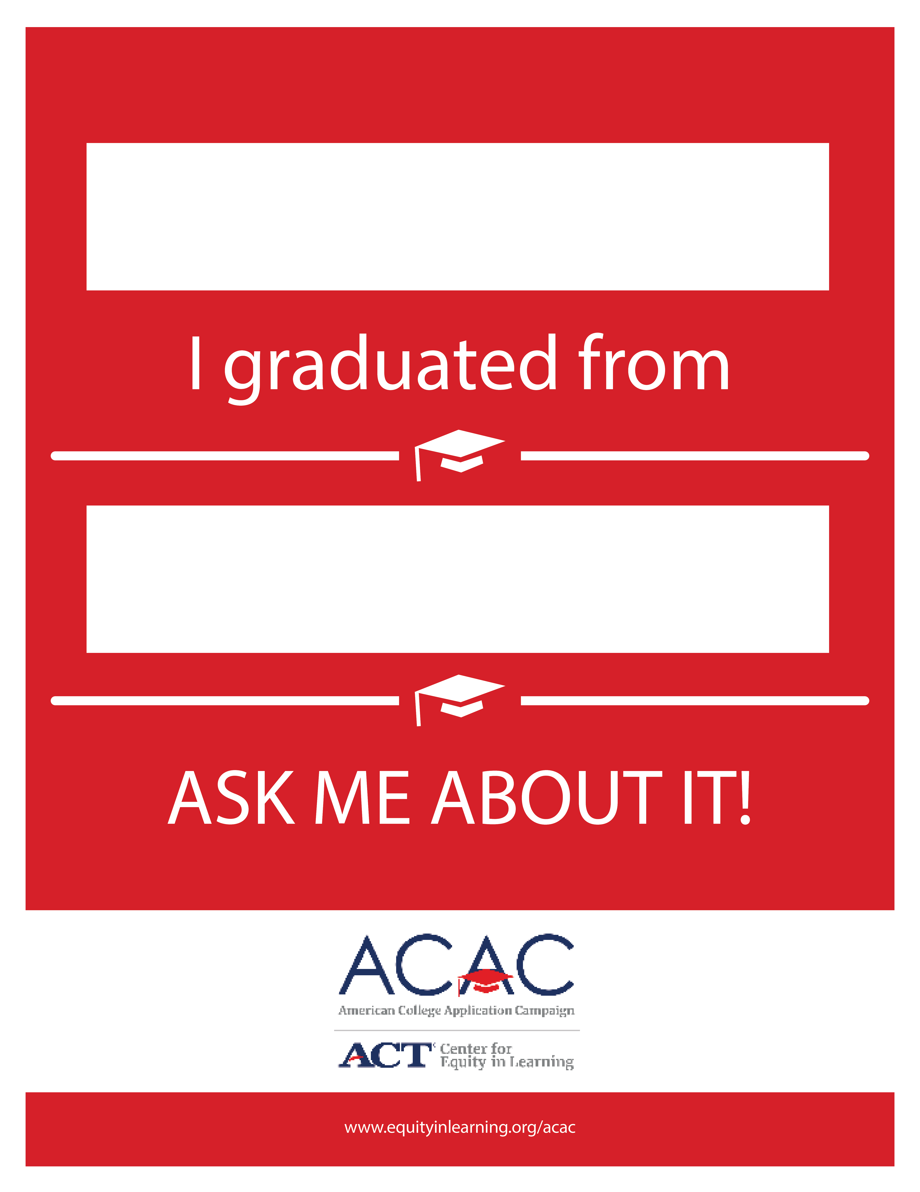

2. Create a bulletin board with pictures of the various concepts and cards with simple definitions. Review the information with the students over time, and then one day pull the definition away and have the students match them to the correct image. Consider discussing the two levels of education separately during the school year. It is important for students to learn about secondary education prior to being introduced to postsecondary education.

Education in the United States

Secondary Education: 12-14 years
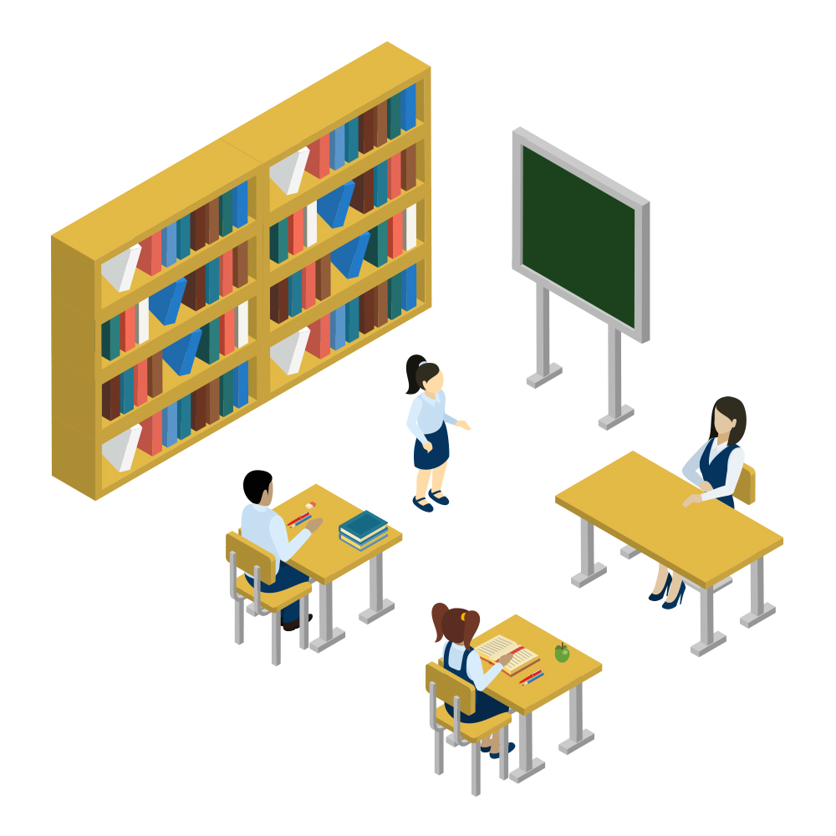 | Primary School Education  This is the beginning stage of formal learning for children between ages 3 and 11 years old. Pre-Kindergarten and Kindergarten are the beginning steps with grades 1 – 5 or 1 – 6 as the elementary school steps. Basic education regarding the alphabet, learning to read, counting, remembering information, and developing good habits are taught.
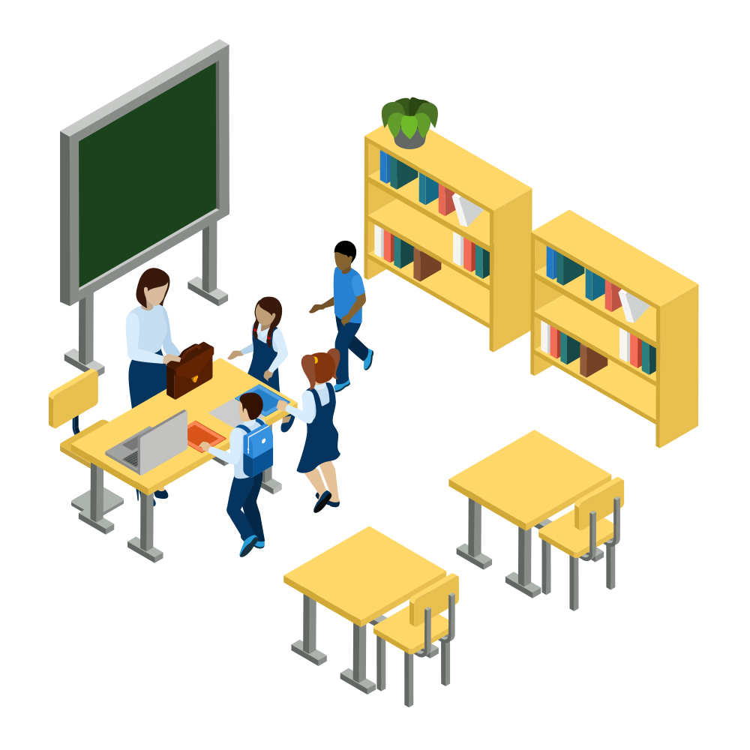 | Middle School Education  This is the middle state of formal learning between Primary School and High School Education. Most often, students in grades 6-8 or 7-9 are in middle school. Language, math, and science are introduced at more sophisticated levels.
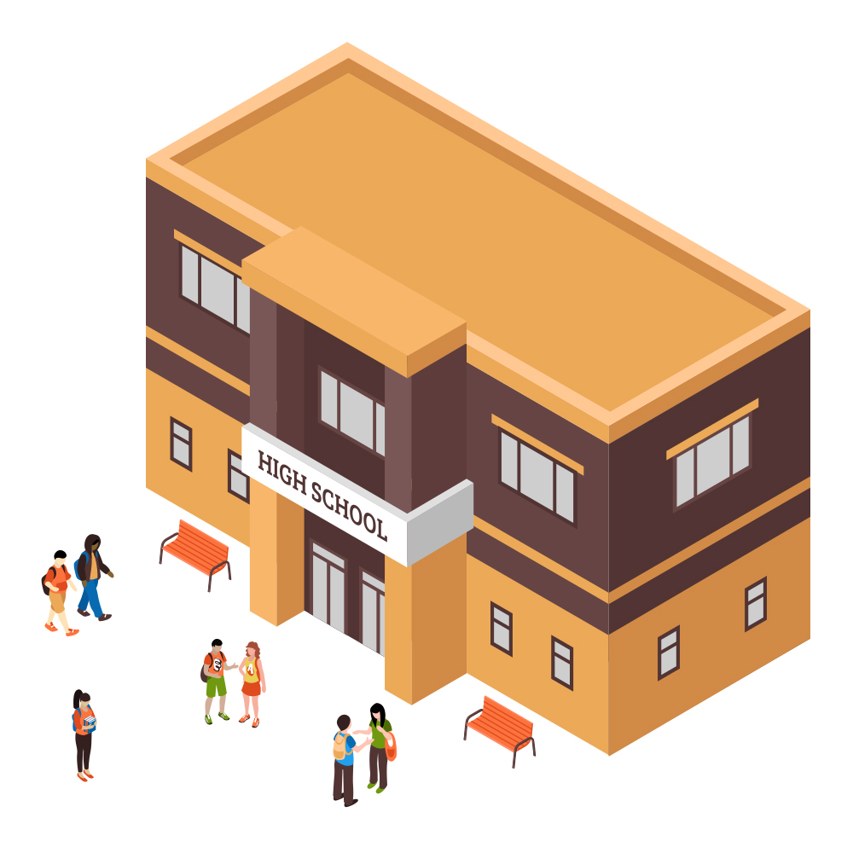 | High School Education  This is the highest level of secondary education. Students in grades 9-12 or 10-12 are taught more complicated ideas in all subjects as well as moved to greater independence as learners.
Postsecondary Education
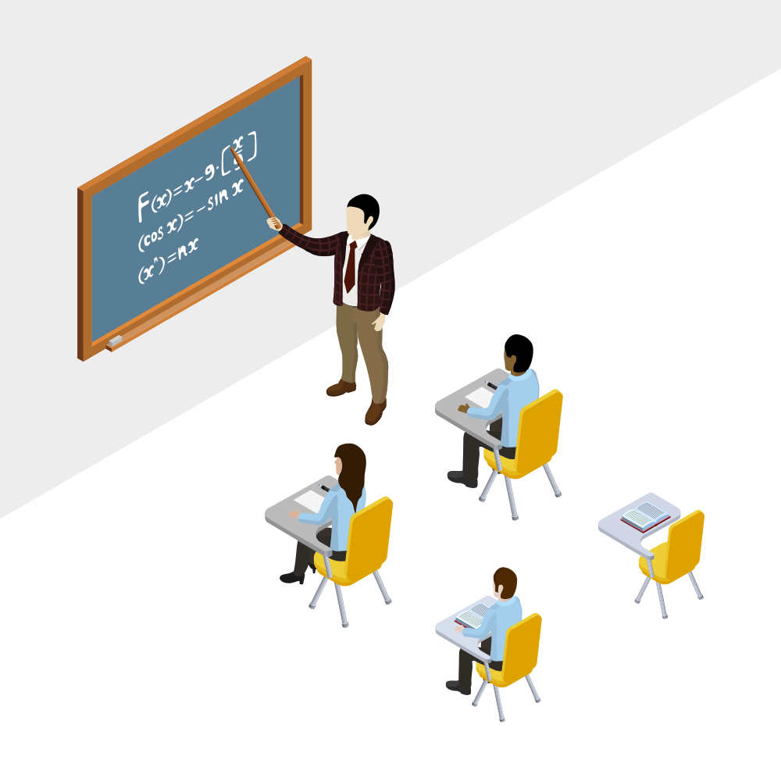 | “College” is the most common term used to talk about where you get your education after you finish high school. There are other words used to describe specific types of educational experiences.
 | Technical school teaches skills used by individuals in certain jobs such as a car mechanic, computer hardware repairman, restaurant chef, heat and air conditioning repairman. Technical schools provide a hands-on environment that prepares you to work in these types of jobs. Military training is considered technical school training.
 | Community college provides 2-year degrees in certain areas of study like technical schools. Many community colleges prepare you to transfer to a 4-year college or university for further study.
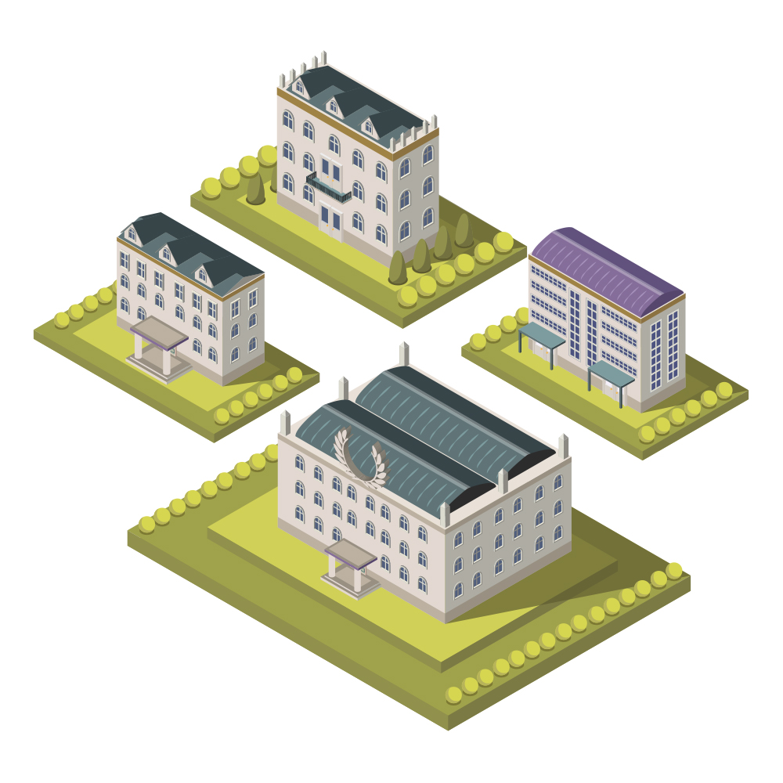 | A university is usually considered different from a college because of the many different levels of education that you can complete.
 | Postsecondary education is made up of all of these opportunities.

Older Student Activities

- Each classroom teacher needs to complete the “Ask Me About It” sign (found on page 16) to put outside their classroom door. Then, follow up with a question and answer session. It is a good idea for an older age group to be encouraged to add their own questions that are randomly drawn out to be answered. You can seed the pot by having questions on note cards for students to ask such as:

How did you decide what to study in college? | What did you learn during middle/high school that helped you in college?
Did you have difficulty with any courses? | What did you do when you had difficulty in your courses?
Where did you live? On campus, at home, off campus? | How did you pay for college?
How much did college cost?

2. Assign students the task of decorating the class door with information about colleges in your state. They can use pictures but they must also include: a map which shows the distance from your town to the school, the cost of attendance, the number of students attending, a list of majors, and the types of degrees that can be earned. You can encourage them to research some of the people who graduated from each institution. Lastly, you can ask students to find pictures that show why they might want to attend college (for ex.: attending or participating in sports, working in science labs, performing in theatre productions, or meeting new people).

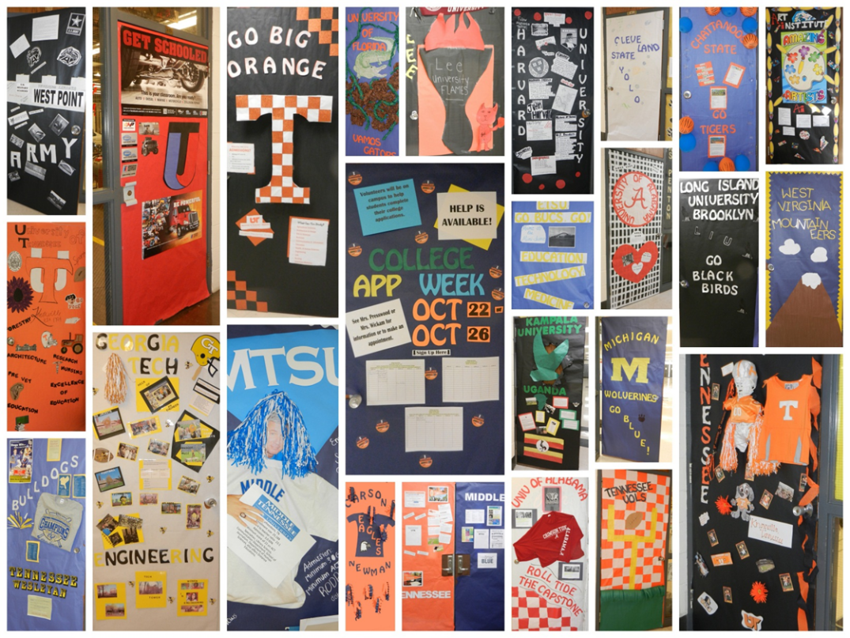
High schools across Tennessee participate in a door decorating contest.
COLLEGE and CAREER AWARENESS ACTIVITY 2

Career Bingo and Human Bingo

Career Bingo

Career Bingo reinforces awareness of various jobs and careers that students can pursue. Identifying work that is of interest early on motivates students to stay in school and to prepare for that opportunity. This is a two part activity.

The first part is to review the common list of jobs. Ask students which jobs they have heard of, and to provide a brief summary of the work involved. Then, ask students to create their own Bingo cards with the names of 24 of the 30 jobs on the list; this increases the likelihood that all cards will be unique.

The second part is to play Bingo. Students use their own cards and you draw cards out of a bowl. Each job on the list should be in the bowl 5 times – once each with “B,” “I,” “N,” “G,” “O” assigned to it.

COMMON LIST OF JOBS that require some training beyond high school

You should feel free to modify this list based the needs of your state or local community. Ask students what they think is involved in these jobs and supplement their answers with the descriptions provided.

Architect – a person who works in the construction industry designing new buildings, restoring old and conserving old buildings, and creating new ways of using existing buildings.

Auto Mechanic – a person familiar with cars and can make repairs.

Budget Analyst – a person who assists organizations use their money.

Chef – a professional cook, esp. in a restaurant or hotel.

Computer Games Developer – a person who makes games for the internet, mobile phones, PCs, and other electronic devices.
Computer Repairman – a person who figures out how to repair and maintain your computer.

Dental Hygienist – a person who provides basic dental care tasks, mostly focused on keeping teeth and gums cleaned.

Dentist – a person who diagnoses and treats problems related to teeth, gums, and the mouth.

Dietician – a person who advises others on food and nutritional needs.

Fashion Designer – create clothes, accessories, and shoes.

Firefighter – a person who serves as a rescuer trained in firefighting.
Landscape Architect – a person familiar with plants, land, geographic location, and specific local, state, and national laws regarding each of these items.

Lawyer - a person who advises, counsels or advocates for others in the context of legal rights and expectations.

Librarian – a person who works professionally in a library and gives access to information and resources.

Logistics Analyst – a person who coordinates and figures out how to get items and services from one place to another.

Medical Assistant – a person who works alongside physicans in medical facilities.

Military Police – a person who serves as a law enforcement officer for both the military and civilian population.

Nurse – a person trained to care for sick people, esp. in a hospital.

Pediatrician – a person who treats children and their diseases.

Photographer – a person who makes photographs.

Policeman/Policewoman –a person who is expected to enforce the law by arresting criminals and detecting and preventing crimes.

Preschool Teacher – a person who provides resources for students to explore as well as teach basic ideas such as colors, shape, letter recognition, numbers, basic hygiene, and social skills.

Purchasing Agent – a person who buys products and services for an organizaton to use or resell.

Real Estate Agent - a person who sells or rents out buildings and land.

School Counselor - a person who works in a school to provide academic, career, college access/affordability/admission, and social-emotional competencies to all students through a school counseling program.

School Principal – a person who runs a school and is responsible for schools running smoothly, is safe, and supports learning for students.

Store Manager - a person responsible for the day-to-day operations of a store that sells items. All workers in that store report to the store manager.

Teacher – a person who helps others acquire knowledge.

Tractor-Trailer Truck Drivers – a person who delivers goods from one location to another.

Train Conductor- a person who is responsible for safety and operation of a train but NOT the actual operation of the train.

CAREER BINGO CARD

B | I | N | G | O
FREE
SPACE

Human Bingo

The purpose of Human Bingo is to demonstrate the variety of college experiences that adults in the school have and to reinforce that adults in their schools are “ready resources” for college information. This activity takes 1-2 weeks. Credit for this activity goes to Washington State’s GEAR UP Program. They have been a strong supporter and implementer of the American College Application Campaign as well as systemic efforts to increase college attainment.

Find a teacher, administrator, or other adult in your school for whom the following statements about college experiences are true. Ask that person to sign the box that contains their true statement. Up to 5 people may sign your sheet twice. Five in a row wins – horizontal, vertical, or diagonal.

HUMAN BINGO CARD

Never thought they would go to college | Went to an state public university | Had a job while in college | Lived in a dorm | Played a varsity sport while in college
Had an internship | Graduated in 4 years | Was the first in their family to go to college | Went to a private college | Took out loans to help pay for college
Studied on a Saturday night while they were in college | Changed their major at least one time | FREE SPACE | Received a scholarship to help pay for college | Went to a party during college
Belonged to a fraternity or sorority | Was a member of the student government association | Studied overseas while in college | Transferred from one college to another | Went more than 500 miles away from home
Lived at home during college | Went to a community college | Was in college for more than 4 years | Belonged to a student group | Did scientific research
COLLEGE and CAREER AWARENESS ACTIVITY 3

Match the Mascot to the College

Customize for your state: The following is an example of the Match the Mascot to the College game using North Carolina. Please change out the North Carolina college information to recreate for your state!

Did you know that North Carolina has over 200 colleges that include 16 public institutions and 58 community colleges. One fun way to learn about schools is through their mascots. During sports events, these mascots encourage the crowds to cheer. And while all colleges do not have sports, they can still choose a mascot. It can be fun to learn the history of each school mascot. How many North Carolina public university mascots do you know?
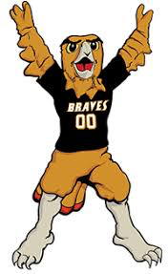
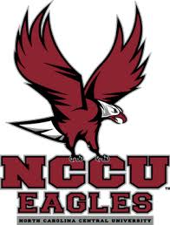
Appalachian State University

East Carolina Unversity

Elizabeth City State University
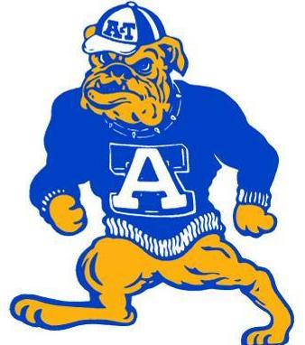
Fayetteville State University
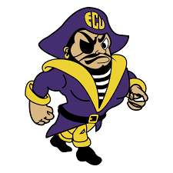
North Carolina A&T University

North Carolina Central University

North Carolina State University
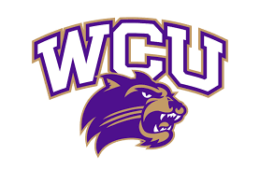
Pembroke University

University of North Carolina - Asheville
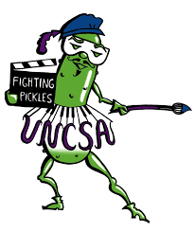
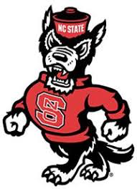
University of North Carolina – Chapel Hill

University of North Carolina – Charlotte

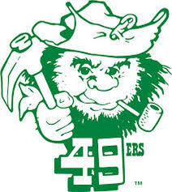
University of North Carolina – Greensboro

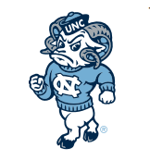
University of North Carolina School of the Arts

University of North Carolina – Wilmington
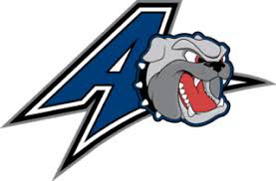
Western Carolina University

Winston-Salem State University
COLLEGE and CAREER AWARENESS ACTIVITY 4

Dress For Your Future

Younger Student Activites

- Use Halloween as an opportunity to have younger students come to school dressed as the person/action figure/hero/shero/job they want to have when they grow up. Use this as a “show and tell” where each student has an opportunity to tell who/what their costume represents and why this inspires them.

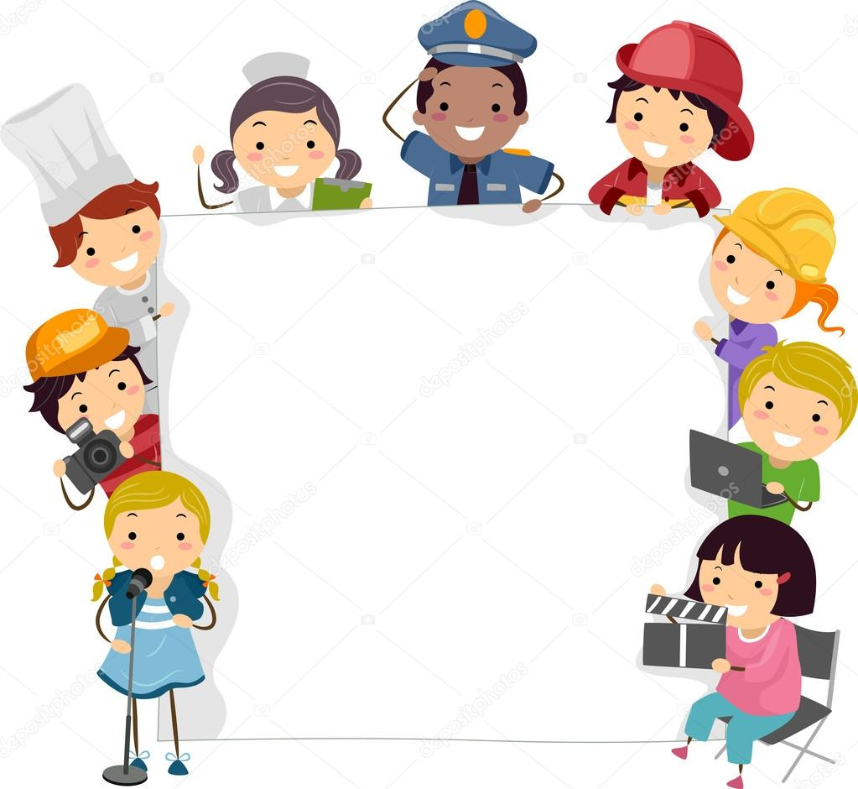

- Each student is requested to bring in a picture of someone performing a job that appeals to the student. The picture should be 5-8 inches tall and 3-4 inches in width) and be cut from a magazine, newspaper, or printed off a computer. The students are asked to work together and put figures doing similar work together in a group on a bulletin board. Each grouping should come up with words or phrases that describe the pictures in their group, telling why the work is similar.

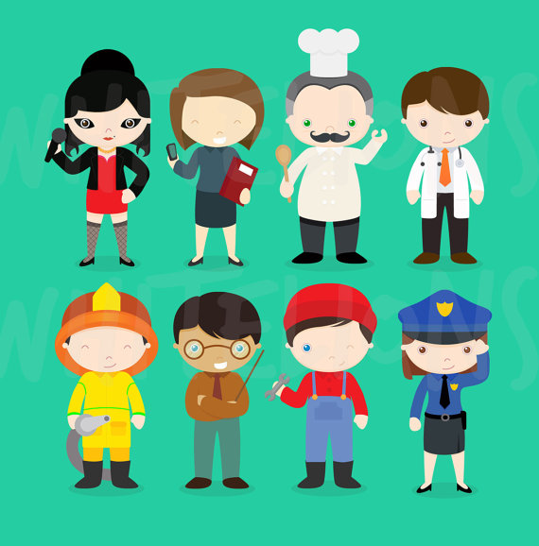

COLLEGE and CAREER AWARENESS ACTIVITY 5

Starting a College Savings Account

The sooner this lesson is approached, the greater the impact. There are a variety of ways to influence students to save money for college, even as early as elementary school. One of the more visible ways is to ask students to always think about ANY money or talent they have as belonging to one of three pots:
- 1 pot to do something for someone else (gifts for family and friends, supporting a charity, etc.);
- 1 pot to do something for themselves (buying a small reward now or saving towards a bigger one); and
- 1 pot for their future (specifically college).

The goal is to have students begin to see that they can influence their independence while doing good for others. If a student receives an allowance, it is something concrete they can divide by three (3) and put funds in appropriate jars/envelopes. In the case of students who do not receive a regular allowance, they should divide ANY money they receive (birthdays, holidays, chores, shopping, candy funds, etc.) into three jars/envelopes, etc. At the end of one month, they can see exactly how their money for now, for someone else, and for their future is growing or disappearing. A great question to ask students who agree to work on this is: If you put in a pot for now – do you remember what you bought with it? If you put in a pot for doing good for others – how much do you have and how much do you think will make a difference in the lives of others? Finally, if you put money in a pot for the future (college fund), how much do you think you can save in a year? This is an especially important lesson to share with all students and especially students from low-income families. It is important not to set this up as a competition but a personal commitment to understanding how they value money.

For older students, this same activity can be an opportunity for deeper learning. Students can be supported in creating a savings account or contributing to a 529 Plan that officially supports their college savings.

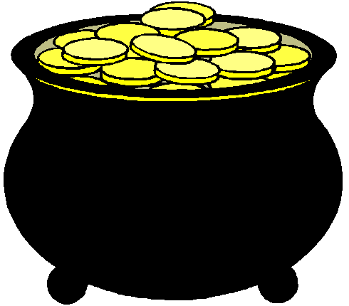

NOW OTHERS FUTURE

COLLEGE and CAREER AWARENESS ACTIVITY 6

School-Based Career Fair

Ask students to write down a list of all of the grownups who work in their school. In small groups of 3-5 students encourage them to share their lists and see if they can combine answers to make a longer list. They should include all workers – housekeepers, grounds crew, cafeteria workers, administrative assistants, nurses, bus drivers, teachers, administrators, school counselors, safety officers, coaches, and others who contribute to making the school a healthy and safe learning environment.

Then, invite these individuals to attend the class (one or two at the time) and speak for 3-5 minutes about the type of work they do every day in their job. Allow students to then ask questions such as: How did you find your job? What education requirements are needed? What do you like least about your job? What do you like best about it?

Students can create a bulletin board with pictures of each person, their job at the school, and any other information they want to remember. You can refer to the bulletin board when focusing on career awareness.

How Do I Become…….????

NURSE
COACH
TEACHER
PRINCIPAL
BUS DRIVER
GROUNDS KEEPER
FINANCE MANAGER
ASSISTANT PRINCIPAL
SCHOOL COUNSELOR

COLLEGE and CAREER AWARENESS ACTIVITY 7

Host A College Colors Day

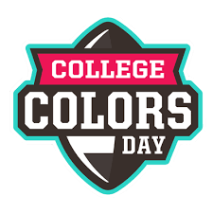
Younger and Older Student Activity
In celebration of College Application Week/Month in your state, host a “College Colors Day!” This is a free event and provides a visual reminder of the diversity of colleges.
Students are encouraged to wear the colors of their favorite college or university or of an institution of an older sibling, parent, or relative.

For additional fun, host a contest for the most creative college-themed outfit. Students who participate should plan to wear their outfit all day — so make sure it is comfortable and will not distract from their learning.

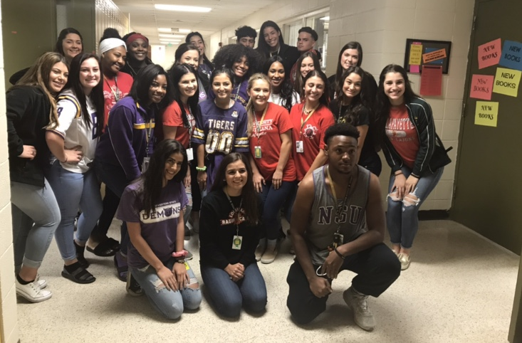

Create a College Colors Map for Your State

Older Student Activity

College colors can energize fans and reinforce awareness of the existence of college resources. Consider a research project for middle school students: one team can research the colors of community colleges in your state, a second team can research the colors of public state colleges and universities, and a third team can research the colors of private colleges and universities. Have each team create a state map with the appropriate colors in the the correct geographical locations. Sometimes a town has to sponsor multiple sets of team colors – let your students figure out how to represent this situation.

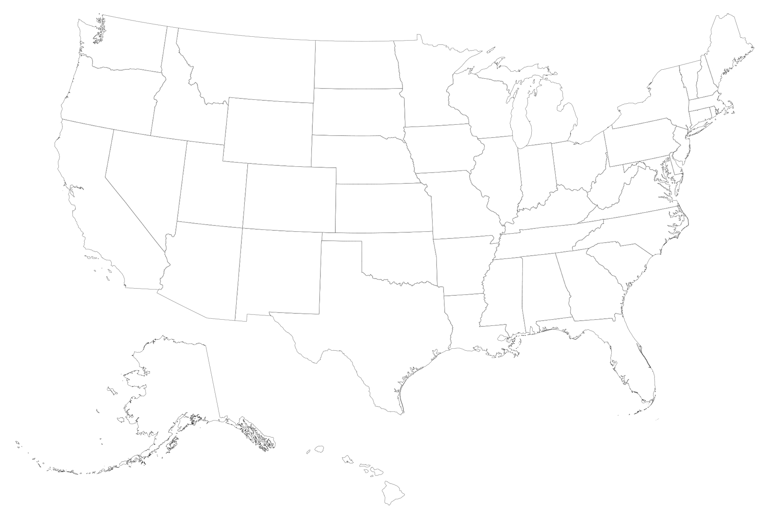

COLLEGE and CAREER AWARENESS ACTIVITY 8

My Career and College Dreams Collage

This is one of the easiest activities to implement. Ask your students to create a personal collage of their possible dream jobs/careers. Suggest that they identify the first step (entry level) job for work they find interesting. They should find corresponding photos in magazines, on the computer, or create a drawing for that position. Then, they should look for pictures (or draw one) of someone in the middle of their career in this field. Finally, they should be encouraged to look for images of someone who is a master or at the top of their career. For younger students, it is useful to encourage students to connect specific jobs to “career clusters” while older students can connect career clusters, educational expectations, and salaries.

ACT CAREER CLUSTERS AND CAREER AREAS (A–Z)
Source: https://www.act.org/content/dam/act/unsecured/documents/EOS-CareerClusters.pdf
ADMINISTRATION & SALES CAREER CLUSTER
Employment-Related Services
Managers (Human Resources, Training/Education, Employee
Benefits, etc.); Recruiter; Interviewer; Job Analyst
Marketing & Sales
Agents (Insurance, Real Estate, Travel, etc.); Buyer; Sales/
Manufacturers’ Representatives; Retail Sales worker; Telemarketer
Management
Executive; Executive Secretary; Purchaser; General Managers
(Financial, Office, Property, etc.); Specialty Managers (Retail Store,
Hotel/Motel, Food Service, etc.). Other managers are in Career
Areas related to their work. For example, see Career Area X.
Regulation & Protection
Inspectors (Customs, Food/Drug, etc.); Police Officer; Detective;
Park Ranger; Security Manager; Guard

BUSINESS OPERATIONS CAREER CLUSTER
Communications & Records
Receptionist; Secretary (including Legal and Medical); Court
Reporter; Clerks (Order, Billing, Hotel, etc.)
Financial Transactions
Accountant/Auditor; Cashier; Bank Teller; Budget/Credit Analysts;
Tax Preparer; Ticket Agent
Distribution & Dispatching
Shipping/Receiving Clerks; Warehouse Supervisor; Mail Carrier;
Dispatchers (Flight, Cab, etc.); Air Traffic Controller

TECHNICAL CAREER CLUSTER
Transport Operation & Related
Truck/Bus/Cab Drivers; Locomotive Engineer; Ship Captain; Aircraft
Pilot; Sailor; Chauffeur
Agriculture, Forestry & Related
Farmer; Nursery Manager; Pest Controller; Forester; Logger;
Groundskeeper; Animal Caretaker
Computer & Information Specialties
Programmer; Systems Analyst; Information Systems Manager;
Computer Repairer; Desktop Publisher; Actuary
Construction & Maintenance
Carpenter; Electrician; Bricklayer; Tile Setter; Painter; Plumber;
Roofer; Firefighter; Custodian
Crafts & Related
Cabinetmaker; Tailor; Chef/Cook; Baker; Butcher; Jeweler;
Silversmith; Hand Crafter
Manufacturing & Processing
Tool & Die Maker; Machinist; Welder; Bookbinder; Printing Press
Operator; Photo Process Worker; Dry Cleaner
Mechanical & Electrical Specialties
Mechanics/Technicians (Auto, Aircraft, Heating & Air Conditioning, Electronics, Dental Lab, etc.); Repairers (Office Machine, Appliance, TV/VCR, CD Player, etc.)

SCIENCE & TECHNOLOGYCAREER CLUSTER
Engineering & Technologies
Engineers (Aerospace, Agriculture, Nuclear, Civil, Computer, etc.);
Technicians (Electronics, Mechanical, Laser, etc.); Surveyor; Drafter;
Architect; Technical Illustrator
Natural Science & Technologies
Physicist; Astronomer; Biologist; Statistician; Soil Conservationist;
Food Technologist; Crime Lab Analyst
Medical Technologies (Also see Area W)
Pharmacist; Optician; Prosthetist; Technologists (Surgical, Medical
Lab, EEG, etc.); Dietitian
Medical Diagnosis & Treatment (Also see Area W)
Physician; Psychiatrist; Pathologist; Dentist; Optometrist;
Veterinarian; Physical Therapist; Audiologist; Physician’s Assistant
Social Science
Sociologist; Experimental Psychologist; Political Scientist
Economist; Criminologist; Urban Planner

ARTS CAREER CLUSTER
Applied Arts (Visual)
Artist; Graphic Artist; Photographer; Illustrator; Floral/Fashion/
Interior Designers; Merchandise Displayer
Creative & Performing Arts
Writer/Author; Musician; Singer; Dancer; Music Composer; Movie/TV
Directors; Fashion Model
Applied Arts (Written & Spoken)
Reporter; Columnist; Editor; Advertising Copywriter; Public Relations
Specialist; TV Announcer; Librarian; Interpreter

SOCIAL SERVICE CAREER CLUSTER
Health Care (Also see Areas Q and R)
Administrator; Nurse; Occupational Therapist; Psychiatric
Technician; Dental Hygienist/Assistant; Geriatric Aide
Education
Administrator; Teachers & Aides (Preschool, Elementary &
Secondary, Special Education, PE, etc.). Other teachers are in
Career Areas related to their specialty. For example, Physics
Teacher is in Career Area P.
Community Services
Social Service Director; Social Worker; Lawyer; Paralegal; Home
Economist; Career Counselor; Clergy
Personal Services
Waiter/Waitress; Barber; Cosmetologist; Flight Attendant; Household
Worker; Home Health Aide; Travel Guide

