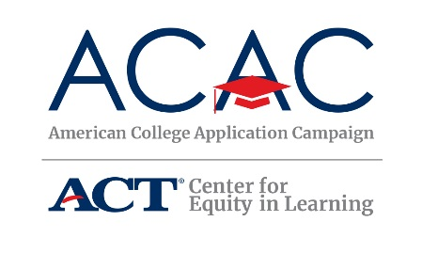
#WhyApply 2019 Social Media Toolkit
This fall, students across the country will be submitting college applications and celebrating their plans for the future. Nearly 600,000 of them will do so when schools in all 50 states and the District of Columbia host American College Application Campaign (ACAC) events. To celebrate college application season and our students, ACAC encourages participation in the #WhyApply social media campaign.
Join ACAC on Friday, September 20, for #WhyApply Day by heading to social media and answering the question, “Why apply to college?”
#WhyApply Day celebrates the college application season by sharing supportive and motivating messages on social media about the importance of applying to college. Whether applying to a certificate program, two-year college or four-year university, it’s important to celebrate this critical and necessary step on the journey to postsecondary education.
How to show your support
On Friday, September 20, wear your college gear and share why you believe students should apply to college and/or why you applied to college. Be sure to use the hashtag #WhyApply and tag the American College Application Campaign. Encourage your friends, family, and colleagues to do the same. Not sure what to post? You might:
- Write your answer on this #WhyApply printout and post a photo of you holding it
- Type a short response in your status
- Make a video of yourself, your kids, or your friends answering the question “Why apply?”
- Draw a picture depicting your reasons

Sample Posts to Promote #WhyApply Day:
- Twitter: #WhyApply Day is Friday, Sept. 20! Join us and @American_CAC by sharing your “why apply to college?” reason. Use @American_CAC’s #WhyApply printout available here: https://equityinlearning.act.org/acac/resources/state-coordinator-materials/
- Facebook: #WhyApply Day is Friday, September 20! Join us and the American College Application Campaign by sharing your “Why apply to college” reason. Use ACAC;s #WhyApply printout available here: https://equityinlearning.act.org/acac/resources/state-coordinator-materials/
- Twitter and/or Facebook: This Friday, Sept. 20 is #WhyApply Day! Wear your college gear and tell students why it’s important to apply to college!
- Twitter: Applying to college is a necessary and critical step on the path to #college. This Friday, Sept. 20, tell students #WhyApply to college. Use @American_CAC’s #whyapply printout available here: https://equityinlearning.act.org/acac/resources/state-coordinator-materials/
- Facebook: Applying to college is a necessary and critical step on the path to college. This Friday, September 20, tell students #WhyApply to college. Use the American College Application Campaign’s #WhyApply printout available here: https://equityinlearning.act.org/acac/resources/state-coordinator-materials/

Sample Posts for #WhyApply Day:
- Because you can’t go if you don’t apply
- To reach your fullest potential
- To open new doors of opportunity that will last a lifetime
- Because my parents didn’t
- Because you are college material
- Because #RepresentationMatters
- Because education is a powerful tool to change your life and the world

ACAC on Social Media
Facebook: www.facebook.com/americancac
Twitter: https://twitter.com/american_cac
Instagram: www.instagram.com/american_cac

Promotional Graphics
