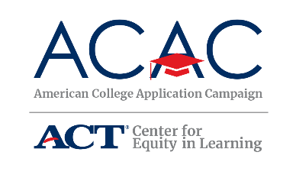

For helping more students complete a critical step to college.

* X of your X seniors participated in college application activities
* [# of] applications were completed
* [If applicable – break down application in state vs out of state]
* [If applicable – share # of students who will be first in their family to attend college]
* [Optional – This is the X year your school has hosted a college application event]

CERTIFICATE OF PARTICIPATION

Congratulations on your successful 2019 college application event.

This certificate is awarded to:

[High School Name]

[STATE CAMPAIGN SIGNATURE and LOGO]

ACAC Director: 