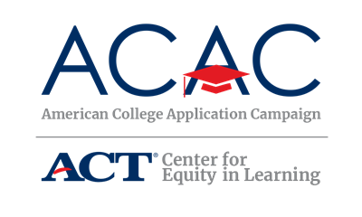

High School Volunteer Recruitment Letter - Template

SCHOOL LOGO
SCHOOL ADDRESS
September 2020

Dear [NAME OF ORGANIZATION],

[NAME OF YOUR HIGH SCHOOL] is pleased to announce its participation in [NAME OF STATE CAMPAIGN]! In an effort to further expand college access initiatives, the [NAME OF LEAD ORGANIZATION] is sponsoring [NAME OF STATE CAMPAIGN] from [CAMPAIGN DATE(S)]. The goal of [NAME OF STATE CAMPAIGN] is to provide every graduating high school senior the opportunity to apply to college [INSERT ADDITIONAL GOALS, IF NECESSARY].

[NAME OF STATE CAMPAIGN] can open the door for students by encouraging them to take significant steps toward college during their senior year. What began in 2005 as a single day at one high school in North Carolina has evolved into 50 state campaigns to help students. This year, [STATE] expects over [NUMBER] high schools to participate in our statewide campaign. A critical component of [NAME OF STATE CAMPAIGN] is the one-on-one support provided by volunteers who help students fill out applications at school. Volunteers may include high school staff, registrars and admissions officers, and financial aid advisers from nearby postsecondary institutions, and representatives from the community.

We will be hosting our event on [DATE(S) AND TIME] and would welcome representatives from [NAME OF ORGANIZATION] to visit our school during this exciting and important time. Volunteers can greet and sign-in students, assist students with the completion of online college applications, or distribute additional information about financial aid opportunities. Our students would really appreciate your help and support as they take a big step toward going to college.

If you or any of your colleagues at [NAME OF ORGANIZATION] are interested in working with [NAME OF YOUR HIGH SCHOOL] in any capacity, please contact me at [SITE COORDINATOR INFO].

Thank you!

Volunteer resources and webinar information are available at [WEBSITE].

[SITE COORDINATOR NAME]
[YOUR TITLE]
[CONTACT INFO]

