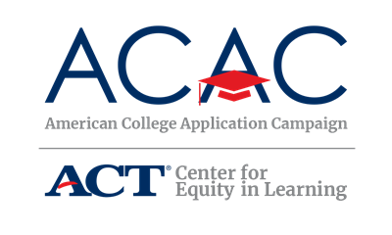

Sample Interest Form

The following questions can be built into an online interest form via Google Form, Survey Monkey, etc. This interest form can be used in early recruitment and promotional opportunities to gather contact information of interested high schools. The purpose of this form is much like a Letter of Intent before applying for a grant. You do not need to do an interest form if your registration opens in the spring prior to the fall campaign events. However, if you do not open registration until the fall, this interest form will allow to you engage schools much earlier in the process.

Thank you for your interest in joining [State’s Campaign name]. We look forward to working with your school as we implement this exciting initiative together. Please complete the form below to indicate your school’s interest in joining [State’s Campaign name]. [State Coordinator’s Name], [State’s Campaign name] Coordinator, will follow up with you with more details about Campaign requirements and how to register your school for official participation in the program.

High School Name:

School District:

Number of seniors at your high school:

Date(s) that you anticipate implementing [State’s Campaign name]. As a reminder, [State’s Campaign name], will be held [dates]:

Site Coordinator for High School (typically a school counselor or assistant principal):

Site Coordinator’s title:

Site Coordinator’s email address:

Site Coordinator’s phone number:

Site Coordinator’s mailing address:

If our school becomes an official site, we understand we must:

Identify a Site Coordinator.

Host a college application program during the school day.

Submit the number of participating seniors and the number of applications submitted to [State Coordinator’s Name] after the event.

