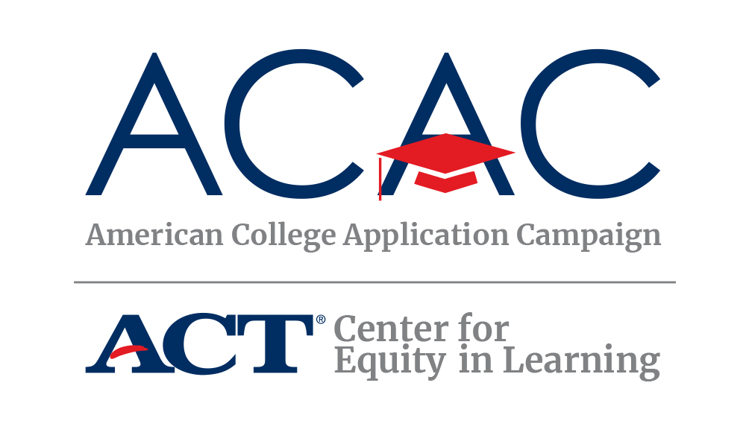

**#IAPPLIED SOCIAL MEDIA CAMPAIGN**

Hey students! You have joined hundreds of thousands of students across the country submitting college applications this fall. The American College Application Campaign wants to celebrate you!

**Tell us where you applied to college**

Help us celebrate you by sharing where you applied to college on social media. It’s easy! Use the #IApplied print out on page two and write the name(s) of the college(s) where you applied. You might:

* Use the #IApplied print out on page two and write the name(s) of the college(s) where you applied
* Take a selfie, ask a friend to take the picture, or make a short video
* Post the photo/video on your favorite social media channels (SnapChat, Instagram, TikTok, Twitter, Facebook)
* Be sure to use the hashtag #IApplied
* Tag the American College Application Campaign and your state college application campaign so we can celebrate you!

**Follow ACAC on Social Media**

We plan to highlight students on our social media channels. Be sure to **like our page** and/or **follow us** to where other students apply and for tips on the college-going process.

 [www.facebook.com/americancac](http://www.facebook.com/americancac)  <https://twitter.com/american_cac>

[www.instagram.com/american_cac](http://www.instagram.com/american_cac)

