American College Application Campaign
College Match
and
Fit Toolkit

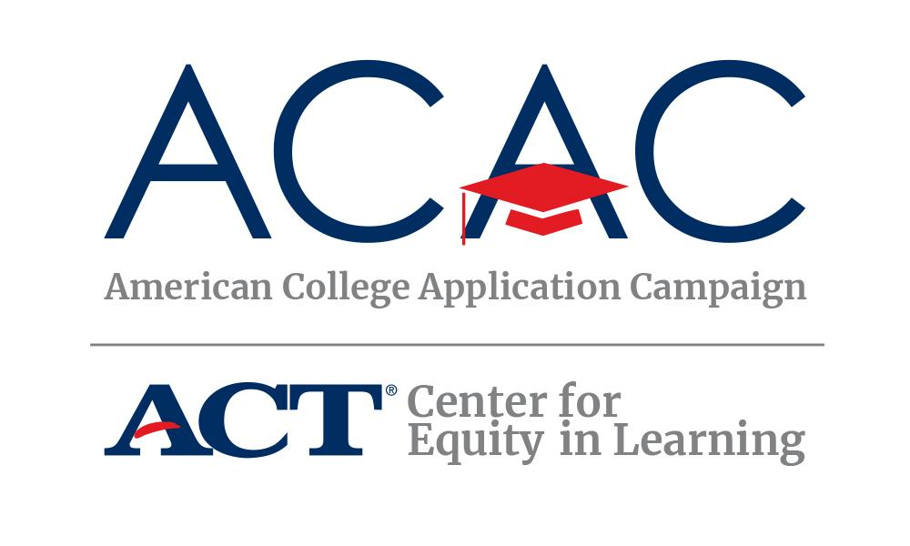

Purpose
This College Match and Fit Toolkit outlines and specifies activities and technology to be used by school counselors working with students as they explore educational opportunities after high school. The toolkit provides an interactive experience for students and aims to positively impact the application, enrollment, and persistence behaviors of all students and particularly students who are systemically underserved from low-income families and first-generation college students.

Framework
The following components act as the framework for the College Match and Fit Toolkit. Each of these characteristics is identified as a critical decision-making factor for each student when identifying and applying to college.
- Lifestyle Preferences
- College Majors/Programs Offered
- Academic Readiness
- Retention and Graduation Rates
- College Costs/Affordability

Technology

Using myOptions® and myOptions Encourage
The College Match and Fit Toolkit will leverage existing tools in myOptions for students and myOptions Encourage for school counselors, mentors, family members, and college advisors. For clarity purposes, these individuals will all be referred to as “counselors” throughout this document. Each counselor and student will need to create a free account at myoptions.org. Once their profiles are created, they will be able to link their myOptions accounts so that both are informed about the student’s interest in institutions, submission of applications, and FAFSA completion progress. For assistance connecting with a student, please see Appendix I below. No other technologies are required to use myOptions or any of the resources provided in this toolkit.

Defining Match and Fit
Students may be wondering about the difference between Match and Fit. Match refers to the GPA, rank, and test scores within the different competitive college bands. This can also include college completion percentages. Fit refers to what the student is looking for in a college, such as culture and social environment, student supports and services, size, location, majors offered, etc.
Throughout this toolkit and within myOptions, we will refer to College Match as the match and fit activities centered around the college discovery feature which allows a student to discover colleges based on various characteristics, including geography, campus atmosphere, and academic profile.

Implementing with Students
Students will complete the activities by using the myOptions platform to create a “smart list” of colleges that align with the various activities. Counselors will be able to monitor students they are connected with through the Mentoring dashboard in myOptions Encourage.

Student Activities and Curriculum
Students and counselors are encouraged to use three additional tools to complement myOptions features and the curriculum provided in this toolkit.
- The American College Application Campaign’s College Research Worksheet.
- The complementary Student Worksheet for the College Match and Fit Toolkit
- Appendix: Navigating myOptions and myOptions Encourage

Learning Goals
- Students will understand how their lifestyle preferences or desired college atmospheres impact their options for college.
- Students will understand how their major choices impact their options for colleges.
- Students will understand how their academic profiles (via GPA “what if”) impact their options for colleges.
- Students will understand how to consider retention and graduation rates in selecting colleges.
- Students will understand how affordable their college options are for their families.
- Students will produce defined lists of colleges that meet the above factors.

Curriculum/Lesson Plan
Activity 1: Find Colleges that Fit Your Desired Atmosphere
Timing: 15 minutes
Counselor/Educator Prompt Suggestion: “Let’s start by formulating a list of college options that fit your personal preferences or the type of atmosphere you want (e.g., geographic location, school size, religious affiliation, school type). It’s ok if you’re not sure about what you want yet. Keep your selections broad for now, and you can always change your preferences to update this list once you figure that out!”
Student Activity: Students will complete the ACAC College Research Worksheet “Identifying Your College Fit” exercise on pages 6-7 to identify the factors that are important to them in a college. Students will then log in to their myOptions accounts and navigate to the School Match and complete the preference survey. Students will receive up to twenty-five broad matches.
Note: Students participating in the ACAC myOptions e-registration will already have college matches provided if they have activated their accounts via the automated email sent directly to the student after completing the registration. If their preferences have changed, they may re-run a college match by updating their preferences under School Match.

Output: Students will complete the ACAC College Research Worksheet “Identifying Your College Fit” to identify and rate the importance of each factor. Following this exploration, students will also identify the number of schools that meet their preferences.
Guidance Points: Encourage students to look at how each factor narrows their search results. Students should not be too specific as it may eliminate all schools. Encourage students to identify the lifestyle preferences that are most important to them for this part of the exploration process.
Navigation:
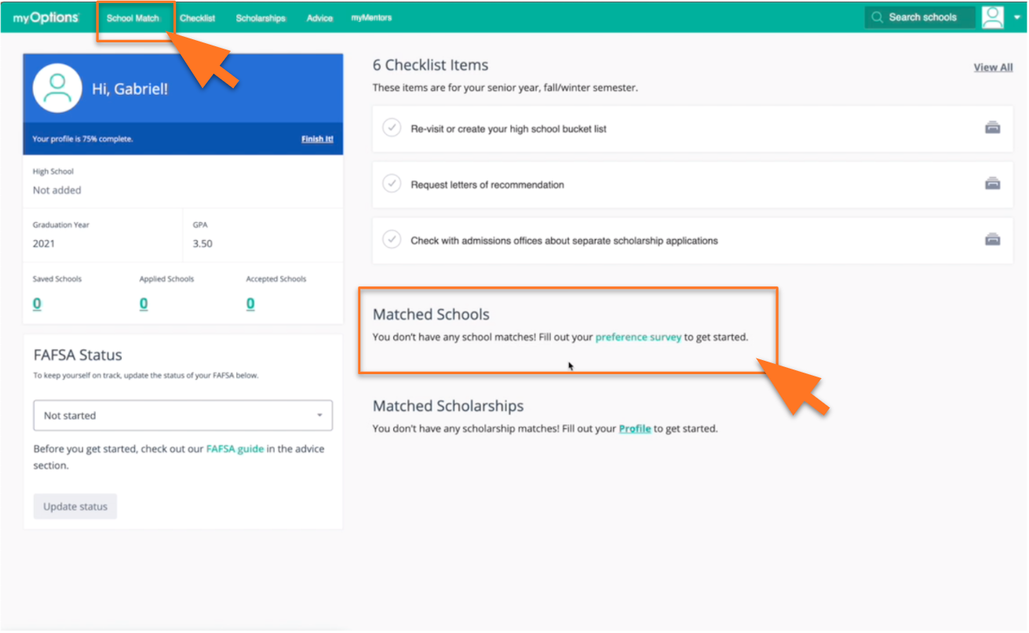
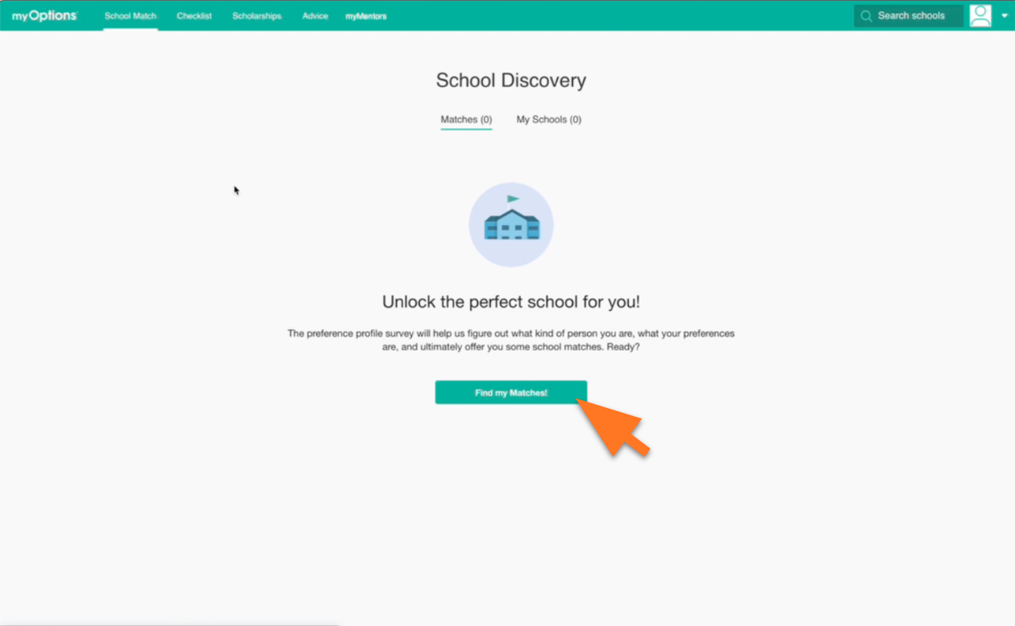
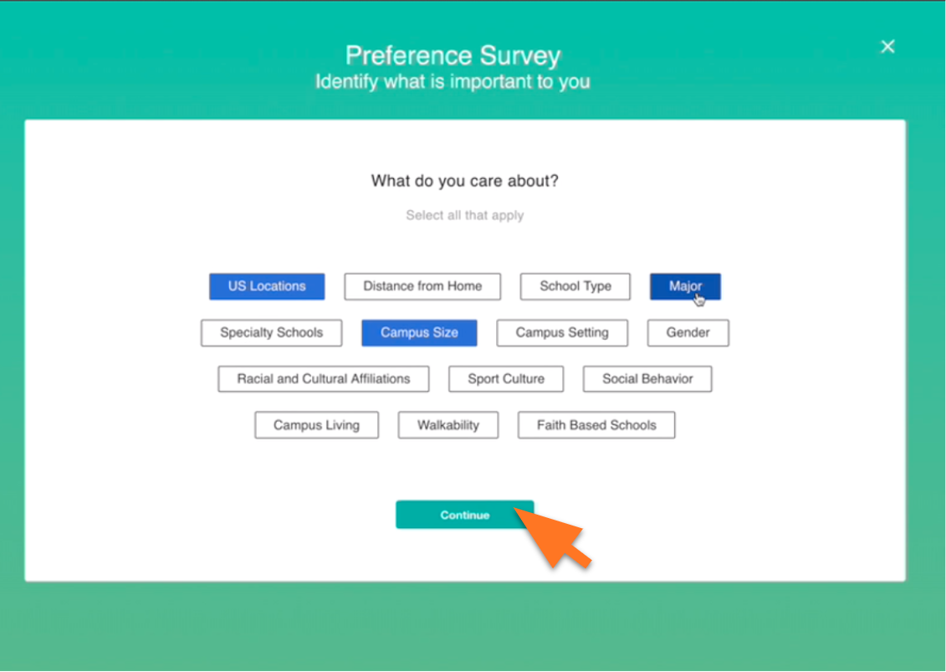
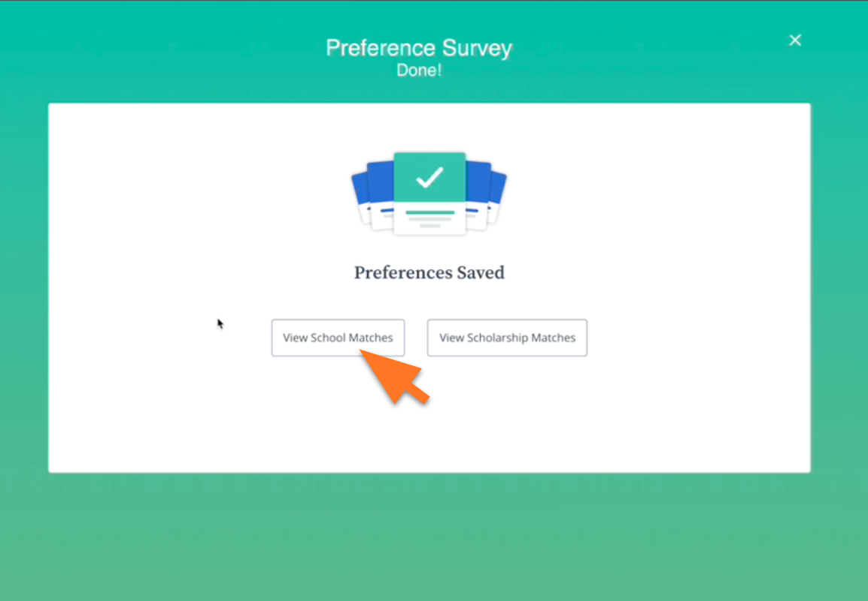

Activity 2: Select Colleges Based on Major
Timing: 30 minutes
Counselor/Educator Prompt Suggestion: “While completing the preference survey, you were asked to select up to three majors you might like to study. If you skipped this question, that’s ok. Proceed to your college matches, and let’s look at how your college matches might be affected by your field of study.”
Student Activity: Students will log in to their myOptions accounts and navigate to the School Match. Students will open a College Profile and scroll down to Areas of Study to enter a few options and see what majors are offered in that field of study at each institution. If a major in that field of study is offered and matches what the student is looking for, you can scroll back to the top of the College Profile and click “Like.” Students who are unsure of their desired major(s) might see colleges in their matches do not offer programs in the fields they are considering. This exercise will most likely significantly reduce the number of college options for individual students.
Once students have found the schools that offer majors in their fields of study, students should scroll back to the top of their college matches and select My Schools to see how many colleges offer their majors. Students selecting more general majors will likely have more college choices than students interested in specialty fields.
Output: Students will identify on their Student Worksheet the number of schools that offer their favorite majors. This will serve as a guidance point for the subsequent activities.
Guidance Points: Students may find that their searches are already too limiting (possibly under ten colleges). If they’ve selected very specific majors, guide them back to related or adjacent majors to identify more potential options.
Navigation:
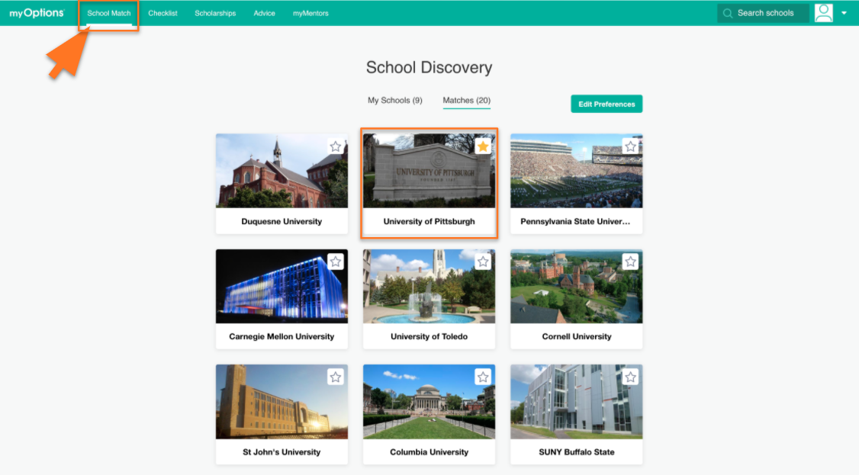

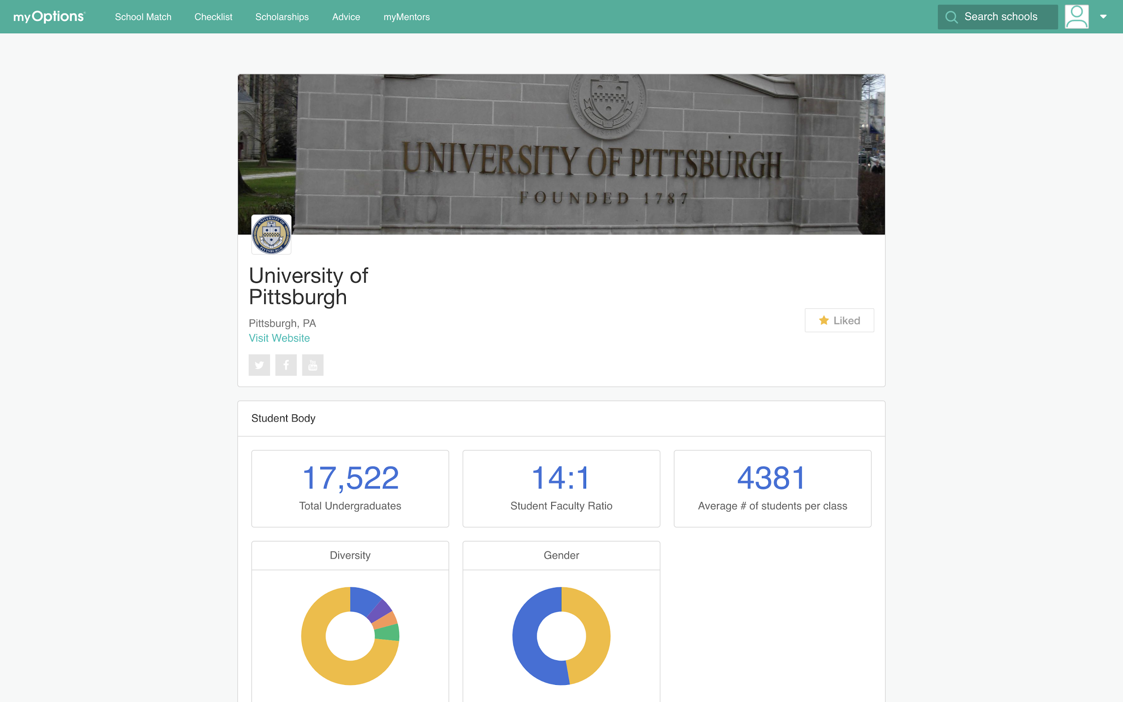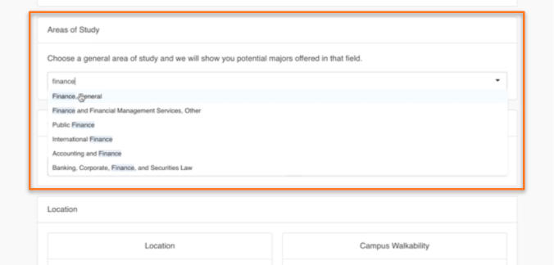
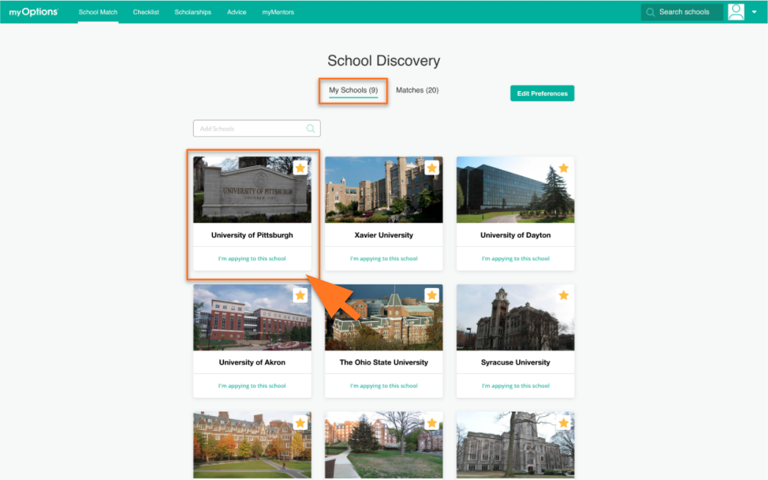

Activity 3: Academic Readiness
Timing: 20 minutes
Counselor/Educator Prompt Suggestion: “Now let’s understand what different schools require for college entrance test scores, either the ACT or SAT, and grade point averages. Let’s first add your scores and GPAs; then, we will revisit the school search and narrow by score ranges.”
Student Activity: First, students will log in to their myOptions accounts and navigate to My Profile>Academic Profile and enter their best scores, if applicable, and their GPAs.
Then, they will navigate to the School Match and add any new schools that offer their desired majors to My Schools. Students will note on the worksheet how many schools match their academic profiles compounded by their major selections on their worksheets.
Students will then click into each College Profile on the My Schools lists, scroll to Admissions, and navigate to the institutions’ admissions websites to see their specific entrance requirements.
Output: Students will note not their student worksheet how many colleges in their My Schools lists typically accept students with their GPAs and test score combinations.
Guidance Points: Academic match is a factor colleges will use to review their applications. At the close of this research opportunity, we will spend some time reflecting on whether colleges are a reach, target, or likely school for students based on their academic records. As outlined in the ACAC College Research Worksheet, students should keep in mind that what a school requires could be different from the averages of whom they admit. They should plan to apply to at least four schools, making sure to have applications going to each of the following types of schools:
• REACH SCHOOL – A reach school does not mean out of reach. It just means that the school may be more selective (look at the percent of applicants admitted), and a student’s academic record may be on the lower end of what the college typically accepts. In other words, the student may be admitted to this school. We recommend at least 1-2 applications to reach schools.
• TARGET SCHOOL – Typically, at a target school, the student’s academic record will be similar to the “average” student admitted to this school. In other words, the student is expected to be admitted. We recommend at least two applications to target schools.
• LIKELY SCHOOL – A likely school will usually have either open enrollment (meaning anyone who submits a completed application is admitted) or will be considered a “less selective” institution. A student’s academic record will exceed the institution’s requirements and averages for students admitted. In other words, the student will almost definitely be admitted. We recommend at least one application to a likely school.

Navigation:
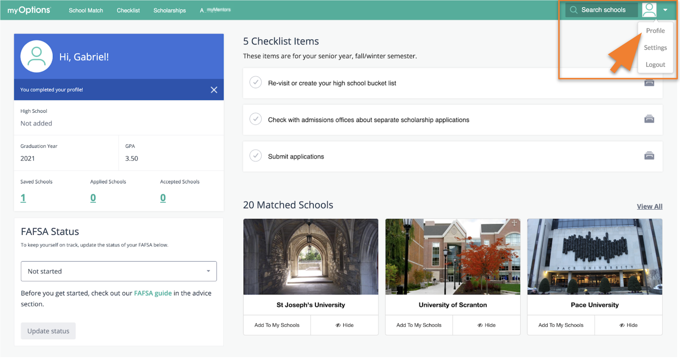
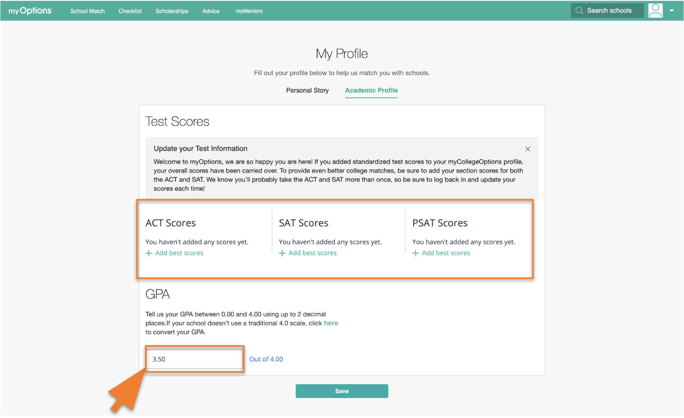
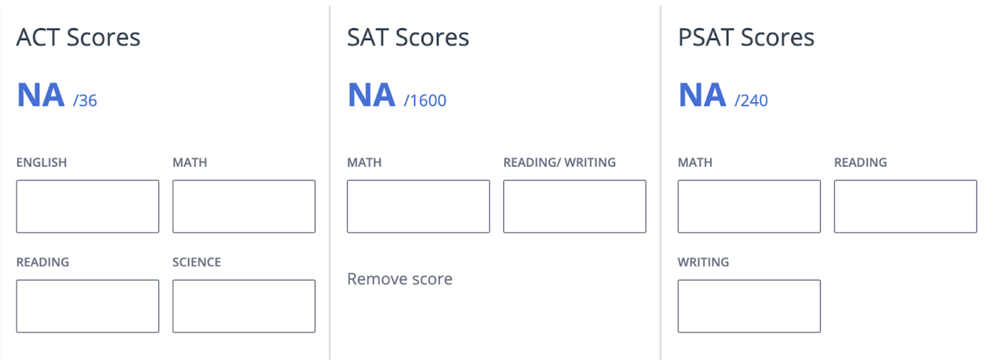

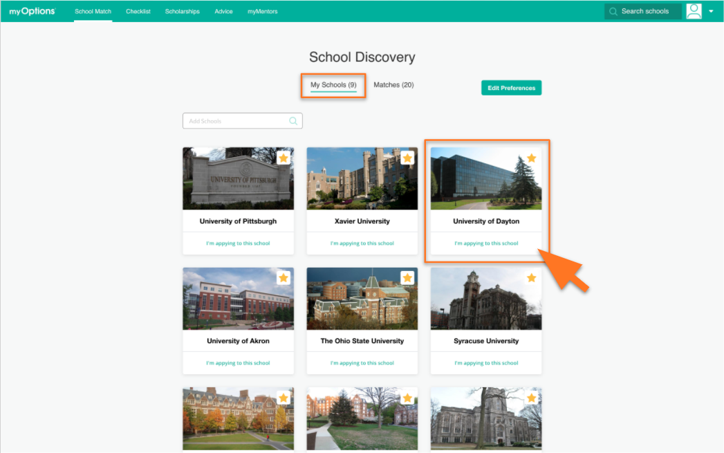
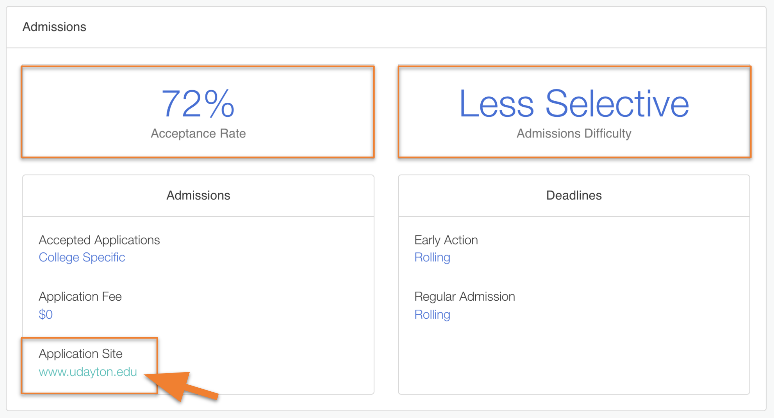

Activity 4: Understanding Retention and Graduation Rates
Timing: 20 minutes
Counselor/Educator Prompt Suggestion: “Now let’s see how the colleges perform on retaining and graduating students. This is very important because it indicates potential factors that could impact your success. When we talk about retention, we mean how many students return to a college for their second years. When we talk about graduation, we mean how many students graduate from a college within six years.”
Student Activity: Students will log in to their myOptions accounts and navigate to School Search > My Schools. From there, they will use the Retention and Graduation Rates posted on the College Transitions website to see if the schools on their lists rank above or below the national average of 78% retention.
The students will note on their Student Worksheets the number of schools that have higher retention and graduation rates. Students may also note specific schools and their actual retention and graduation rates.
Output: On their Student Worksheets, students should identify how many schools rank above or below the national average of 78% retention. Students should also note any colleges in their My Schools lists in myOptions that have strong retention and graduation rates on their worksheets.
Guidance Points: Encourage students to look for schools with higher retention and graduation rates.
Navigation:

Activity 5: College Affordability
Timing: 30 minutes
Counselor/Educator Prompt Suggestion: “Let’s take a look at your favorite colleges to determine affordability. The cost of attending a college is often much less than the listed or “sticker price.” Through scholarships and grants, the cost of attending a specific college may be greatly reduced. Because of this, it is very important to research what we call “net price” for each college you are considering. Net price is the bottom line of what you will pay when you factor in scholarships and grants. So a school that may at first glance seem very expensive and unattainable for you and your family’s financial situation may offer financial aid that would allow you to attend for far less.”
Note: We recommend assigning this exercise as homework. Students will need basic financial information from their families and be able to self-identify as free or reduced lunch.

Student Activity: Students will log in to their myOptions accounts and navigate to My Schools. Students will review the College Profiles of up to 10 schools to determine the sticker price located at the top of the School Costs section. The College Profiles include information for in-state and out-of-state tuition (depending on residency), living costs, books & supplies, etc. Students will record this cost for each of their schools in their “College Match Worksheets.” Next, the students will identify their three most desired schools from their My Schools lists and calculate the net prices using the U.S. Department of Education’s Net Price Calculator tool. Once complete, the students will be presented with a sticker and net price for each institution. The students should record each on their worksheets.
Note: Some colleges may not have costs listed on their College Profiles in myOptions. Additionally, they may not have configured their websites correctly for the Net Price Calculator tool. If this is the case, students can navigate to the colleges’ admissions websites from the College Profiles under “Admissions” to find their estimated costs or use their net price calculators if they offer one on their websites.

Output: Students and their families will understand the difference between sticker prices and net prices and what their estimated net prices will be at the schools they are most interested in attending.
Guidance Points: There are other financial options, like scholarships and federal aid, families can explore to finance their students’ educations. Refer students to the U.S. Department of Education’s Federal Student Aid office to learn more about their financial aid options: https://studentaid.ed.gov/sa/. myOptions also provides a tailored list of scholarship opportunities to each student as part of the college matching process. You can direct students to log in to myOptions and select Scholarships in the top navigation bar to view.

Navigation:
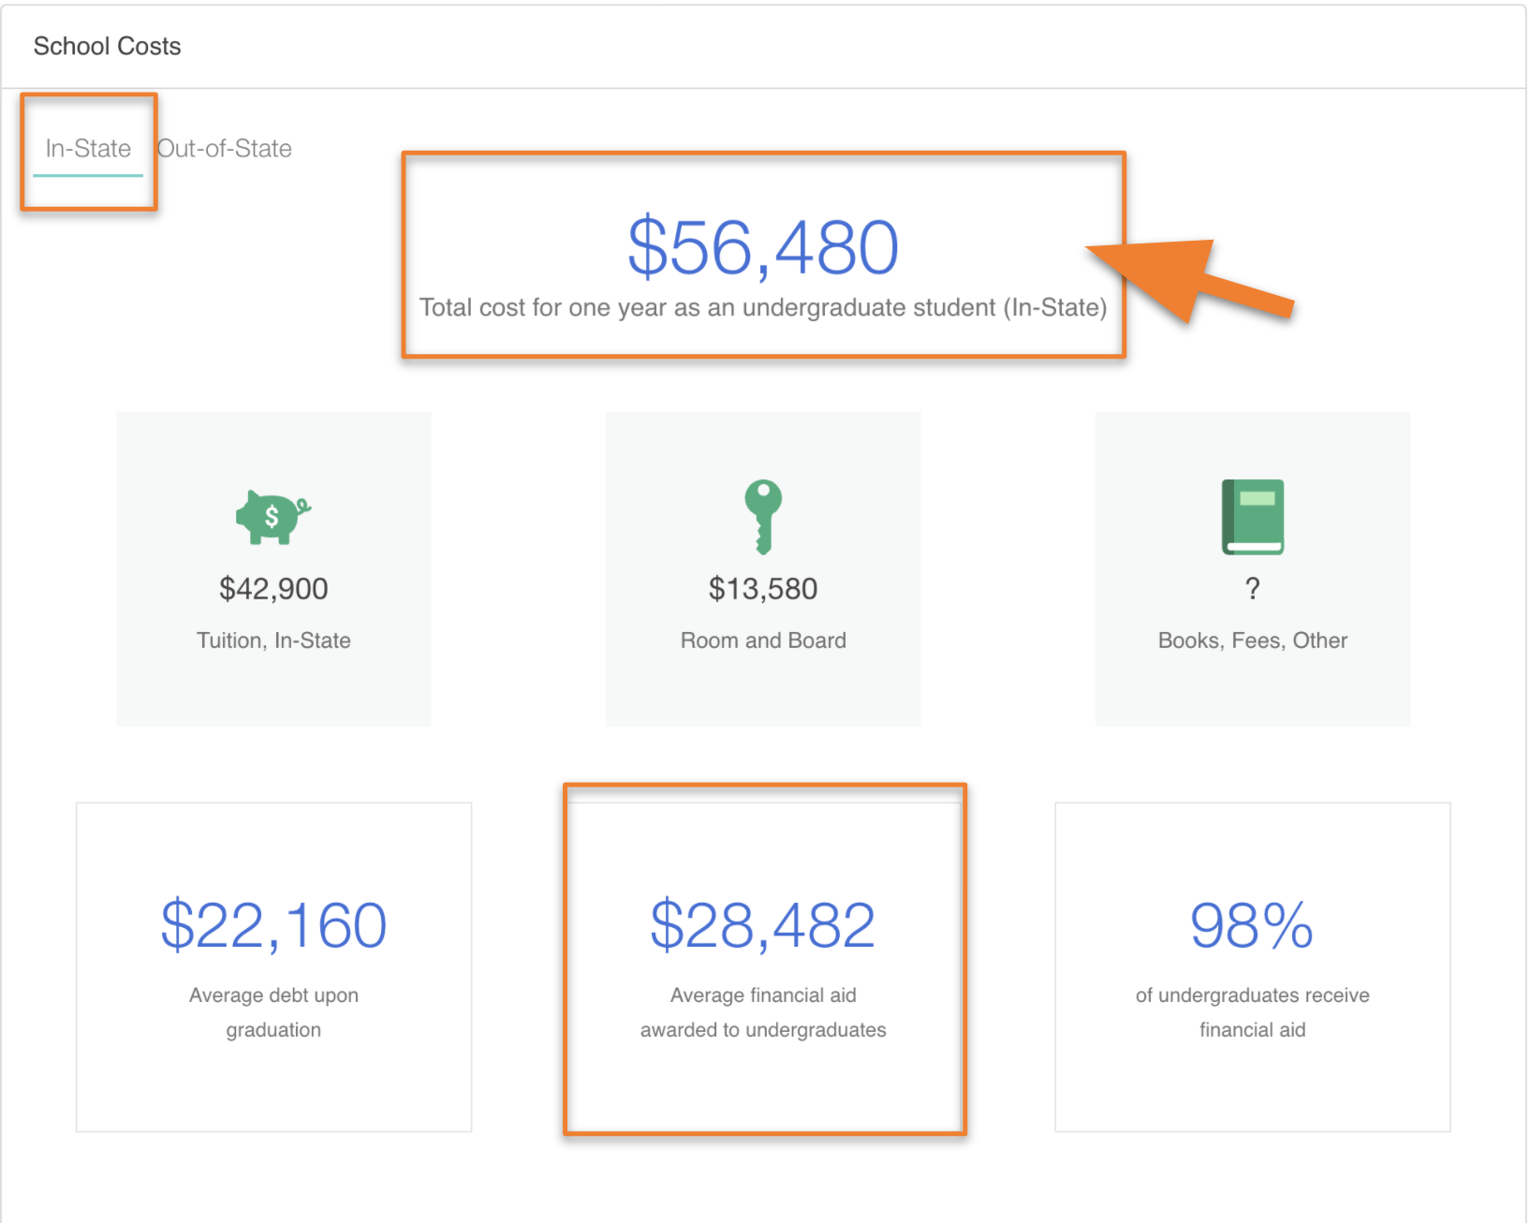

Activity 6: Summary & Reflection
Timing: 20 minutes
Counselor/Educator Prompt Suggestion: “We’ve now explored most of the major factors influencing college choice. Let’s summarize that by identifying schools that are the best match and fit for you. You should consider each of the previous activities as you categorize your matches.”
Student Activity: Students use the College Match and Fit Table on pages 8-9 in the ACAC College Research Worksheet to collect the information for the four to six colleges to which they want to apply. This will help students ensure they have a nice mix of reach, target, and likely schools that reflect on how well each college aligns with their preferences. These guides will help students keep track of upcoming deadlines and specific characteristics of each college they have identified for application. In myOptions, students will have already “Liked” roughly four to six colleges that are the best match and fit based on all of the previous exercises. Once students have selected the schools to which they will apply, they should return to their My Schools lists in myOptions and mark “I’m applying to this school” on each one.
Note: Marking “I’m applying to this school” on any school in myOptions will allow the Counselor using myOptions Encourage to monitor the application progress as students update their status.

Output: Students should identify a list of four to six colleges to which they want to apply. Using the College Match and Fit Table in the ACAC College Research Worksheet, they can identify key considerations and next steps.
Guidance Points: Ideally, students will identify at least four colleges to which they want to apply. In reviewing the lists of colleges for students, counselors should talk through the various research points to ensure the lists align with students’ preparedness, goals, and financial situations. Remind students they should have applications going to each of the following types of schools:
• REACH SCHOOL – A reach school does not mean out of reach; it just means that the school may be more selective (look at the percent of applicants admitted), and a student’s academic record may be on the lower end of what the college typically accepts. In other words, the student may be admitted to this school. We recommend at least 1-2 applications to reach schools.
• TARGET SCHOOL – Typically, at a target school, the student’s academic record will be similar to the “average” student admitted to this school. In other words, the student is expected to be admitted. We recommend at least two applications to target schools.
• LIKELY SCHOOL – A likely school will usually have either open enrollment (meaning anyone who submits a completed application is admitted) or will be considered a “less selective” institution. A student’s academic record will exceed the institution’s requirements and averages for students admitted. In other words, the student will almost definitely be admitted. We recommend at least one application to a likely school.

Appendix I

Connecting with Students
Establishing mentor connections with your students in myOptions.org is easy! You and your students should create an account on your respective platforms-- myOptions and myOptions Encourage-- at myoptions.org. Students will log in to their myOptions accounts and navigate to myMentors > Add Mentor. Students will enter the counselor’s name, email, and relationship. Once submitted, you will receive an email inviting you to accept the students’ mentoring requests. All students you mentor will appear under the Mentoring app in myOptions Encourage.
Note: Students should select School Staff to indicate a relationship with a school counselor, faculty member, or administrator. Representatives of college access and community-based organizations should be described as Other Mentor. Other Mentors and Parents/Guardians will have the ability to view application statuses and monitor activities on the college planning checklist for each student connected to their accounts.

