Student Worksheet
for use with the
American College Application Campaign
College Match and Fit Toolkit

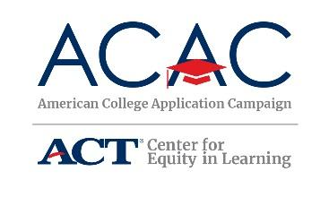

Activity 1: Lifestyle Preferences

Be sure to complete the “Identifying Your College Fit” section of the ACAC College Research Worksheet starting on page 6.

The number of colleges that meet your college preferences:

________________________________________________________

Activity 2: Select Colleges Based on Major

The number of colleges that offer your favorite majors:

________________________________________________________

Activity 3: Academic Readiness

Be sure to complete the “Match – Your Academic Record” section of the ACAC College Research Worksheet found on page 7.

The number of colleges that typically accept the score range you’ve selected:

________________________________________________________

Did you use actual, expected, or both score(s) for this search? Note that actual test scores are the best to use for this search.

________________________________________________________

Activity 4: Understanding Retention and Graduation Rates

The number of colleges that meet graduation and retention requirements:

________________________________________________________

Activity 5: College Affordability

The sticker price and net price for up to 10 of your favorite colleges:
Name of College | Sticker Price | Net Price

Activity 6: Summary & Reflection

Be sure to complete the “College Match and Fit Table” section of the ACAC College Research Worksheet found on pages 8 and 9 for each of the 4-6 schools you have identified. This will help you keep track of deadlines and specifics for each college you are interested in. Also, don’t forget to mark “I’m applying to this school” on 4-6 schools on your My Schools list in myOptions so your counselor can support your efforts as you begin to apply. Your counselor is an excellent resource to speak with as you review your list of favorite colleges to ensure you have a nice mix of reach, target, and likely colleges.

