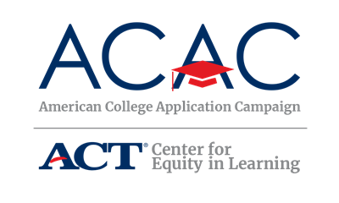

Reporting Test Scores

Applying to college requires a new vocabulary. This is particularly true regarding the reporting of standardized test scores such as ACT, SAT, TOEFL, Advanced Placement, and International Baccalaureate. Among the phrases you will encounter are: Test Required, Test Optional, Test Flexible, and Test Blind. Since each term means something a little different, it makes sense to provide you with a quick reference guide.

Test Required – This is pretty straightforward. The institution requires either the ACT, SAT, or TOEFL (an English language proficiency test for international students). You should ask if there is a preferred test for your campus. If they do not have a preference, submit the best scores you receive.

Test Optional – The institution does not require test scores. Instead, your high school academic record is the most important information. Additionally, your personal essay, recommendation letters, extracurricular activities, and personal interview will complete the admissions decision-making process. Institutions that are test optional are a great choice for students who are confident that their high school academic record and achievements provide a more complete picture of your intellectual abilities than a single standardized test.

Test Flexible – This one is a bit different. Institutions that are text flexible allows you to submit multiple standardized test scores to support your application. You need to ask the admissions office which of the following they will consider: International Baccalaureate, Advanced Placement scores, SAT and/or ACT.

Test Blind – This means that students are not required to submit any standardized test scores, but students may choose to do so. Sometimes, students are exempt from submitting scores if their high school grade point average is above a certain point. It is very important to ask the admissions representative to assist you in determining your best plan.

As with any question you have about the application process, contact the institution’s admission office to receive the most up-to-date information about their expectations for a complete college application. This is how you can confidently and proudly wear an #IApplied badge!

