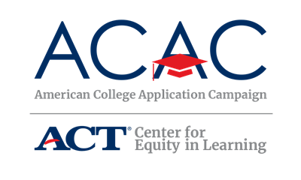

Communication Audit: State Level

Use the following table to identify current communication channels managed by the steering/planning committee members and other critical college access partners in your state. These channels should be considered as a way to promote the Campaign, call for host sites and to recruit volunteers. Charting the information will help you identify when and where to share the Campaign messaging. In addition, this piece is an excellent way to keep a record of the outreach conducted for the campaign to support successful transition of the work to a new state coordinator, should that occur in your state.

Additionally, use this audit to identify ways to build off current efforts and develop a plan specific to the College Application Campaign communication needs. Questions on page 2 will help you determine if some basic communication tools are in place.

Communication Channel | Frequency | Target Audience | Organization/Primary Contact | Contact Name, Phone and Email
Example: Email newsletter | Monthly | Counselors | State Counselor Association
Example: Webinars | Twice a month | Counselors, college access professionals | State College Access Network
Example: Instagram | Daily | Students | Higher Edu. Institution
Example: Conference Calls | Monthly | Counselors | Host sites

Does the state campaign have talking points readily available for steering committee members?

Yes If yes, where is file saved? Who has access to it?

No If no, date to complete:

Does the state campaign have a logo?

Yes If yes, where is file saved? Who has access to it?

No If no, date to complete:

Does the state campaign have a website or dedicated webpage?

Yes If yes, where is file saved? Who has access to it?

No If no, date to complete:

Do state campaign materials reference the American College Application Campaign?

Yes If yes, where is file saved? Who has access to it?

No If no, date to complete:

