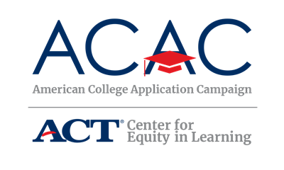

FAFSA Completion Campaign

Nearly all students would receive money for college if they applied for it, yet only 57 percent of high school seniors do so before graduation. The National College Attainment Network's (NCAN) “Form Your Future” campaign urges young people -- particularly low-income, minority students who would be the first in their family to attend college -- to claim what is theirs and achieve their educational dreams by filling out the Free Application for Federal Student Aid (FAFSA). The campaign partners with celebrities and social media influencers with the goal of engaging students and reaching them on channels where they are most active. The campaign website also provides helpful free resources to volunteers and educators who want to provide one-on-one assistance on completing the FAFSA to students and their families, as well as ideas on how to spread the word and get others involved in the effort to encourage millions of students nationwide to apply for financial aid.

www.FormYourFuture.org

Below are some samples of marketing/communication from the Form Your Future campaign that states and schools can use to encourage students and their families to submit their FAFSA and apply for aid. If your state currently runs a FAFSA Completion Campaign, ACAC encourages you to connect with the coordinator of the initiative to see how the two opportunities can be seamlessly linked through communications, leveraging of resources, etc., to connect and support these two college-going processes for your state’s students.

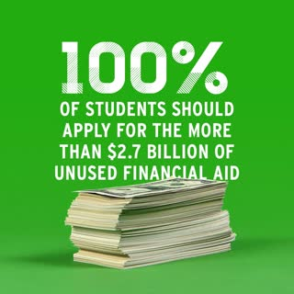
FAFSA Promotion Flyer

