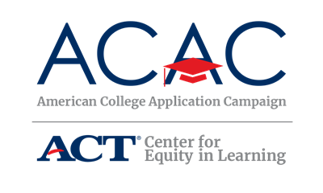

High School Training: Materials and Sample Agenda

Materials
ACAC has compiled some of the most effective materials on our website (https://equityinlearning.act.org/acac) under the Resources tab in the Site Coordinator Toolkit section. Please review the Site Coordinator materials and download the materials that would be beneficial to your state’s program, ensuring they are customized as necessary to reflect your state’s implementation.

Customizable ACAC materials in the Site Coordinator Toolkit section include:

Pre-Event Planning

Site Coordinator Checklist and Timeline

Planning Committee Agenda

Student, Family and Community Information Letters

Volunteer Task Assignments

College Application Worksheet for Students

“Ask Me About It” posters

Sample Press Release

Day of Event

“Ask Me!” buttons and stickers

I Applied! Stickers and pennants

Accepted pennants

Student Instructions for College Application Event

Student Next Steps After Applying handout

College Application Event Sign-Out Sheet

Post-Event

Volunteer Thank You Letters

Understanding Financial Aid Award Letters handout

Reminders for FAFSA events

College Signing Day FAQ

Training Agenda Template
It is highly recommended state coordinators provide a training for all host sites, even those returning to host an event again. It is up to each state, based on the number of host sites and geography of the state to determine how this training is provided. Some states provide an in-person training while others offer a series of webinars and some states utilize both approaches. A recommended training best practice is to engage returning sites by asking them to share best practices and examples of how their high school utilized the tools available.

A training PowerPoint template is also available on the ACAC website for states to customize for their program. Please contact ACAC for assistance.

- Welcome and Thank You!
- Have all host sites briefly introduce themselves. This helps the schools identify neighboring schools/districts that may be able to coordinate efforts.

- Purpose of American College Application Campaign and [INSERT STATE CAMPAIGN]
- To encourage and assist all students to apply to college, especially those who are from low-income and first-generation college families, because applying to college will increase their options as they decide what to do after high school.
- To provide dedicated time to support all students in determining a postsecondary path for life after high school.
- To provide additional information to all students about the college-going process.
- To reinforce a college-going culture in the school and community.
- This is not a recruitment activity for a specific college or university.
- This strategy/event is intended to enhance, not replace the work school counselors are already doing to support students through the college-going process. It may be helpful to have a conversation regarding what schools are already doing to support students and how they think this could enhance their work.
- [INSERT ADDITIONAL STATE GOALS]

- Host Site Coordinator Requirements
- Host sites must identify a site coordinator who will be responsible for implementing the program at their school. This can be a high school counselor, a college advisor, assistant principal, or a teacher who works in the building on a regular basis and is known by the students and staff.

- Preparing for and Implementing a College Application event
  - College Application Campaign events will be held at the school during normal school hours
  - Expectations before, during and after event
  - Data collection process – what data are required, how to collect, and how and when to submit to the state coordinator
  - Volunteer support

- Review Site Coordinator Toolkit and Available Resources
  - Site Coordinator Toolkit
  - Resources
  - Demonstrate how to access and download from state campaign website

- Questions?

- Thank you!

