2021 Convening – Resources shared in Chat
DAY 1 – May 11, 2021
State Presentations
WV resources: https://cfwvconnect.com/college-commons-week/; https://www.cfwvconnect.com/college-application-and-exploration-week/; (Or – for all of their resources: https://www.cfwvconnect.com/)

DAY 2 – May 12, 2021
State Campaign Structures
ACAC resource for a steering committee audit: https://equityinlearning.act.org/acac/resources/state-coordinator-materials/ under "Making the Case"
State Presentations
CO resources: https://highered.colorado.gov/colorado-free-application-day-will-be-october-19-october-21-2021; https://www.mycoloradojouney.com/
Building logic models: https://lmcourse.ces.uwex.edu/#
Partner Presentations
College Point video: How CollegePoint Helped Gina Choose Yale | Bloomberg Philanthropies
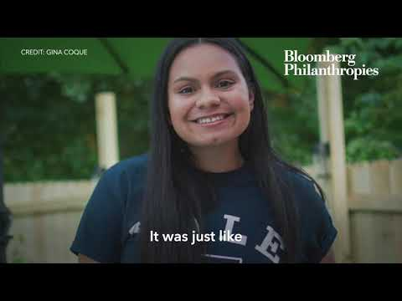
College Point partner toolkit: https://docs.google.com/document/d/1GjhQj2WiJmFXBSwooZ6sOcGmsKRUjjLfVRB5qZsWD_o/edit?usp=sharing
SDSU College Counseling Now: https://education.sdsu.edu/ccnow
EAB Survey on impact of COVID-19 on FAFSA completion: https://eab.com/insights/blogs/enrollment/fasfa-fillings-2021/?utm_source=EABStudentSurvey_IHE&utm_medium=PR
IdeaBoardz convening work: https://ideaboardz.com/for/Addressing%20Covid%20Melt/3872457

DAY 3 – May 13, 2021
Goal Setting and Campaign Planning
FL case study on BRACE Cadets program: http://floridacollegeaccess.org/wp-content/uploads/2021/03/FCAN-210211-CaseStudyOneSheet-85x11-digital.pdf
Website created by and for students/parents: https://bethefuturebeu.com/
WA materials, available in 5 languages: https://www.wcan.org/college-knowledge/
IN program focused on Spanish-speaking and Latinx families: https://learnmoreindiana.org/scholars/alumni-partners/padresestrellas/; or for the general website: www.learnmoreindiana.org
Utah children’s books about going to college: https://utahfuturesonramp.org/training/downloads/MonteBook.pdf; https://ushe.edu/wp-content/uploads/pdf/k-12/monte_goes_to_college_web.pdf
MN video about what happens after the FAFSA: Financial Aid - What Happens Now?
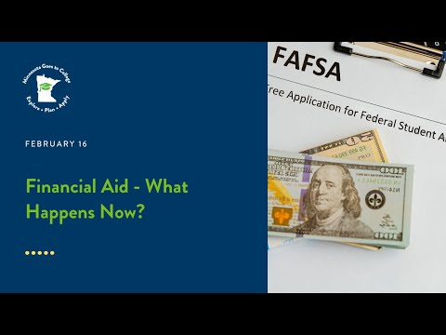
MN video about busting FAFSA myths: Myths and Truths about Financial Aid
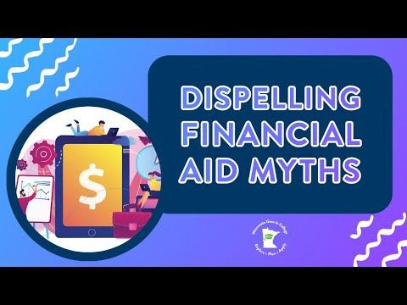
myOptions resources for ACAC state and site coordinators: https://myoptions.org/acac-resources/ and on YouTube: https://www.youtube.com/channel/UCTC7JuHFGzZLEgVmzvcaeaw

Partner Presentations
Get Schooled educator resources: http://getschooled.com/educators
Closing
Gratitude wheel tool: http://wheelofnames.com
Decision Day blog by ACT CEO Janet Godwin: https://leadershipblog.act.org/2021/05/be-brave-college-signing-day.html

