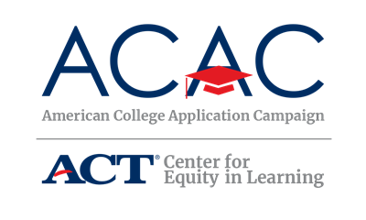

College Application Event Sample Student Sign-Out Form

State Coordinators: The following sign-out sheet is an option that allows host sites to provide the students an individual form to complete. Host sites can modify this form to meet their site needs. You can provide this template as is or make modifications based on state campaign needs.

If your state campaign is looking for a way to track data online, consider using myOptions® Encourage™ to help track student participation and analyze summary reports on the college and scholarship interests of participating students.

Site Coordinators: The following sign-out sheet is an option that allows you to provide the students an individual form to complete. You can modify this form to meet your event needs, but be sure you collect the two required data points of the national campaign: number of students participating and number of applications submitted. Be sure to check with your state campaign coordinator about what data needs to be submitted after your event(s). Copies of this document will need to be made in order for each participating student to receive one.

If you’re looking for a way to track data online, consider using myOptions Encourage to help track student participation and analyze summary reports on the college and scholarship interests of participating students. Contact your ACAC state coordinator for guidance and state data collection requirements.
[Insert Host Site Event Name] Student Sign-Out Form

Students: please complete this form before leaving the event today. Congratulations on reaching this exciting milestone, you’re on your way!

Student Name:

How many colleges have you applied to total (including those that you submitted before today’s event)?

How many colleges did you apply to today?

Is today the first time you submitted a college application?

Please list the colleges and indicate if a transcript request has been completed for each college:

College Name | Transcript Requested?

Have you registered for your FSA ID? Yes No
Have you submitted the FAFSA? Yes No

Will you be the first person in your family to attend college? (First-generation means no one in your immediate family has earned a college degree) Yes No

