#WhyApply 2021 Social Media Toolkit
This fall, students across the country will be submitting college applications and celebrating their plans for the future. Nearly 760,000 of them will do so when schools in all 50 states and the District of Columbia host American College Application Campaign (ACAC) events. To celebrate college application season and our students, ACAC encourages participation in the #WhyApply social media campaign.
Join ACAC on Friday, September 17, for #WhyApply Day by heading to social media and answering the question, “Why apply to college?”
#WhyApply Day celebrates the college application season by sharing supportive and motivating messages on social media about the importance of applying to college. Whether applying to a certificate program, two-year college or four-year university, it’s important to celebrate this critical and necessary step on the journey to postsecondary education.

HOW YOU can PARTICIPATE
- Share your #WhyApply on social media: Post your photo or video on social media
- Print a #WhyApply selfie printout or use a blank piece of paper with the hashtag on it.
- Write your response to “Why apply to college?” on the paper.
- Put on your college gear and take a photo or record a short video with your #WhyApply statement.
- On September 17, post your photo, video or statement to your personal or organization’s social media channels using the hashtag #WhyApply and tag the American College Application Campaign:
Twitter: @American_CAC | Facebook: @americancac | Instagram: @American_CAC
Sample posts to use on #WhyApply Day:
• Because you can’t go if you don’t apply • Because my parents didn’t
• To reach your fullest potential • Because you are college material
• To open new doors of opportunity that will last a lifetime • Because #RepresentationMatters
Get creative! We love seeing the pictures and your smiling faces, but there are other ways to participate. If you’re camera shy, draw a picture or simply update your status. Video is a great way to share your passion and capture people’s attention, so try sharing a brief video with your #WhyApply statement.

- promote #whyapply day in advance (copy/paste images & text)
Help us spread the word to ensure more educators and mentors join in the celebration! Post on social media 1-2 weeks before #WhyApply Day to invite others to share their own reasons on September 17.
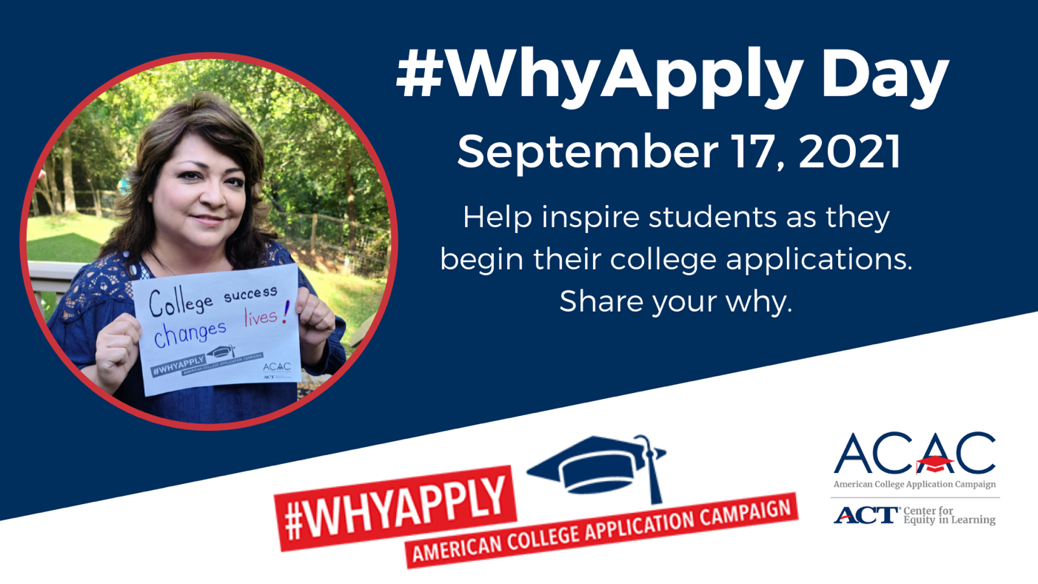
Sample social media posts to promote #WhyApply Day:
Twitter
• #WhyApply Day is Friday, Sept 17! Join us and @American_CAC by sharing your “Why apply to college?” reason. Use the #WhyApply printout available here: https://equityinlearning.act.org/acac/resources/why-apply/
• Applying to college is a necessary and critical step on the path to #college. This Friday, Sept. 17, tell students #WhyApply to college. Use @American_CAC’s #WhyApply printout available here: https://equityinlearning.act.org/acac/resources/why-apply/.
• This Friday, Sept 17 is #WhyApply Day! Wear your college gear and tell students why it’s important to apply to college!
Facebook
• #WhyApply Day is Friday, Sept 17! Join us and @americancac by sharing your “Why apply to college?” reason. Use ACAC’s #WhyApply printout available here: https://equityinlearning.act.org/acac/resources/why-apply/
• Applying to college is a necessary and critical step on the path to #college. This Friday, Sept. 17, tell students #WhyApply to college. Use @americancac’s #WhyApply printout available here: https://equityinlearning.act.org/acac/resources/why-apply/.
• This Friday, Sept 17 is #WhyApply Day! Wear your college gear and tell students why it’s important to apply to college!

- invite colleagues and networks to share their #whyapply
Send an email to your staff or include #WhyApply in your newsletter 1-2 weeks before #WhyApply Day. Copy and paste the image below or download other sizes at https://equityinlearning.act.org/acac/resources/why-apply/
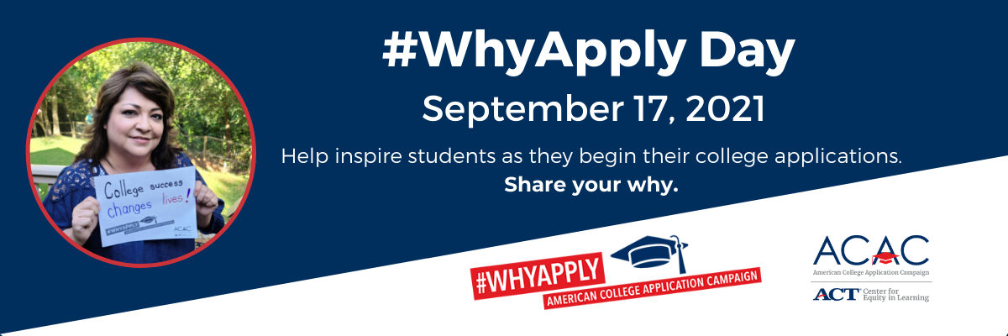
Sample newsletter copy (short form/blurb):
What was your reason for applying to college? Join us and the American College Application Campaign in celebrating #WhyApply Day on Friday, September 17. Share your why on social media. Use the template or make a video. Post with #WhyApply and help inspire students as they begin their college applications.

Sample newsletter copy (long form):
Subject line: Celebrate #WhyApply Day this September 17
To kick off the college application season, the American College Application Campaign, a national initiative of ACT’s Center for Equity in Learning, will host it’s fifth annual #WhyApply Day on Friday, September 17. I invite you to join [insert organization name] in participating by heading to your personal social media accounts and answering the question “Why apply to college?”
#WhyApply Day celebrates the college application season by sharing supportive and motivating messages on social media about the importance of applying to college. Whether applying to a certificate program, two-year college or four-year university, it’s important celebrate this critical and necessary step on the journey to postsecondary education. Here’s how you can participate on social media:
- Print a #WhyApply selfie printout or use a blank piece of paper with the hashtag on it
- Write your response to “Why apply to college?” on the paper
- Put on your college gear and take a photo with your #WhyApply statement
- On September 17, post your photo or statement to your personal or organization’s social media channels using the hashtag #WhyApply and tag the American College Application Campaign”
Twitter: @American_CAC | Facebook: @americacac | Instagram: @American_CAC
Together, we will inspire more students to apply to college!

