Instructions for using this file
This file is set up for a mail merge so that you can easily create and print certificates for all of your sites. To do this, follow the steps below. Don’t want to do a mail merge? You can manually fill in the information for each individual school by deleting the merge fields (the parts enclosed by << >>) and typing the data directly into the certificate.

- Download the companion Excel file (Certificate of Participation Data File.xlsx)
- Enter the data for your sites, as you would like it to appear in the certificate:
  - Site Name (high school or organization)
  - # of participants
  - Size of the senior class
  - # of completed applications
  - % of applications that were submitted to in-state colleges or universities (just the number!)
  - % of applications that were submitted to out-of-state colleges or universities (just the number!)
  - % of first-generation students (just the number!)
  - # of years the school has participated in your campaign (ordinal number – i.e. 1st, 2nd, 3rd, etc.)
- Save your Excel file
- Update the Word certificate file:
  - Add your campaign’s logo
  - Add your state coordinator’s signature (or you can sign them by hand after they are printed)
  - Remove any of the data statements you don’t want to include on your certificates (e.g. if you don’t know the number of first generation students, delete that line). You may need to hit the “return” key once for each line you remove to keep the logos and signatures correctly aligned.
- Now you will merge the data into the Word file:
  - Choose the “Mailings” menu
  - Choose “Select Recipients”
  - Choose “Use an Existing List”
  - Choose your saved data file
DELETE THESE INSTRUCTIONS BEFORE THE NEXT STEP!
  - Choose “Finish & Merge” and “Edit Indvidual Documents”
  - Review each of your certificates for any errors or spacing issues
  - Save and print certfiicates

CERTIFICATE OF PARTICIPATION

Congratulations on your successful 2023 college application event!

This certificate is awarded to
«High_School_Name»

for helping more students complete a critical step to college.
- «Participants» of your «Class_Size» seniors participated in college application activities
- «Completed_Applications» applications were completed
- «M__in_state_apps»% were submitted to in-state colleges & «M__out_of_state_apps»% went out of state
- «M__first_generation»% will be the first in their family to attend college
This is the «years_participating» year of participation in the campaign.
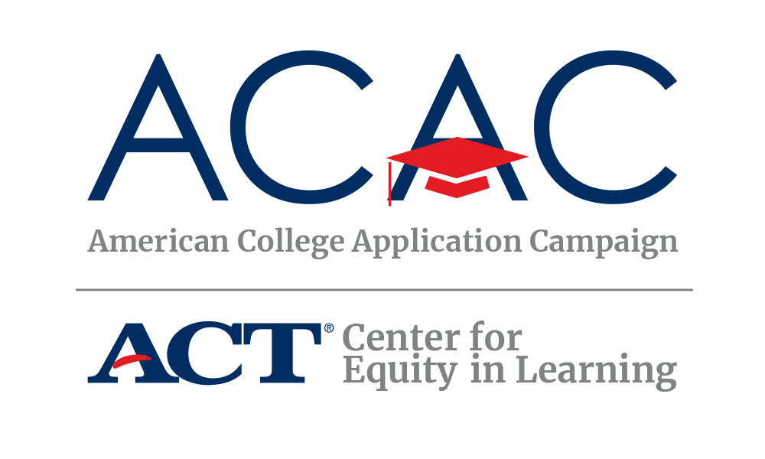

A ACAC Director [Insert State Campaign Logo and Signature]

