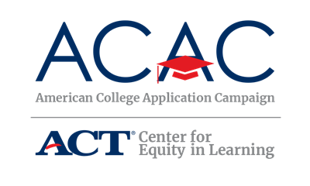

Sample Mayoral/Governor Proclamation

WHEREAS the college application process may be a barrier to some high school students pursuing postsecondary education due to an absence of information or support;

WHEREAS obtaining a postsecondary degree has been linked to higher income, better health, and increased community involvement;

WHEREAS only [percent]% of [State’s Name]’s working population, aged 25-64, has an associate degree [Pull data from Lumina’s A Stronger Nation Report: https://www.luminafoundation.org/stronger-nation/report/#/progress If you have this information specific to your town/city or region, feel free to adjust the language.];

WHEREAS [Town/City Name] and [participating high school(s) name] are working to prepare students for the opportunities and challenges of the 21st century; and

WHEREAS [high school(s) name] is/are part of a statewide initiative, [Name of State’s ACAC Program] and national initiative, American College Application Campaign, designed to increase the number of students who apply to and enroll in college with a particular focus on first-generation college-going students and students from low-income families,

I, [Mayor’s Name] do hereby declare [Dates of School’s College Application Program(s)] [Name of State’s ACAC Program] in [town/city] and encourage all seniors to take advantage of the assistance provided through this initiative.

