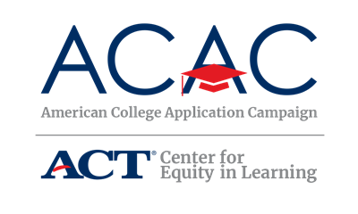

Why and How Branding Can Help ACAC and State Campaigns
Goal: Create more local, state, and national success by telling the entire story of the college application efforts. We can do this through more coordinated and stronger branding.

The more unified the individual state campaigns appear, the more recognizable our efforts will be. Though many states have created their own logos and websites to fit the needs of the state, we encourage you to utilize the ACAC name and logo as much as possible. Please keep this in mind as you adapt the available ACAC templates.

If your state has access to a marketing specialist, leverage their knowledge and expertise to create a brand for your College Application Campaign event. Consider including this individual on the state steering committee. In addition, if your state already has a college access marketing or branding strategy, investigate how your College Application Campaign initiative can become a part of it and how the ACAC name and logo can also be included to demonstrate your state’s participation in a national initiative.

- Consistent use of the logo, graphic style, wording and other elements will result in greater acceptance and awareness in the marketplace of ideas.
- National and state partners often work together in other initiatives. These branding partnerships bolster each partner. Examples include:
  - Local United Way campaigns that align with national campaign
  - Local TV affiliates of national networks
  - Local school districts that are tied to state education departments

Things State Campaigns Can Do
- Consistently use the ACAC logo on email messages, e-newsletters, backdrops, printed material, videos, webinars, website, etc. Consider ways to incorporate the ACAC colors or compatible colors in state campaign logos and material.
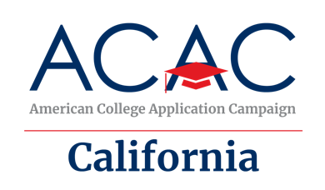
Remember: state logos with ACAC branding were created for states to use if you don’t already have a state campaign logo. They are available on the ACAC Network SharePoint.
- Use the ACAC message: ACAC is a national effort to increase the number of first-generation college students and students from low-income families pursuing a postsecondary degree. The goal of the campaign is to increase the number of students who apply to and enroll in college. At events held in the fall during the school day, students complete and submit at least one college application. Participating high schools create a college-going culture prior to and during each event.
- There are creative ways to build this brand alignment. For example, “Louisiana College Application & Access Month, partner of the American College Application Campaign” or “Wisconsin Students Go 2 College is proudly affiliated with the American College Application Campaign.”
- Help stakeholders, influencers and the media understand that your state campaign is part of a national movement. ACAC messages can be included in news releases, talking points, speeches, social media posts, and mayoral and gubernatorial proclamations as a way to make the connection.

National ACAC Color Palette

ACAC Red ACAC Blue

RGB: 203 51 64 RGB: 0 45 97

CMYK: 0 92 72 6 CMYK: 100 69 0 56
HEX#: CB3340 HEX#: 002D61

Recommended font
Montserrat is ACAC’s main typeface for designed materials. Arial is an acceptable replacement in some circumstances. Work Sans is used throughout the website.
Logo
The ACAC logo and recommended font are available on the ACAC Website and/or can be made available upon request. Contact Lisa.King@act.org if you have questions.

