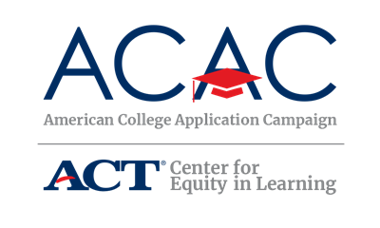

Community Information Letter

[School Logo]
[School Address]

[Date]

Dear Community Member,

[Name of Your High School or organization] is pleased to announce its participation in [Name of State Campaign]! In an effort to further expand college access across the state, the [Names of State Campaign Sponsoring Organizations] are sponsoring [Name of State Campaign] from [Campaign date(s)]. The goal of [Name of State Campaign] is to provide every graduating high school senior the opportunity to apply to college [Insert additional goals, if necessary].
This event is possible due to the collaborative efforts of the administration, faculty, and staff at [Name of your high school], as well as students, their families, and volunteers across the community.

The purpose of this [day/week/month] is to communicate the importance of applying to college and to support students with the college application process. Information about completing the Free Application for Federal Student Aid (FAFSA) [if appropriate, add any state financial aid applications that will be supported] will also be made available during the event.

[Name of your high school] will be hosting our [Name of College Application event] event on [Date(s) of event] to assist students during the application process. We welcome the community to be a part of the program. If you are interested in volunteering or being a guest speaker during the event, please let me know. Volunteers can greet and sign-in students, assist students with the completion of college applications, or distribute information about financial aid opportunities.

Our event is one of many happening around the state and country as part of the American College Application Campaign. We’ll be participating in national #WhyApply Day on September 22. We invite you to join us in this social media celebration of college application process. We encourage you to use the hashtag #WhyApply to share with students the importance of applying for college. Students will also be encouraged to use #IApplied as they complete their applications.

If you have any questions please call [Site Coordinator’s Name, Site Coordinator’s Title], at [Site Coordinator’s phone number]. Thank you in advance for your support of this exciting initiative to encourage all [State’s Name] students to make college a part of their future.

Sincerely,
[Name of Site Coordinator]
[Title]

