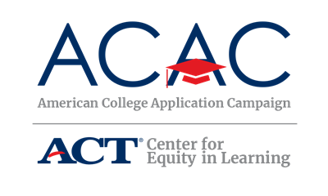

Data Collection Worksheet

This worksheet details some of the common data elements that participating ACAC states may want to consider collecting for their annual college application program including FAFSA completion variables. Space has been provided at the bottom of the table to add additional variables associated with your state’s outlined goals. The ACAC team is available to assist your state as you develop a data collection and analysis strategy for your Campaign program.

It is important to keep FERPA regulations, security needs, and required agency approvals (IRB), in mind as you develop your state’s data collection and analysis plan. Samples of surveys for site coordinators, students, and volunteers are available on the ACAC Network SharePoint for state coordinators.

We recommend updating this worksheet annually. This piece is an excellent way to keep a record of data to support successful transition of the work to a new state coordinator, should that occur in your state.

*Required by ACAC

Data Variable | Source for Data (survey, agency, etc.) | When are data available? | Level of data (student, school, district, state)
Number of high schools participating in ACAC*
Number of students participating in ACAC*
Number of applications submitted during ACAC*
Number of applications submitted to:
- 4-year institutions
- 2-year institutions
- Public institutions
- Private Institutions
Number of students indicating this was the first time they applied to college
High school free-or-reduced lunch rates
Student demographics – race/ethnicity
Student demographics – first generation college going
Number of in-state postsecondary institutions that accept fee waivers
Site Coordinators experiences with ACAC
Student experiences with ACAC
Volunteer experiences with ACAC
Number of FSA IDs created
Number of FAFSAs submitted

