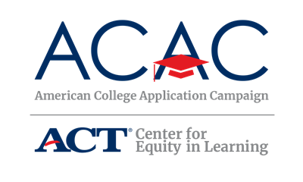

FAFSA Completion Event Reminders

[Name of State’s FAFSA Completion Event]
[FAFSA Completion Event’s Logo]

Assistance with Your Free Application for Federal Student Aid (FAFSA)
[If your state offers state aid for undocumented an DACAmented students, consider including support for that financial aid application in this event]

Date: [FAFSA Completion Event Date]
Time: [FAFSA Completion Event Time]
Location: [Nearest location]

Contact Info
Host: [FAFSA Completion Event Group or Organization]
Contact Phone Number: [Phone Number for FAFSA Completion Event]
Contact Email: [Email for FAFSA Completion Event]

What to Bring
The following items are what you should bring to the event.
- Your FSA ID, if you have already applied and been assigned one. The FSA ID is a username and password you use to log in to the U.S. Department of Education online systems. You may have registered for your FSA ID during [Name of State’s ACAC program]. If you do not already have a FSA ID or if you have forgotten your FSA ID and need to retrieve it, you can go here: https://studentaid.ed.gov/sa/fafsa/filling-out/fsaid. Be sure to do this prior to the event!
- If you have previously completed a FAFSA on the Web Worksheet, please bring it with you. This worksheet will help you collect the information needed to complete the online FAFSA form. It is available at studentaid.gov. This is not the financial aid application nor is it part of the application. It is a guide to help you complete the application.
- Your Social Security Number (SSN).
- Your driver's license (if any).
- Your parents' [Tax Year] W-2 forms (if you are a dependent student). If you earned income in [Tax Year], you should also bring your [Tax Year] W-2 forms.
- Your [Tax Year] untaxed income records (e.g., Veteran's non-education benefit records, child support received, worker's compensation).
- Your current bank statements.
- Your current business and investment mortgage information, business and farm records, stock, bond and other investment records.
- Your resident alien registration or permanent resident card (if you are not a U.S. citizen and are eligible for federal aid).
- [Include any additional information undocumented or DACAmented students need to appy for state aid.]

For more information, visit the [Name of State’s FAFSA Completion Event] website here:
[FAFSA Completion Event Website]

