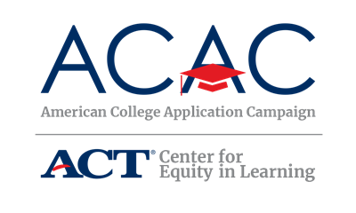

Host Site Volunteer Recruitment Letter - Template

SCHOOL LOGO
SCHOOL ADDRESS
September 2022

Dear [NAME OF ORGANIZATION],

[NAME OF YOUR HIGH SCHOOL or ORGANIZATION] is pleased to announce its participation in [NAME OF STATE CAMPAIGN]! In an effort to further expand college access initiatives, the [NAME OF STATE CAMPAIGN AGENCY] is sponsoring [NAME OF STATE CAMPAIGN] from [CAMPAIGN DATE(S)]. The goal of [NAME OF STATE CAMPAIGN] is to provide every graduating high school senior and/or recent high school graduate the opportunity to apply to college [INSERT ADDITIONAL GOALS, IF NECESSARY].

[NAME OF STATE CAMPAIGN] can open the door for students by encouraging them to take significant steps toward college during their senior year or shortly after. What began in 2005 as a single day at one high school in North Carolina has evolved into 50 state campaigns to help students. This year, [STATE] expects over [NUMBER] high schools and community organizations to participate in our statewide campaign. A critical component of [NAME OF STATE CAMPAIGN] is the one-on-one support provided by volunteers who help students fill out applications during the school day or at a community-based event. Volunteers may include high school staff; registrars, admissions officers, and financial aid advisers from nearby postsecondary institutions; parents and representatives from the community.

We will be hosting our event on [DATE(S) AND TIME] and would welcome representatives from [NAME OF ORGANIZATION] to visit our [school/organization] during this exciting and important time. Volunteers can greet and sign-in students, assist students with the completion of online college applications, or distribute additional information about financial aid opportunities. Our students would really appreciate your help and support as they take a big step toward going to college.

If you or any of your colleagues at [NAME OF ORGANIZATION] are interested in working with [NAME OF YOUR HIGH SCHOOL OR ORGANIZATION] in any capacity, please contact me at [SITE COORDINATOR INFO].

Thank you!

Volunteer resources and training webinar information are available at [WEBSITE].

[SITE COORDINATOR NAME]
[YOUR TITLE]
[CONTACT INFO]

