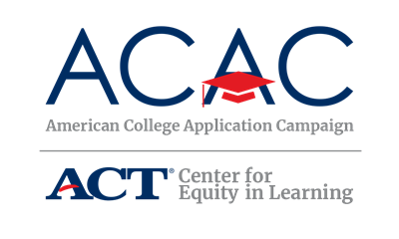
Host Site Planning Committee Audit

Identifying Stakeholders and Convening a Host Site Team
Schools and organizations that have successfully implemented a College Application Campaign event have done so through the collaboration of multiple stakeholders. A key approach to engaging stakeholders is the creation of a host site team that will provide input on and support for the various logistics necessary to implement a successful College Application Campaign event at the school level.

Below, you will find a list of recommended local resources that you can use to identify the key stakeholders in your community. Keep in mind that this list is not exhaustive, and you should engage any other community partners that have a vested interest in college access and student success. When planning and implementing your school’s College Application Campaign initiative, you should follow all district and school policies regarding non-school personnel visiting, volunteering, or otherwise assisting with your school’s program.

Potential community partners include:
- Admissions representatives from local colleges (two-year and four-year)
- Local business leaders
- Local Chamber of Commerce
- College access initiatives (federally-funded, state-funded, or community-based)
- Faith-based community
- Nonprofit organizations such as the YMCA, 4H, Boys and Girls Club, etc.
- PTA and other parents/family members who want to be engaged in the process
- Student leaders in your high school
- Retired school personnel
- Local government officials or elected representatives
- Alumni (near-peer recent high school graduates)

Host Site Planning Committee Audit cont.

Host Site Partners
Use the following table to identify potential education partners in your community for your College Application Campaign event. Remember, planning committee members don’t have to be individuals already working on college access initiatives, though it is helpful. They also don’t need to be experts on the college application process. Space has been provided at the bottom of the table for you to add additional partners, if needed. Additionally, if someone is unable to serve on a planning committee, consider asking if they will volunteer during the event.

Potential Partners | Name of Contact | Email Address | Phone Number
Parent Teacher Association
Faculty and Staff
Teachers
Chamber of Commerce

Nonprofit representative
High school student representative

Faith-based community representative
Junior League Associations
Local corporation representative
Local college or university representative
College student representative (could be an alum of your school)

