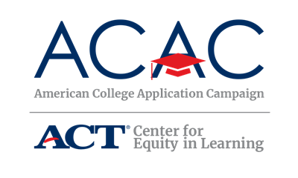

Partner Site Request Letter Template – State Level

[Date]

Dear [Organization],
I serve on [state’s] steering committee for the [state campaign name], an initiative led by [state lead organization]. We are excited to announce that [state campaign name] will be held [dates]. We’re currently recruiting participating partner sites and hope your organization will join us!
A partner of the American College Application Campaign (ACAC), the purpose of [Name of State’s ACAC Program] is to communicate the importance of applying to college and support students with the college application process. On [Date(s) of event], all seniors at [Number] high schools across the state who are expected to graduate at the end of this academic year will be encouraged to apply for admission to at least one college or university. In 2022, [insert data] students completed [insert data] applications in [state’s name] during [Name of State’s ACAC Program]!
Community-based organizations interested in registering can go to [link].
Additionally, we encourage you to join us in celebrating the college application process on social media. ACAC kicks off the season with #WhyApply Day on September 22, 2023. We encourage you to use the hashtag #WhyApply on September 22, and during our state campaign’s [day/week/month] to share with students the importance of applying for college. You can also celebrate students as they share with us where they applied using the hashtag #IApplied.
If you have any questions about how your organization can join [Name of state’s ACAC initiative] please call [State Coordinator’s Name, State Coordinator’s Title], at [State Coordinator’s phone number]. Thank you in advance for your support of this exciting initiative to encourage all [State’s Name] students to make college a part of their future.
Sincerely,
[Name of State Coordinator]
[Title]

