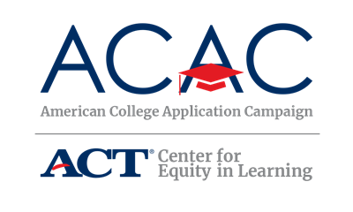

Reporting Test Scores

When you apply to college, it can feel like you are learning a new vocabulary. This is particularly true regarding the reporting of standardized test scores such as ACT, SAT, TOEFL, Advanced Placement, and International Baccalaureate. You will see terms like: Test Required, Test Optional, Test Flexible, and Test Blind. Since each term means something a little different, it makes sense to provide you with a quick reference guide.

Test Required – This is pretty straightforward. The institution requires either the ACT, SAT, or TOEFL (an English language proficiency test for international students). Most colleges do not have a preference for which test you take, but it is a good idea to ask. If they do not have a preference, submit the best scores you receive.

Test Optional – The institution does not require test scores. Instead, your high school academic record is the most important information. Additionally, your personal essay, recommendation letters, extracurricular activities, and personal interview may complete the admissions decision-making process. Students may choose to submit scores and ask the admissions committee to consider them along with the other application materials. Institutions that are test optional are a great choice for students who are confident that their high school record and achievements provide a more complete picture of their academic abilities than a single standardized test.

Test Flexible – Institutions that are text flexible allow you to submit multiple standardized test scores to support your application. You need to ask the admissions office which of the following they will consider: International Baccalaureate, Advanced Placement scores, ACT and/or SAT.

Test Blind – This means that students are not required to submit any standardized test scores, and colleges will not consider submitted scores when making an admissions decision.

As with any question you have about the application process, contact the institution’s admission office to receive the most up-to-date information about their expectations for a complete college application. Testing requirements may be different depending on the applicant’s circumstances. For example, some institutions may be Test Required for out-of-state applications but Test Optional for in-state applications. Others may require test scores for specific majors or to be considered for scholarships.

As you do your research and build your college list, make notes about the test score reporting requirements using ACAC’s College Application Worksheet. This is how you can confidently and proudly wear an #IApplied badge!

