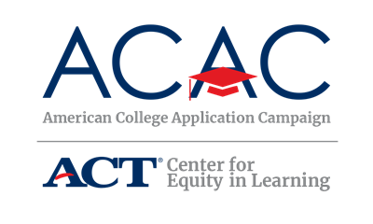

College Application Event Sign-Out Sheet Template

State Coordinators: The following sign-out sheet is an option that allows host sites to collect student application information in one place before students exit the event. Host sites can modify this form to meet their site needs. You can provide this template as is or make modifications based on state campaign needs.

If your state has a secure online portal, encourage sites to use this as a way to track students’ completed applications.

Site Coordinators: The following sign-out sheet is an option that allows you to collect student application information in one place before students exit the event. You can modify this form to meet your event needs, but ensure you collect the two required data points of the campaign: number of students participating and number of applications submitted. Be sure to check with your state campaign coordinator about what data needs to be submitted after your event(s). Copies of this document will need to be made in order to ensure enough space for all students to provide their information.

[Insert Host Site Event Name] Sign-Out Sheet

Students, please write your name, the colleges to which you applied and whether you registered for your FSA ID at this college application event. Congratulations on reaching this exciting milestone, you’re on your way!

Student Name | List Colleges You Applied To | Registered for FSA ID? (Y/N)

[Insert Host Site Event Name] Sign-Out Sheet

Students, please write your name, the colleges to which you applied and whether you registered for your FSA ID at this college application event. Congratulations on reaching this exciting milestone, you’re on your way!

Student Name | List Colleges You Applied To | Registered for FSA ID? (Y/N)

