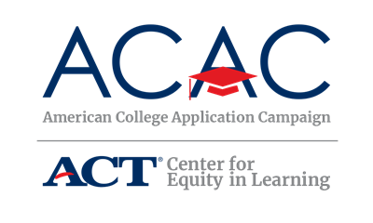

College Application Event Student Sign-Out Form – option 2 of 3
Template for collecting
- Number of participating students
- Number of applications submitted by each student
- Colleges to which applications have been submitted and transcript requests
- Information about student’s progress in submitting the FAFSA
- First-generation status

State Coordinators: The following sign-out form is an option that allows host sites to provide the students an individual form to complete. Host sites can modify this form to meet their site needs. You can provide this template as is or make modifications based on state campaign needs.

If your state has a secure online portal, encourage sites to use that as a way to track students’ completed applications.

Site Coordinators: The following sign-out sheet is an option that allows you to provide the students an individual form to complete. You can modify this form to meet your event needs, but be sure you collect the two required data points of the national campaign: number of students participating and number of applications submitted. Be sure to check with your state campaign coordinator about what data needs to be submitted after your event(s).

Copies of this document will need to be made in order for each participating student to receive one or build an online form using Google Forms or something similar. Students may be more apt to follow a link or QR code to provide the information needed.

[Insert Host Site Event Name] Student Sign-Out Form

Students: please complete this form before leaving the event today. Congratulations on reaching this exciting milestone, you’re on your way!

Student Name:

How many colleges have you applied to total (including those that you submitted before today’s event)?

How many colleges did you apply to today?

Is today the first time you submitted a college application?

Please list the colleges and indicate if a transcript request has been completed for each college:

College Name | Transcript Requested?

Have you registered for your FSA ID? Yes No
Have you submitted the FAFSA? Yes No

Will you be the first person in your family to attend college? Yes No

