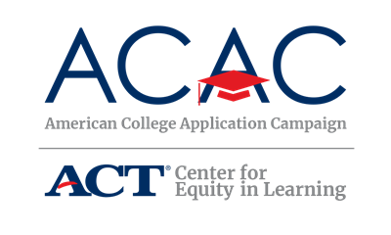

Student/Family Information Letter

[School Logo]
[School Address]

[Date]

Dear Students and Families,

During the [week/weeks/month] of [Dates of ACAC State Campaign], [Names of State Campaign Sponsoring Organizations] will be sponsoring [Name of State Campaign]. On [Date(s) of event], all seniors expected to graduate at the end of this academic year will be encouraged to apply for admission to at least one college or university, if they have not already done so. This event is possible due to the collaborative efforts of the administration, faculty, and staff at [Name of your high school], as well as students, their families, and volunteers across the community.

The purpose of this [day/week/month] is to communicate the importance of applying to college and to support students with the college application process. Information about completing the Free Application for Federal Student Aid (FAFSA) will also be made available during the event.

If your state campaign has specific resources to assist with preparing for the event, add those there. Otherwise, use the following, and provide copies of these resources, both found on the American College Application Campaign’s website: https://equityinlearning.act.org/acac/resources/site-coordinator-materials/: We have two student resources that we encourage all students to use in preparation for the college application event. First, there is a College Research Worksheet designed to support students and their families as they narrow down the list of colleges to which each student wants to apply. We encourage students to apply to multiple and varied schools, including at least one local college or university, such as [enter name(s) of local institutions]. In addition, there is a College Application Worksheet which we encourage students to complete prior to the event. This worksheet allows students to collect information that is typically asked on college applications. Having this worksheet completed and available at the college application event will allow students to quickly and easily complete college applications.

We anticipate that students and their families will need to work together in gathering the information listed in the College Application Worksheet. Families are welcome to visit [Name of your high school] on [Date(s) of event] to assist their student during the application process. In addition, if family members are interested in volunteering or guest speaking during the event, please let me know. Volunteers can greet and sign-in students, assist students with the completion of college applications, or distribute information about financial aid opportunities.

Additionally, we encourage families to join us in celebrating the college application process on social media. September 22, 2023, will kick off the American College Application Campaign with #WhyApply Day. We encourage you to use the hashtag #WhyApply to share with students the importance of applying for college.

If you have any questions please call [Site Coordinator’s Name, Site Coordinator’s Title], at [Site Coordinator’s phone number]. Thank you in advance for your support of this exciting initiative to encourage all [State’s Name] students to make college a part of their future.

Sincerely,
[Name of Site Coordinator]
[Title]

