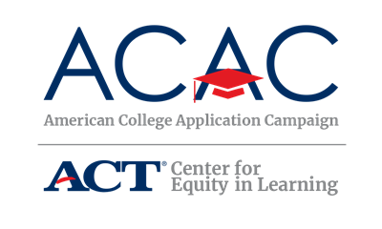

Volunteer Audit: State-Level

Volunteers are critical to the success of any College Application Campaign initiative and the Steering Committee is an excellent resource to identify potential pools of volunteers such as:

Admissions representatives

Community-based organizations focused on college access

Retired educators

Returning college students

College students seeking school counselor degrees

Business leaders

Potential Volunteers
Use the following table to identify potential volunteers in your state for your College Application Campaign event. Remember, volunteers don’t have to be individuals already working on college access initiatives, though it is helpful. They also don’t need to be experts on the college application process. Space has been provided at the bottom of the table for you to add additional partners, if needed. If the state will not be assisting in volunteer outreach and support or if some schools would like to lead their volunteer outreach and coordination, a modified version of this state-level audit is available for a school to conduct a community-level audit below.

Potential Volunteers | Name of Contact | Email Address | Phone Number
School Board Association
School Counselor Association
School Administrators Association
Teacher Association

Financial Aid Association
State College Access Network

Business Committee for Education Organization
Chamber of Commerce
State PTO/PTA Association
State or local college access groups

Volunteer Audit: Community-Level

Volunteers are critical to the success of any College Application Campaign initiative and the Steering Committee is an excellent resource to identify potential pools of volunteers such as:

Admissions representatives

Community-based organizations focused on college access

Retired educators

Returning college students

College students seeking school counselor degrees

Business leaders

Alumni who recently graduated from college or are currently attending college

Teachers

Families

Religious leaders

Potential Volunteers
Use the following table to identify potential volunteers in your community for your College Application Campaign event. Remember, volunteers don’t have to be individuals already working on college access initiatives, though it is helpful. They also don’t need to be experts on the college application process. Space has been provided at the bottom of the table for you to add additional partners, if needed.

Potential Volunteers | Name of Contact | Email Address | Phone Number
Parent Teacher Association
Faculty and Staff

Business Committee for Education Organization

Chamber of Commerce

Junior League Associates
Regional or Local College Access Network
Women Leader Associations
Rotary Club
Young Nonprofit Professional Associations
Current college students (Greek Life, service-based student groups, counseling or teacher degree programs)

