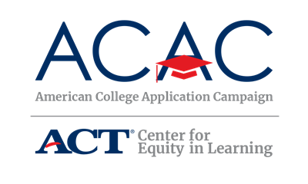

General Volunteer Information

Thank you for volunteering to assist students during [STATE CAMPAIGN NAME]! We appreciate your hard work and dedication to making college a reality for all [STATE] students. Before you report to your volunteer site, you may want to familiarize yourself with the following information about the American College Application Campaign and [STATE CAMPAIGN NAME].

[STATE CAMPAIGN] is an event sponsored by [SPONSOR NAME(S)]. More than [NUMBER] high schools and community-based organizations located throughout the state host college application events to support students through the process.

The goal of the Campaign is to provide every graduating high school senior [IF APPLICABLE, and recent graduates] the opportunity to apply to college, with a particular focus on helping first-generation college students, students from low-income families, and students who may not otherwise apply to college.

Students are encouraged to research different colleges and universities in order to find the best match and fit for them prior to [STATE CAMPAIGN NAME].

Students will be applying to a variety of colleges and universities, based on their prior research. The role of the volunteer is to be supportive of each student’s choices, not to recruit students to a particular school.

Host sites provide designated space and time during their regular operating hours for completing applications.

Students may have questions about college application fees and fee waivers. Note that some colleges and universities in [STATE] do not have an application fee. Others allow for fee deferrals or fee waivers for qualifying students. More information can be found at [URL/RESOURCE].

Some students may be eligible for an application fee deferral or fee waiver from their high school counselor based on their family income status. If students have questions about eligibility, please refer them to their school counselor.

For colleges that require an application fee, students can use credit or debit cards online, or they may print their online application(s) and mail it with a check to the college(s).

[STATE CAMPAIGN] is part of a larger, national campaign effort. We are one of 50 states and the District of Columbia participating in the American College Application Campaign (ACAC). Consider joining us on social media to participate in the national ACAC #WhyApply Day on Friday, September 16, 2022 to kick off college application season.

