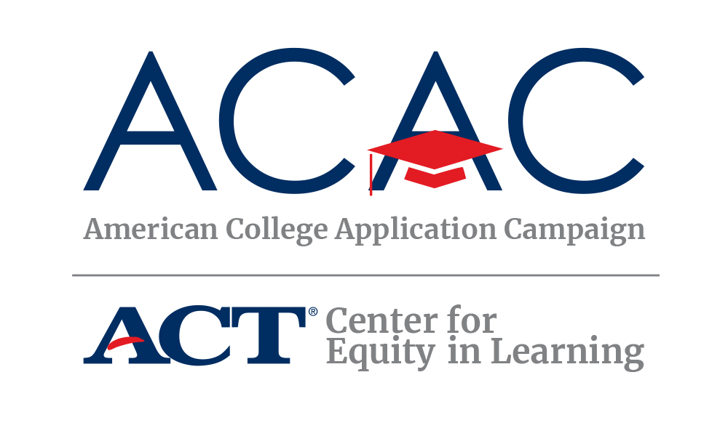
#WHYAPPLY SOCIAL MEDIA CAMPAIGN
This fall, students across the country will be submitting college applications and celebrating their plans for the future. Hundreds of thousands of them will do so when schools in all 50 states and the District of Columbia host American College Application Campaign (ACAC) events. To celebrate college application season and our students, ACAC encourages participating in the #WhyApply social media campaign.
What is #WhyApply Day?
#WhyApply Day is sponsored by the American College Application Campaign, an initiative of ACT’s Center for Equity in Learning, which partners with thousands of high schools across the country each fall to host events supporting students through the college application process, especially first-generation college students and those from low-income families who may not otherwise apply to college. This year we anticipate nearly 6,000 high schools hosting application completion events between September and December. To celebrate the more than 700,000 students who will participate in these application events, #WhyApply Day kicks off the application season and provides encouragement for the students.
How to show your support
On Friday, September 16, 2022 wear your college gear (t-shirt, hats, pins, etc.) and share why you believe students should apply to college and/or why you applied to college, using the hashtag #WhyApply. Then share your response on your favorite social media platform. Encourage your friends, family, and colleagues to do the same. Not sure what to post? You might:
- Type a short response in your status
- Make a video of yourself, your kids, or your friends answering the question
- Draw a picture depicting your reasons
- Write your answer on a piece of paper (feel free to use the #WhyApply template provided) and post a photo of you holding it
- Share an image or photo with your reason
Follow ACAC on Social Media
We plan to highlight every state’s initiative this fall. Like our page and/or follow us to see how colleagues across the country are accomplishing the ACAC goal. Start now by posting photos, media, and other items from past and future events. We look forward to featuring your great work!
www.facebook.com/americancac https://twitter.com/american_cac www.instagram.com/american_cac
