#WhyApply 2022 Social Media Toolkit
This fall, students across the country will be submitting college applications and celebrating their plans for the future. Many of them will do so as schools in all 50 states and the District of Columbia host American College Application Campaign (ACAC) events. To celebrate college application season and our students, ACAC encourages participation in the #WhyApply social media campaign.
Join ACAC on Friday, September 16, for #WhyApply Day by heading to social media and answering the question, “Why apply to college?” More specifically, this year, we’re focusing on WHAT did you learn in college.
#WhyApply Day celebrates the college application season by sharing supportive and motivating messages on social media about the importance of applying to college. Whether applying to a certificate program, two-year college or four-year university, it’s important to celebrate this critical and necessary step on the journey to postsecondary education.

HOW YOU can PARTICIPATE
- Share your #WhyApply on social media: Post your photo or video on social media
- Print a #WhyApply Selfie Printout or use a blank piece of paper with the hashtag on it
- Write your response to the question “Why apply to college?” or “What did you learn in college?” on it
- Put on your college gear and take a photo with your #WhyApply statement
- On September 16, post your photo or statement to your personal or organization’s social media channels using the hashtag #WhyApply and tag the American College Application Campaign:
Twitter: @American_CAC | Facebook: @americancac | Instagram: @American_CAC
Sample posts to use on #WhyApply Day:
• Because you can’t go if you don’t apply • Because my parents didn’t
• I learned how to reach my potential • Because you are college material
• To open new doors of opportunity that will last a lifetime • I learned #RepresentationMatters
Get creative! We love seeing the pictures and your smiling faces, but there are other ways to participate. If you’re camera shy, draw a picture or simply update your status. If you prefer video, share a brief video with your #WhyApply statement.

- promote #whyapply day on social media (copy/paste images & text)
Help us spread the word to ensure more educators and mentors join in the celebration! Post on social media 1-2 weeks before #WhyApply Day to invite others to share their own reasons on September 16.
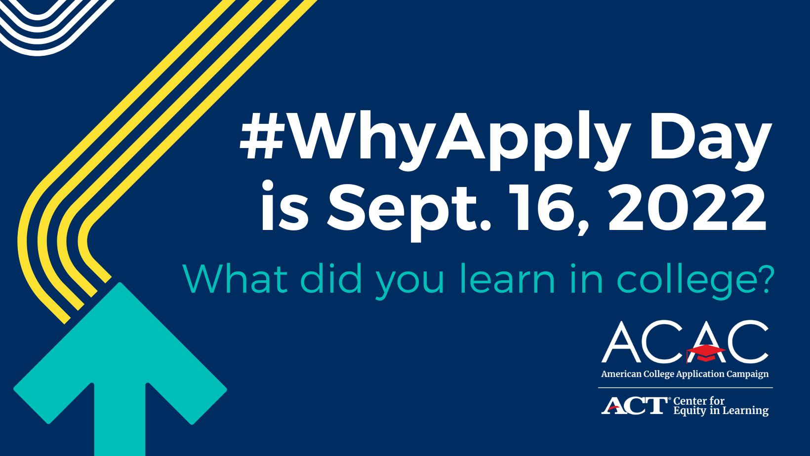
Sample social media posts to promote #WhyApply Day:
Twitter
• #WhyApply Day is Friday, Sept 16! Join us and @American_CAC by sharing what you learned in college. Use the #WhyApply printout available here: https://equityinlearning.act.org/acac/resources/why-apply/
• Applying to college is a necessary and critical step on the path to #college. This Friday, Sept. 16, tell students #WhyApply to college. Use @American_CAC’s #WhyApply printout available here: https://equityinlearning.act.org/acac/resources/why-apply/.
• #WhyApply Day is only one week away! On Sept. 16, join us as we share our perspectives on the lessons we've learned from college.
Facebook
• #WhyApply Day is Friday, Sept 16! Join us and @AmericanCAC by sharing one thing you learned in college. Use the #WhyApply printout available here: https://equityinlearning.act.org/acac/resources/why-apply/
• Applying to college is a necessary and critical step on the path to #college. This Friday, Sept. 16, tell students #WhyApply to college. Use @AmericanCAC’s #WhyApply printout available here: https://equityinlearning.act.org/acac/resources/why-apply/.
• #WhyApply Day is only one week away! On Sept. 16, join us as we share our perspectives on the lessons we've learned from college.

- invite colleagues and networks to share their #whyapply
Send an email to your staff or include #WhyApply in your newsletter 1-2 weeks before #WhyApply Day. Copy and paste the image below or download other sizes at https://equityinlearning.act.org/acac/resources/why-apply/
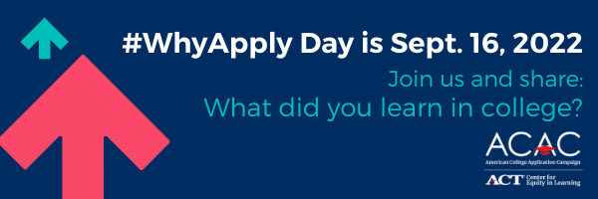
Sample newsletter copy (short form/blurb):
What did you learn in college? Join us and the American College Application Campaign in celebrating #WhyApply Day on Friday, September 16. Share what you learned in college on social media. Use the template or make a video. Post with the #WhyApply hashtag and help inspire students as they begin their college applications.
Sample newsletter copy (long form):
Subject line: Celebrate #WhyApply Day this September 16
To kick off the college application season, the American College Application Campaign, a national initiative of ACT’s Center for Equity in Learning, will host its annual #WhyApply Day on Friday, September 16. I invite you to join [insert organization name] in participating by heading to your personal social media accounts and answering the question “What did you learn in college?”
#WhyApply Day celebrates the college application season by sharing supportive and motivating messages on social media about the importance of college and why students should apply NOW. Whether applying to a certificate program, two-year college or four-year university, it’s important celebrate this critical and necessary step on the journey to postsecondary education. Here’s how you can participate on social media:
- Print a #WhyApply selfie printout or use a blank piece of paper with the hashtag on it
- Write your response to “What did you learn in college?” on the paper
- Put on your college gear and take a photo with your #WhyApply statement
On September 16, post your photo or statement to your personal or organization’s social media channels using the hashtag #WhyApply and tag the American College Application Campaign:
Twitter: @American_CAC | Facebook: @americacac | Instagram: @American_CAC
Together, we will inspire more students to apply to college!

